# 10-3-2-drag-fixed.html

E:\workspace\js\d3.js\jtd3js\chapter10\10.3\10-3-2-drag-fixed.html

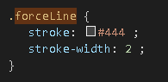

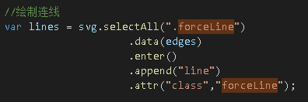

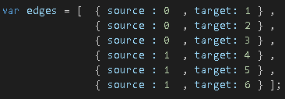

## 2@精通D3.js交互式数据可视化高级编程

### 2.5.4 样式

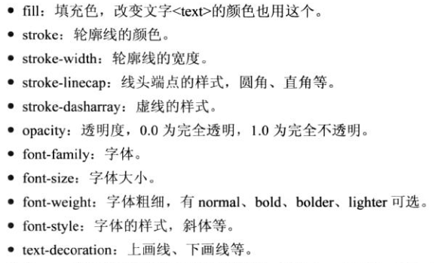

### selectAll

4.1 选择元素

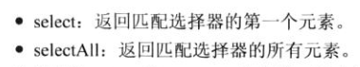

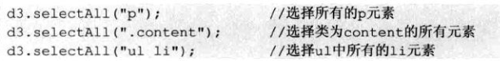

### 4.2 选择集



### 4.4.2 data（）的工作过程



### 4.5.1 enter的处理方法

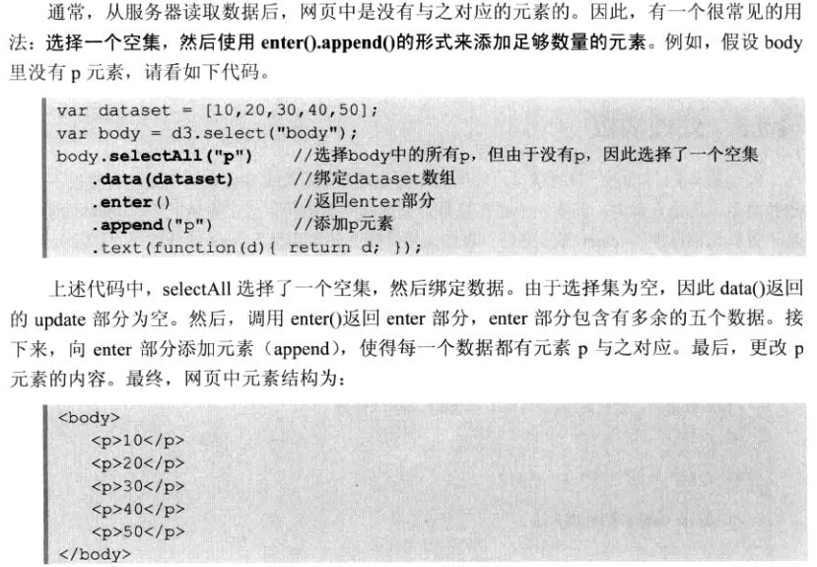

### 比例尺

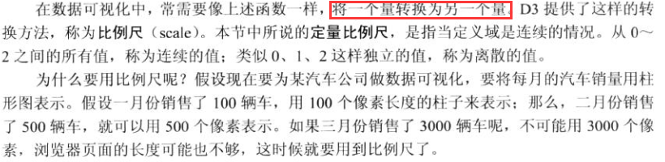

### Drag.on

8.3.1 拖曳

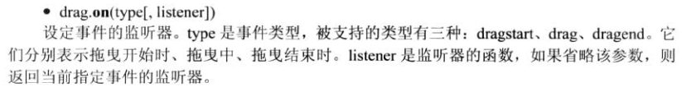

### 10.3 力导向图



## 数据可视化实战.使用D3设计交互式图表

### Category20

7.8　其他比例尺

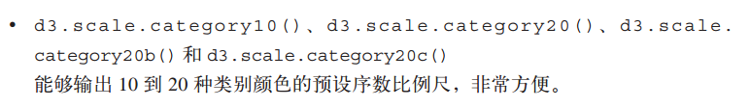

### tick

11.3　力导向布局

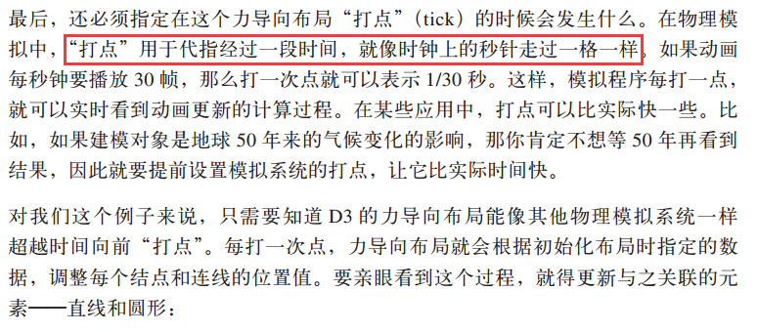

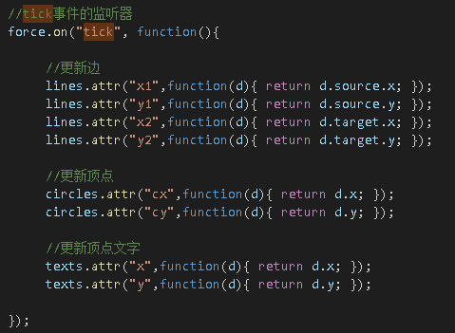

## 2@D3.js数据可视化实战手册

### Category20

4.4 使用有序尺度



# Learning D3.JS - 十二月咖啡馆

http://d3.decembercafe.org/index.html

1简介和安装

2第一个程序

3选择元素和绑定数据

4选择、插入、删除元素

5做一个简单的图表

6比例尺的使用

7坐标轴

8完整的柱形图

9让图表动起来

10理解 Update、Enter、Exit

11交互式操作

12布局是什么

13饼状图

14力导向图

15地图

## 力导向图 - Learning D3.JS

http://d3.decembercafe.org/pages/lessons/14.html

第十四课 力导向图

力导向图中每一个节点都受到力的作用而运动，这种是一种非常绚丽的图表。

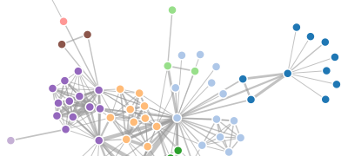

力导向图（Force-Directed Graph），是绘图的一种算法。在二维或三维空间里配置节点，节点之间用线连接，称为连线。各连线的长度几乎相等，且尽可能不相交。节点和连线都被施加了力的作用，力是根据节点和连线的相对位置计算的。根据力的作用，来计算节点和连线的运动轨迹，并不断降低它们的能量，最终达到一种能量很低的安定状态。

力导向图能表示**节点之间的多对多的关系**。

数据

初始数据如下：

**var** nodes = [ { name: "桂林" }, { name: "广州" },

{ name: "厦门" }, { name: "杭州" },

{ name: "上海" }, { name: "青岛" },

{ name: "天津" } ];

**var** edges = [ { source : 0 , target: 1 } , { source : 0 , target: 2 } ,

{ source : 0 , target: 3 } , { source : 1 , target: 4 } ,

{ source : 1 , target: 5 } , { source : 1 , target: 6 } ];

节点（nodes）和连线（edges）的数组，节点是一些城市名，连线的两端是节点的序号（序号从 0 开始）。

这些数据是不能作图的，因为不知道节点和连线的坐标。这句话一说出来，就请想到布局。本章用到的布局是：**d3.layout.force()**。

布局（数据转换）

定义一个力导向图的布局如下。

**var** force = d3.layout.force()

.nodes(nodes) //指定节点数组

.links(edges) //指定连线数组

.size([width,height]) //指定作用域范围

.linkDistance(150) //指定连线长度

.charge([-400]); //相互之间的作用力

然后，使力学作用生效：

force.start(); //开始作用

如此，数组 nodes 和 edges 的数据都发生了变化。在控制台输出一下，看看发生了什么变化。

console.log(nodes);

console.log(edges);

节点转换前后如下图。

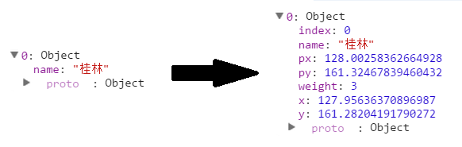

转换后，节点对象里多了一些变量。其意义如下：

* index - 节点的索引号
* px, py - 节点上一个时刻的坐标
* x, y - 节点的当前坐标
* weight - 节点的权重

再来看看连线的变化。

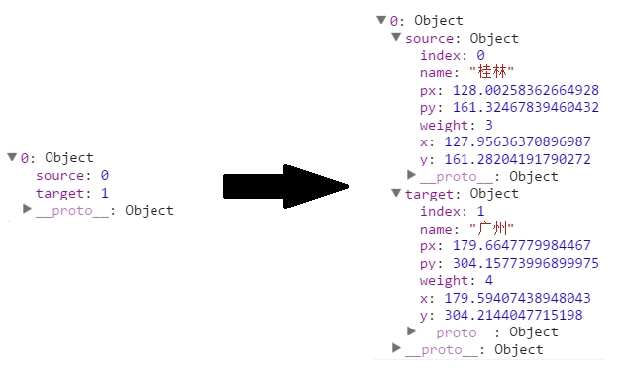

可以看到，连线的两个节点序号，分别变成了对应的节点对象。

绘制

有了转换后的数据，就可以作图了。分别绘制三种图形元素：

* line - 线段，表示连线。
* circle - 圆，表示节点。
* text - 文字，描述节点。

代码如下：

//添加连线

**var** svg_edges = svg.selectAll("line")

.data(edges)

.enter()

.append("line")

.style("stroke","#ccc")

.style("stroke-width",1);

**var** color = d3.scale.category20();

//添加节点

**var** svg_nodes = svg.selectAll("circle")

.data(nodes)

.enter()

.append("circle")

.attr("r",20)

.style("fill",**function**(d,i){

**return** color(i);

})

.call(force.drag); //使得节点能够拖动

//添加描述节点的文字

**var** svg_texts = svg.selectAll("text")

.data(nodes)

.enter()

.append("text")

.style("fill", "black")

.attr("dx", 20)

.attr("dy", 8)

.text(**function**(d){

**return** d.name;

});

调用 call( force.drag ) 后节点可被拖动。force.drag() 是一个函数，将其作为 call() 的参数，相当于将当前选择的元素传到 force.drag() 函数中。

最后，还有一段最重要的代码。由于力导向图是不断运动的，每一时刻都在发生更新，因此，必须不断更新节点和连线的位置。

力导向图布局 force 有一个事件 tick，每进行到一个时刻，都要调用它，更新的内容就写在它的监听器里就好。

force.on("tick", **function**(){ //对于每一个时间间隔

//更新连线坐标

svg_edges.attr("x1",**function**(d){ **return** d.source.x; })

.attr("y1",**function**(d){ **return** d.source.y; })

.attr("x2",**function**(d){ **return** d.target.x; })

.attr("y2",**function**(d){ **return** d.target.y; });

//更新节点坐标

svg_nodes.attr("cx",**function**(d){ **return** d.x; })

.attr("cy",**function**(d){ **return** d.y; });

//更新文字坐标

svg_texts.attr("x", **function**(d){ **return** d.x; })

.attr("y", **function**(d){ **return** d.y; });

});

tick 的英文意思是钟表发出的嘀嗒嘀嗒声，想到这个大家应该很清楚了吧。每次触发时，都会调用后面的无名函数 function。

来看看最终效果图。

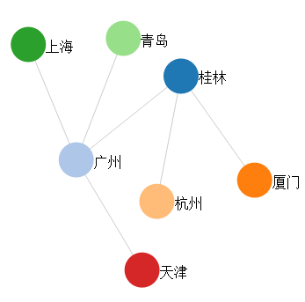

源代码

下载地址：[rm14.zip](http://d3.decembercafe.org/src/rm/rm14.zip)

[在线演示](http://d3.decembercafe.org/demo/rm/lesson14/Force.html)

# D3 进阶系列 | OUR D3.JS - Part 2

http://www.ourd3js.com/wordpress/category/d3-%e8%bf%9b%e9%98%b6%e7%b3%bb%e5%88%97/page/2/

## 【 D3.js 进阶系列 — 2.1 】 力学图的事件 + 顶点的固定

| OUR D3.JS http://www.ourd3js.com/wordpress/606/

D3.js 进阶系列 — 2.1 】 力学图的事件 + 顶点的固定

发表于[**2014/11/08**](http://www.ourd3js.com/wordpress/606)

本章讨论在力学图中常用到的事件（ Event ），然后对【[进阶 – 第 2.0 章](http://www.ourd3js.com/wordpress/555)】的人物关系图进行改进，使用户能够固定拖拽的对象。

[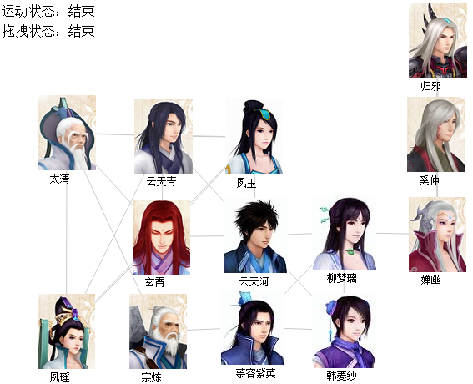](http://www.ourd3js.com/wordpress/wp-content/uploads/2014/11/211.png)

在【[入门 – 第 9.2 章](http://www.ourd3js.com/wordpress/196)】和【[进阶 – 第 2.0 章](http://www.ourd3js.com/wordpress/555)】中，都用到了以下代码：

|  |  |
| --- | --- |
| 1  2  3 | force.on("tick", function(){    }); |

这里的 force 是之前代码中定义的布局（ Layout ），tick 表示当运动进行中每更新一帧时。这是力学图中最常使用的事件，用于设定力学图每一帧是如何更新的。除此之外，还有一些其他常用的事件。

1. 布局的事件

代码中，假设定义如下的布局：

|  |  |
| --- | --- |
| 1  2  3  4 | var force = d3.layout.force()  .size([width,height])  .linkDistance(200)  .charge(-1500); |

力学图布局 force 本身的事件，D3 提供了3个，分别为 start ，end，tick。在写代码时，可形如：

|  |  |
| --- | --- |
| 1  2  3  4  5  6  7  8  9  10  11  12  13  14 | //力学图运动开始时  force.on("start", function(){  console.log("开始");  });    //力学图运动结束时  force.on("end", function(){  console.log("结束");  });    //力学图每一帧  force.on("tick", function(){  console.log("进行中");  }); |

各事件发生时，就会执行相应的代码。

2. 拖拽的事件

在【[入门 – 第 9.2 章](http://www.ourd3js.com/wordpress/196)】和【[进阶 – 第 2.0 章](http://www.ourd3js.com/wordpress/555)】中，都出现了以下代码：

|  |  |
| --- | --- |
| 1 | .call(force.drag); |

即设定当拖拽时调用函数 force.drag()。D3 中提供了3种拖拽事件：dragstart、dragend、drag。

|  |  |
| --- | --- |
| 1  2  3  4  5  6  7  8  9  10 | var drag = force.drag()  .on("dragstart",function(d,i){  console.log("拖拽状态：开始");  })  .on("dragend",function(d,i){  console.log("拖拽状态：结束");  })  .on("drag",function(d,i){  console.log("拖拽状态：进行中");  }); |

上面代码中，分别定义了三种事件后，将此拖拽函数赋值给变量 drag，在调用时，只要使用：

|  |  |
| --- | --- |
| 1 | .call(drag); |

即可。

3. 顶点的固定

使用布局转换数据之后，顶点有一个属性 fixed 。当这个值为 true 时，顶点就是固定不动的；为 false 时，它就是运动的。默认是 false 的。

如果要改进【[进阶 – 第 2.0 章](http://www.ourd3js.com/wordpress/555)】的代码，使得用户能够任意固定和解锁顶点，可添加代码如下：

当拖拽开始时，被拖拽顶点设定为固定的：

|  |  |
| --- | --- |
| 1  2  3  4  5 | var drag = force.drag()  .on("dragstart",function(d,i){  d.fixed = true; //拖拽开始后设定被拖拽对象为固定  label_text_2.text("拖拽状态：开始");  }) |

当鼠标双击顶点时，对顶点解锁：

|  |  |
| --- | --- |
| 1  2  3 | nodes_img.on("dblclick",function(d,i){  d.fixed = false;  }) |

4. 结果

在左上角添加了标签文字，请好好体会一下各事件发生的状况。

拖拽后顶点会固定，双击顶点能够解锁。

完整代码请点击下面链接，右键选择“查看网页源代码”：

<http://www.ourd3js.com/demo/J-2.1/relationforce.html>

源代码和图片打包下载：[j21.zip](http://www.ourd3js.com/src/jj/j21.zip)

谢谢阅读。

**文档信息**

* 版权声明：署名（BY）-非商业性（NC）-禁止演绎（ND）
* 发表日期：2014年11月08日
* 更多内容：[OUR D3.JS – 数据可视化专题站](http://www.ourd3js.com/) 和 [CSDN个人博客](http://blog.csdn.net/lzhlzz)
* 备注：转载请注明出处，谢谢

# D3.js实现力导向图(Dray和Zoom)

- tengxing007 - 博客频道 - CSDN.NET

http://blog.csdn.net/tengxing007/article/details/59712572

今天遇到个问题就是把json(里面nodes和edges属性)文件通过D3.js展示出来，下午终于弄出来了，写篇博客记录一下。   
先展示一下效果图：   
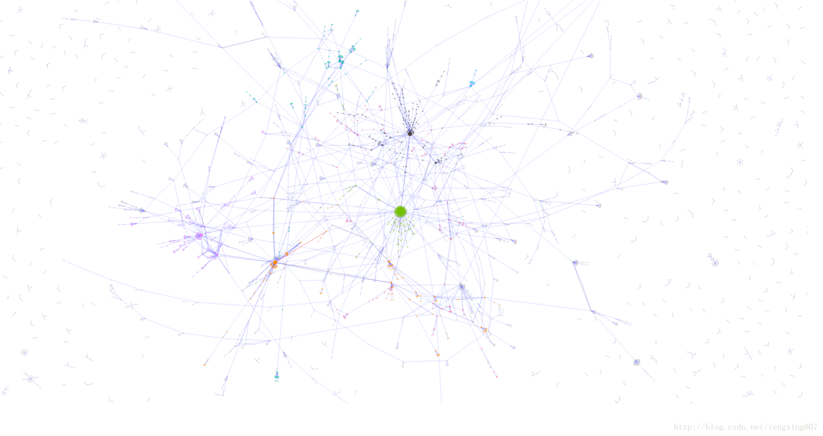  
放大后是这个效果：   
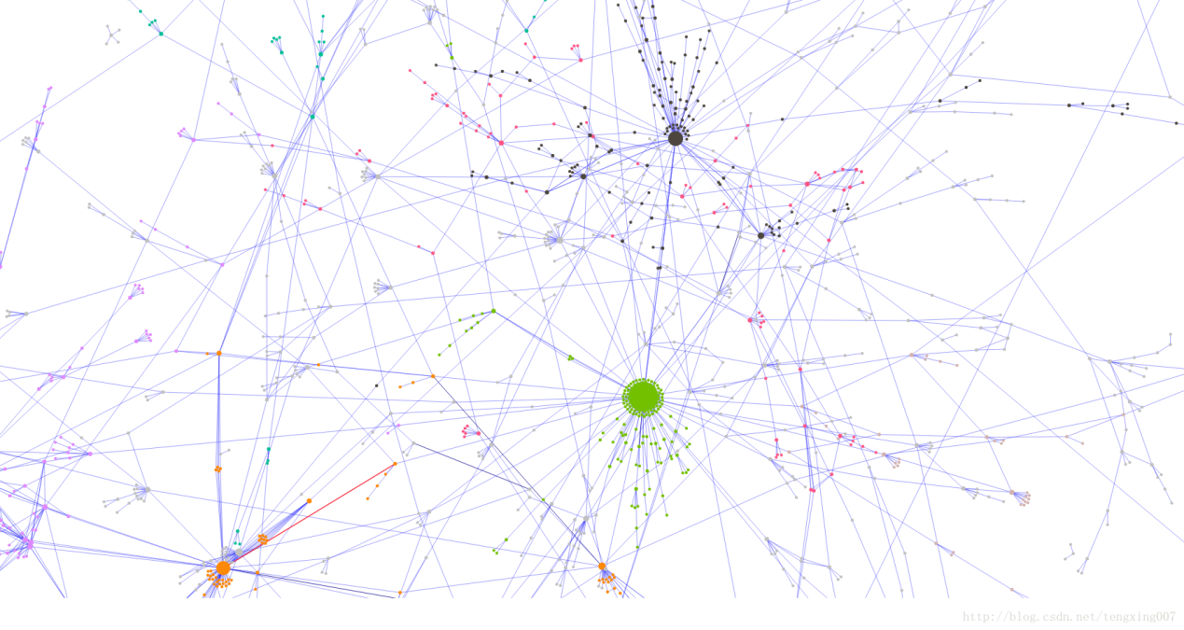

## 什么是力导向图

D3.js官网：<http://d3js.org/>   
D3.js github:<https://github.com/d3/d3>   
力导向图（Force-Directed Graph），是绘图的一种[**算法**](http://lib.csdn.net/base/datastructure)。在二维或三维空间里配置节点，节点之间用线连接，称为连线。各连线的长度几乎相等，且尽可能不相交。节点和连线都被施加了力的作用，力是根据节点和连线的相对位置计算的。根据力的作用，来计算节点和连线的运动轨迹，并不断降低它们的能量，最终达到一种能量很低的安定状态。

## 添加d3.js

//我使用的是v4，v3不能这样使用，具体看API

<script src="https://d3js.org/d3.v4.min.js"></script>

## 定义canvas画板

var width = 900 ,

height = 600,

dataset,

var svg = d3.select("body").append("svg"),

## 构建布局

/* 相关API

d3.forceSimulation - 创建一个力模拟。

simulation.restart - 重启力模拟。

simulation.stop - 停止力模拟。

simulation.tick - 将力模拟向前推进一步。

simulation.nodes - 设置力模拟的节点。

simulation.alpha - 设置当前的α值。

simulation.alphaMin -设置α最小阈值。

simulation.alphaDecay - 设置α指数衰减率。

simulation.alphaTarget - 设置目标α。

simulation.drag - 设置曳引系数。

simulation.force - 添加或移除力。

simulation.fix - 固定节点位置。

simulation.unfix - 释放固定的节点。

simulation.find - 查找给定位置最近的节点。

simulation.on - 添加或移除事件监听器。

force - 应用力模拟。

force.initialize - 使用给定的节点初始化力布局。

d3.forceCenter - 创建一个力中心。

center.x - 设置中心的x-坐标。

center.y - 设置中心的y-坐标。

d3.forceCollide - 创建一个圆碰撞力。

collide.radius - 设置圆的半径。

collide.strength - 设置碰撞检测强度。

collide.iterations - 设置迭代次数。

d3.forceLink - 创建连接力。

link.links - 设置连接数组。

link.id - 连接数组。

link.distance - 设置连接距离。

link.strength - 设置连接强度。

link.iterations - 设置迭代次数。

d3.forceManyBody - 创建多体力。

manyBody.strength - 设置力强度。

manyBody.theta - 设置Barnes-Hut近似精度。

manyBody.distanceMin - 当节点关闭限制力。

manyBody.distanceMax - 当节点太远限制力。

d3.forceX - 创建x-定位力。

x.strength - 设置力强度。

x.x - 设置目标x-坐标。

d3.forceY - 创建y-定位力。

y.strength - 设置力强度。

y.y - 设置目标y-坐标。

*/

var simulation = d3.forceSimulation()

.force("link", d3.forceLink().id(function(d) { return d.id; }))

.force("charge", d3.forceManyBody())

.force("center", d3.forceCenter(width / 2, height / 2));

## 加载数据

(说明：加载数据我以实际遇到的为标准，因为在真正的项目中我们必然使用的是加载数据)

d3.json("dd.json", function(error, data) {

if (error) throw error;

dataset = data;

## 数据放入布局中

simulation

.nodes(dataset.nodes)

.on("tick", ticked);

simulation.force("link")

.links(dataset.edges);

## 绘制node和edge

//加载连线

var link = g.selectAll("line")

.data(graph.edges)

.enter().append("line")

.attr("stroke",function (d) { return d.color; })

.attr("stroke-width", function(d) { return d.size; })

.call(d3.zoom()

.scaleExtent([-5, 2])

.on("zoom", zoomed));

//加载圆

var node = g.selectAll("circle")

.data(graph.nodes)

.enter().append("circle")

.attr("cx", function(d) { return d.x; })

.attr("cy", function(d) { return d.y; })

.attr("r", function(d) { return d.size; })

.attr("fill", function(d) { return d.color; })

.on("click",click)//收起子节点

.call(d3.drag()

.on("start", dragstarted)

.on("drag", dragged)

.on("end", dragended))；

function dragstarted(d) {

if (!d3.event.active) simulation.alphaTarget(0.3).restart();

d.fx = d.x;

d.fy = d.y;

}

function dragged(d) {

d.fx = d3.event.x;

d.fy = d3.event.y;

}

function dragended(d) {

if (!d3.event.active) simulation.alphaTarget(0);

d.fx = null;

d.fy = null;

}

//加载label

node.append("title")

.text(function(d) { return d.id; });

## 添加tick函数(必须)

tick函数的作用：由于力导向图是不断运动的，每一时刻都在发生更新，因此，必须不断更新节点和连线的位置。   
力导向图布局 force 有一个事件 tick，每进行到一个时刻，都要调用它，更新的内容就写在它的监听器里就好。

function ticked() {

link

.attr("x1", function(d) { return d.source.x; })

.attr("y1", function(d) { return d.source.y; })

.attr("x2", function(d) { return d.target.x; })

.attr("y2", function(d) { return d.target.y; });

node

.attr("cx", function(d) { return d.x; })

.attr("cy", function(d) { return d.y; });

}

## 最后

推荐几个比较的学习网站：   
<https://bl.ocks.org/mbostock>   
<http://www.ourd3js.com/>   
<https://github.com/tianxuzhang/d3.v4-API-Translation#hierarchies>   
<http://blockbuilder.org/search#d3version=v4>

# 挖出小马哥？利用d3.js对QQ群大数据资料进行可视化分析

| 36大数据 http://www.36dsj.com/archives/25819

作者: Anthr@X anthrax@insight-labs.org

**背景**

对于前段时间流出的QQ群数据大家想必已经有所了解了，处理后大小将近100G，多达15亿条关系数据（QQ号，群内昵称，群号，群内权限，群内性别和年龄）和将近9000万条群信息（群号，群名，创建时间，群介绍），这些数据都是扁平化的2维表格结构，直接查询不能直接体现出用户和群之间的直接或者间接关系。通过数据可视化，可以把扁平结构的数据作为点和线连接起来，从而更加直观的显示出来从而进行分析。

d3.js是一个近年来推出的基于javascript的数据展示库，全称为Data Driven Document， 在浏览器数据展示领域的地位类似于通用js框架里的jQuery。d3.js的官网是d3js.org，大家可以在上面看到很多例子和应用。d3.js也是图形数据库neo4j所内置的数据展示工具。

说到图形数据库，其实正确的翻译应该是图数据库，图即所谓的Graph，来自于数学里的图论，比如四色定理和推销员过桥的问题（著名的NP问题之一）。图数据库着重于数据之间的关联和属性，对于关系错综复杂的关系分析效率很高。例如，我想知道谁是我朋友的朋友，并且他们有哪些朋友也认识我。对于这种问题，普通关系型数据库的计算复杂度是O(N^c)左右或者更高，N为选择范围的数据集合大小，你好友数量加上好友的好友的数量等，c为关系层数。图数据库的计算复杂度在O(N^2)左右或者更低，但是基本不会超过O(N^2)。

图数据库对于复杂关系数据查询起来效率高的主要原因是在数据输入的时候就已经对关系进行了处理和索引，这样做在查询的时候具有很高的效率，但是在数据导入的时候会很慢。QQ群的15亿个关系在向图数据库neo4j里导入的时候花了3天都没弄完，也没有进度提示，所以后来我直接放弃了。

**数据处理**

在QQ群和群成员关系里面，对于层数我是这么定义的：

第1层：目标QQ加入的所有群  
第2层：目标QQ加入的所有群的所有成员  
第3层：目标QQ加入的所有群的所有成员加入的所有群  
.  
.  
.

大家可以看出这样的查询是可以递归的，假设每个QQ号所加入的群数量和每个群的成员数量为N，那么查询3层数据时总计算量为N*N*N=n^3，所以当查询层数为c层的时候，计算复杂度是N^c。

前面说过，图数据库的计算复杂度一般在N^2以下，所以当使用普通的关系型数据库的时候，如果查询的层数不多，效率和图数据库比起来差不多，加上关系数据库自带的便于管理和导入导出的属性，所以我还是选择了mysql数据库。

对于QQ和QQ群之间的关系，每个QQ号都能加入群，一个群里也有很多QQ，基本都在几十到几百人，所以两个QQ号在同一个群里不一定代表他们的关系很紧密，换句话说QQ和QQ群之间的关系相对于QQ好友而言相对较弱。但是这并不代表我们从中不能分析出有用的资料，俗话说的好，大数据就像一座金矿，只有用力挖才能挖到金子。

d3.js支持多种数据格式，比如JSON,XML,CSV,HTML等，因为PHP的数组可以很简单的转换为JSON格式，所以我选择用PHP写API来获取JSON数据。QQ和QQ群是一种典型的图数据的应用，QQ和QQ群作为节点(node)，QQ加入了哪些群作为关系(link)，d3.js内置了一个功能很强大的内建布局，叫做Force-Directed Graph（受力导向图），后面简称为force。force布局模拟了一些基本的物理粒子原理，比如引力和斥力（确切的说是模拟了电磁力和引力，在离的远的时候会互相吸引，在离的近的时候斥力急剧增加），并且可以调节力的大小和受力距离等等，可以说是自由度相当高。关于d3.js的force布局，在官网有详细的API和不少例子，这里我就不贴代码了。

在force布局里面，数据源的JSON可以有很多种不同的格式和属性，但是基本格式如下:

{"nodes":[{"num":10001,type:"qq"},{"num":12345678,type:"qun"}],"links":[{"source":"10001","target":"12345678","auth":1,"nick":"pony"}]}

其中nodes数组对应的是节点列表，links对应的是关系列表。

每个节点可以有很多自定义属性，在d3.js可以针对每个节点存取节点的属性，比如我定义num是QQ号或者群号，type代表节点是QQ还是群，另外我在js里设定在type==‘qun’的时候显示群的图标，是qq的时候显示qq的图标。关系里面默认的属性有source和target，分别对应一个关系的两头，默认情况下关系里面的source和target对应的数字是节点在节点数组里面的位置index。但是我自定义成了qq号和群号。另外你也可以定义其他属性，比如auth代表这个QQ号在群里的权限，nick是群昵称。

对于QQ群这样的关系来说，基本上在第4层和以上的QQ和群的关系就比较弱了，所以为了提高查询速度和减少节点数量，我只查询2层关系（少么？不少，要想想有些群有超过500人……）。

首先，d3.js需要在浏览器里面运行，我的首选是Google Chrome，V8引擎的效率果然不错，在节点和关系不多的时候基本感觉不到延迟，后来在FF和IE11里面测试了一次，FF比Chrome卡一半左右，IE的话我只能呵呵了……

先拿小马哥做个测试，QQ号是霸气的10001。当d3.js导入完数据JSON的时候，各种节点会在屏幕上乱飞几秒钟，直到他们的力达到一个稳定的平衡点。结果如下:

说明：

企鹅图标的节点代表QQ，群图标的节点是群(废话么)。

每条线代表一个关系，一个QQ可以加入N个群，一个群也可以有N个QQ加入。

线的颜色分别代表：

土豪金：群主

狗腿绿：群管理员

屌丝蓝：群成员

大家也可以看到，群主和管理员的关系线也比普通的群成员长一些，这是为了突出群内的重要成员的关系。

图标旁边自动标注了QQ号和群号，如果有的话还有群名。没有在QQ号旁边标注昵称是因为很多人加入不同的群使用的是不同昵称，所以把昵称放到了其他的地方显示。

在下图中大家可以隐约的看到，所有的关系都是以QQ 10001为起点的。

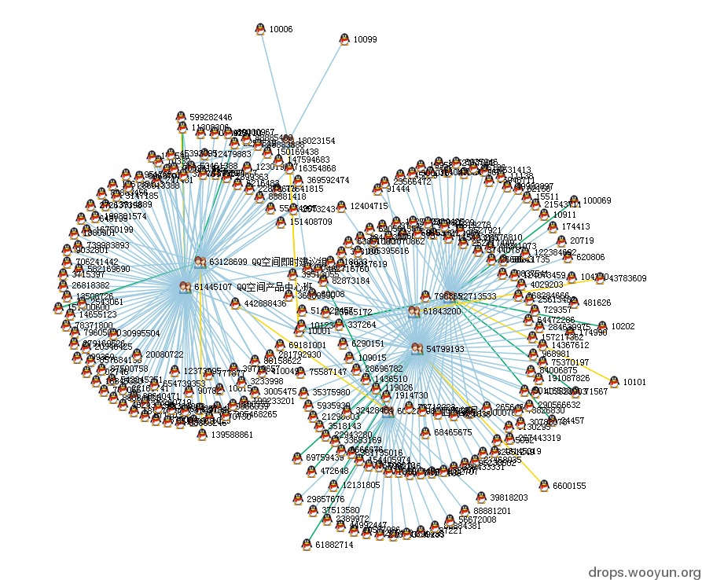

在图上节点是可以拖拽的，拖拽后会固定在你释放的地方。我们把几个群稍微拖的分开一点，关系就一目了然了

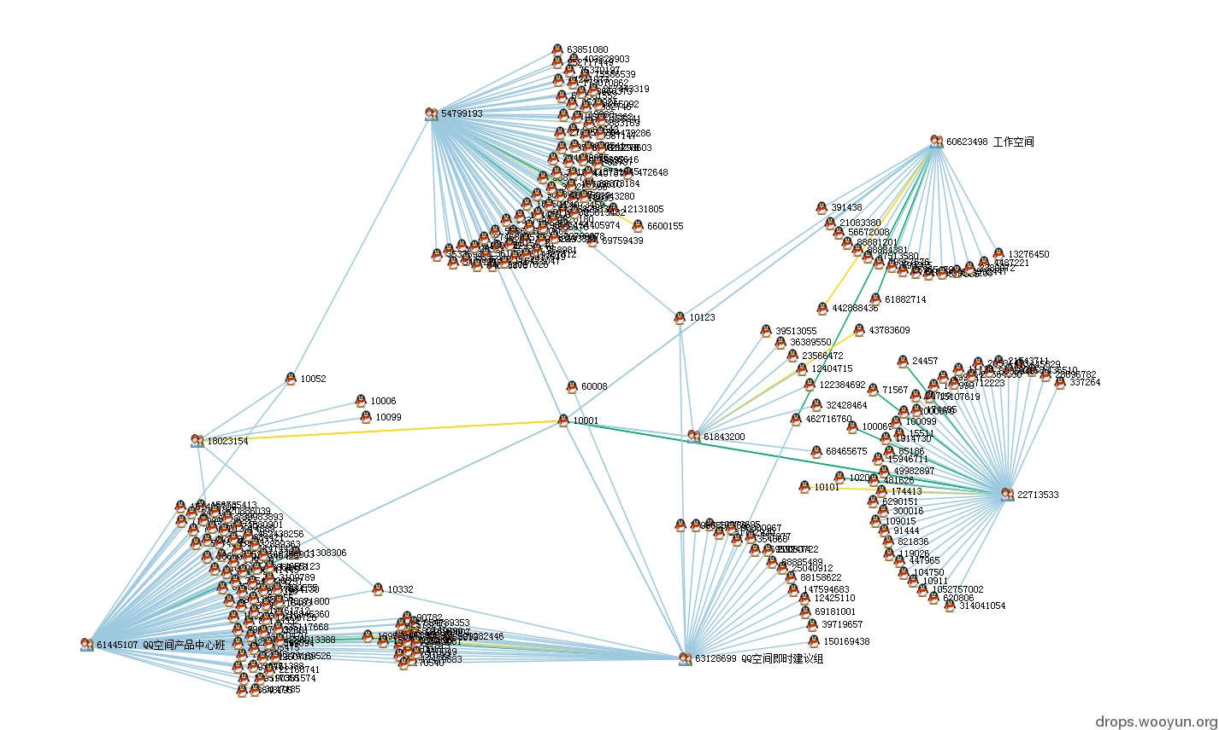

这个时候我们可以看到在目标的QQ群里也有很多共同QQ号，比如有些QQ号同时加入了2，3个群。群名显示的都是各种产品开发讨论群，这些同时加入2，3个产品群的人估计不是产品经理就是主管吧……、

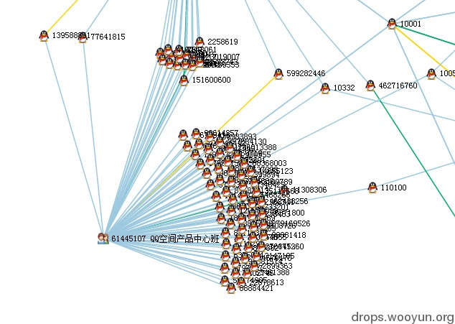

鼠标悬停到群图标上可以看到群的详细信息(如果有的话)



因为很多人在不同群里的昵称不一样，所以群内昵称等信息就只能放到link上面了，因为线比较细，所以鼠标比较难对准，这个功能还待修改。

这个家伙和小马哥一起同时在3个群里，好基友？

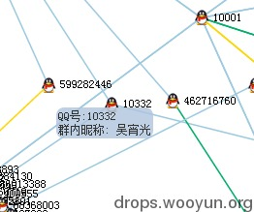

小马哥的QQ群信息展示完了，下面我们来看看更加实际的应用，比如把某圈子里的人找出来。我们先从某土豪大黑阔大牛的QQ号入手：

初始数据好多……此大黑阔加入的群够杂的，不过就是因为杂所以才能更深入的了解一个人的所有喜好。看看群名神马的，我好像看到了dota，XX国际俱乐部，web技术交流，XXsec等群……充分说明了此人……是个屌丝技术宅大黑阔，XX国际俱乐部又似乎带着那么种高大上的感觉……

图中错综复杂的各种关系组成了一朵朵盛开的菊花，向我们诉说着他的历史……

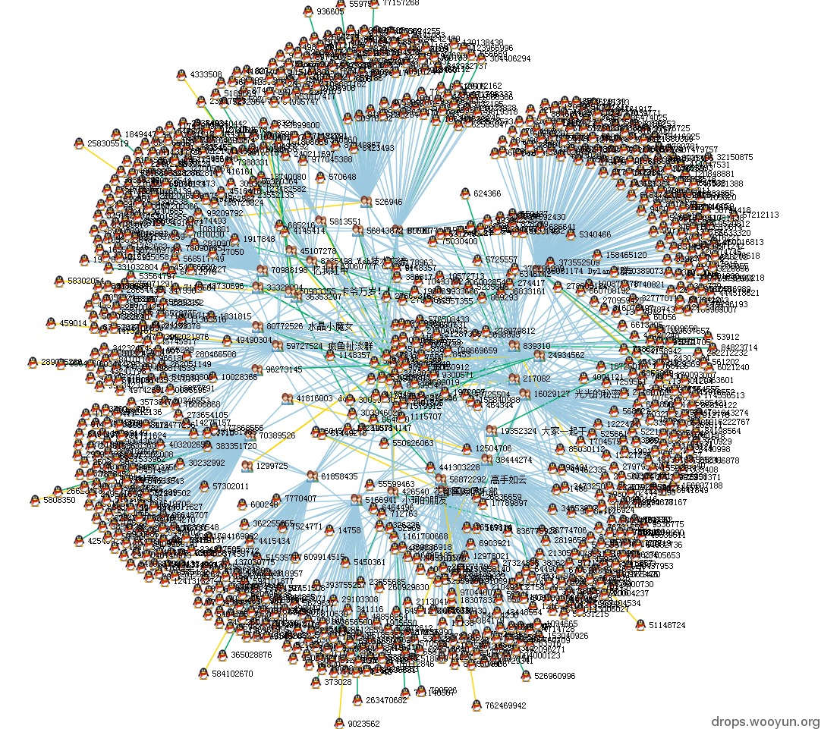

为了理清他那不堪回首的过去和关系网，我特地把浏览器窗口拖到第二个屏幕上，然后把群挨个分开。为了保护当事人的隐私，这张图我打码了。

这张图比较宽，建议大家下载下来放大看

[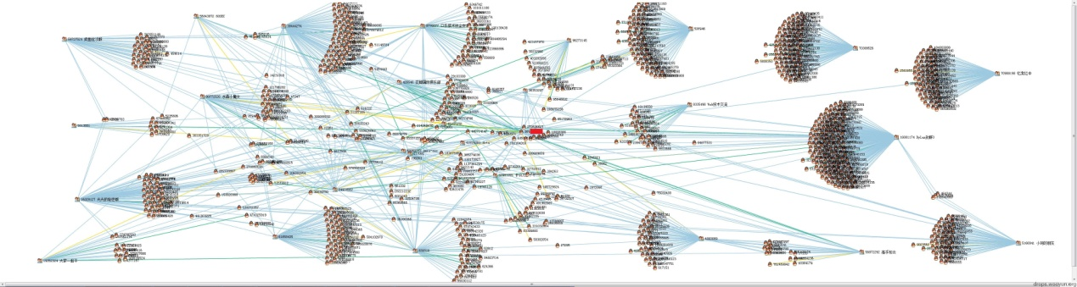](http://www.36dsj.com/wp-content/uploads/2015/03/738.jpg)

右键点击可放大

**总结**

假如把层数扩展到4层，不知能否筛选出中国所有黑阔的QQ号呢？至少我已经在这张图里看到了很多熟悉的名字和号码。

腾讯总是说漏洞早已修复，不存在问题了，广大网民放心，但实际上信息泄露这种事情，岂是你漏洞修复好了就结束了的事情？

End.

转载请注明来自36大数据（36dsj.com)：[36大数据](http://www.36dsj.com/) » [挖出小马哥？利用d3.js对QQ群大数据资料进行可视化分析](http://www.36dsj.com/archives/25819)

# 2@用数据全方位解读《欢乐颂2》

| 欢乐颂结局 | 欢乐颂2_科技猎

http://www.kejilie.com/woshipm/article/jma67r.html

用数据全方位解读《欢乐颂2》 - 推酷

http://www.tuicool.com/articles/bMrmiin

时间 2017-05-31 14:29:43  [人人都是产品经理](http://www.tuicool.com/sites/qMNZbm)[相似文章](http://www.tuicool.com/articles/dup?id=bMrmiin) (1)

原文  [http://www.woshipm.com/data-analysis/675883.html](http://www.woshipm.com/data-analysis/675883.html?utm_source=tuicool&utm_medium=referral)

主题 [数据挖掘](http://www.tuicool.com/topics/11000063)[新浪](http://www.tuicool.com/topics/10050038)[数据分析](http://www.tuicool.com/topics/11020089)

作为数据分析爱好者，本文作者将想从数据的角度去解读《欢乐颂2》这部热播剧的方方面面，包括舆情传播、网络口碑、人物社交网络分析及，以及小说内容的文本分析。



5月11日，让众多安迪粉期待已久的《欢乐颂》第二季终于播出。相比首季，《欢乐颂2》在造型和场景上显得更为精致时尚，且其中每个角色的造型却都是遵从的其身份和背景，并不突兀。

正所谓“外行看热闹，内行看门道”，作为数据分析爱好者的笔者，自然想从数据的角度去解读这部热播剧的方方面面，包括舆情传播、网络口碑、人物社交网络分析及，以及小说内容的文本分析。

以下是笔者在这篇文章想要着重分析的内容：

* 这部分在互联网上的舆情传播如何？包括该剧的全网传播趋势、关注人群画像，及网络营销手法。
* 和大获成功的第一部相比，第二部的口碑如何？主要涉及本剧豆瓣影评的文本分析。
* 对第一、二季的小说文本分析。主要涉及关键词提取、主要人物的社交网络关系及关联词分析等。

在笔者进行分析的过程中，会用到一些常用的（大）数据分析工具，以及环环相扣的数据分析讨论，虽然对于常规的数据运营并无直接的帮助，但“他山之石，可以攻玉”，分析的思路却可以作为参考，以期应用到其他实际的场景中。

1 《欢乐颂2》的大数据舆情分析

在第一部分中，笔者选取了2017.05.07~2017.05.29期间关于《欢乐颂2》的全网舆情数据作为数据分析对象，利用新浪微舆情的“信息监测”和“全网事件分析”作为数据采集、数据分析和可视化的工具。

以下分别从《欢乐颂2》的全网传播概况及传播趋势两方面进行分析。

1.1《欢乐颂2》的全网传播概况

（1）全网传播走势

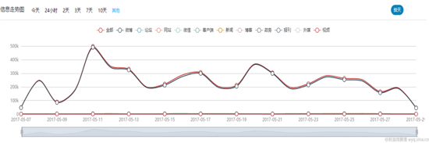

上图是《欢乐颂2》在这段时间内信息传播走势图，自开播之日起，该剧的全网声量出现了明显的提升，而且里面出现了几个信息传播的“波峰”，说明当日全网关于该剧的讨论（包括媒体和网民个体）较多。尤其需要注意的是，本剧开播当日（5-11）的波峰峰值是该时间段内最大的一个，这是不是一个巧合呢？不要急，笔者会在后面为各位小伙伴解开谜底。

（2）全网正负面信息占比

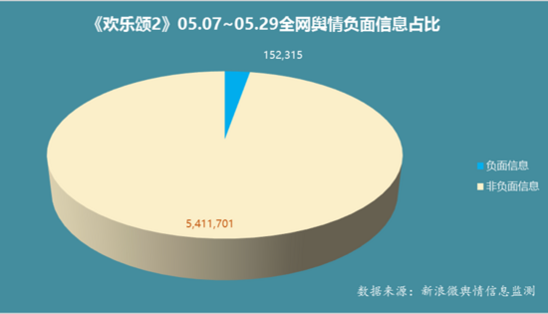

从上图中可以看到，这段时间内，全网关于《欢乐颂2》的信息量有5,564,016条，其中负面信息的占比达到152,315条，占到总信息量的2.74%。

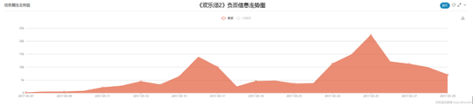

同时，在总体上，负面信息随着时间的推移又不断增长的趋势。

结合二者来看，如此这般的负面信息占比和发展情形对于该剧来说不太有利，说明全网关于该剧的负面口碑评价比较显著，需要引起制片方的重视，笔者会在接下来的分析中，探明到底出现了哪些负面口碑，以及它们出现的原因。

（3）全网关注度来源

因为在影视剧的传播声量中，微博这块占据较大的比重，所以笔者在排除微博这一信息来源后，对余下的信息来源TOP10进行了统计，如下图所示：

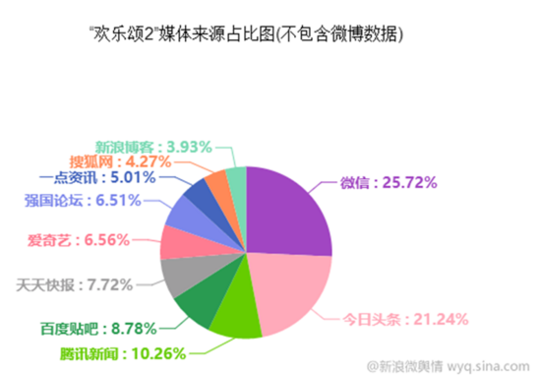

从上图可以看出，除开微博外，微信、今日头条这两大社会化媒体平台上关于本剧的信息量贡献最多，尤其微信在近日推出了「微信实验室」，通过新增加的“搜一搜”和“看一看”这两个入口，使用户能够主动搜索关键词，能够浏览热点资讯、好友关注的资讯以及自己感兴趣的文章，这样的动作加上数年的优质内容沉淀，使得微信在社会化媒体内容生产方面的重要性日渐突出。

（4）全网信息地域分布

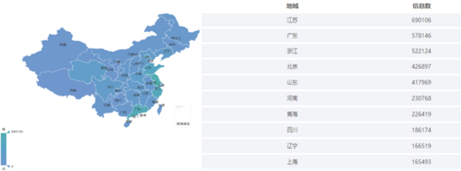

有点意外，全网关注度（关于这部剧的全网信息量）排名榜首的是江苏，竟然不是北京和上海这两大年轻白领云集的现代化的都市，尤其是上海，关于本剧的信息量分布在TOP10中垫底，难道上海的网民和媒体绝大部分都弃剧了？或者说是本剧的口碑极差？

对于此种疑问，笔者将会在第二部分进行分析。

1.2 人群画像

因为关于本剧的探讨，微博（主要是新浪微博）占据大头，所以笔者选取该平台上的人群作为分析对象。

（1）  性别分布

毫无疑问，女生是该剧的忠实拥簇，他们对该剧的狂热绝对超过男生。

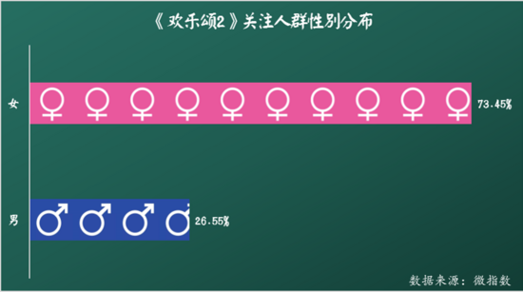

（2）  年龄分布

从下图中可以看出，19-34这个年龄区间占据关注人群的70%左右，也就是说青年群体对该剧很感兴趣。

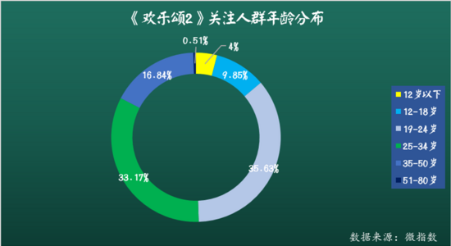

（3）  兴趣图谱

下图给出了关注该剧的人群的兴趣标签TOP5，可以看出，这部分人群比较追星，热爱生活，都是一些极具年轻人特质的兴趣爱好。

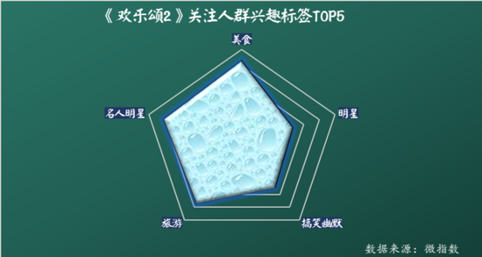

结合前面的信息地域分布，关注《欢乐颂2》的主体是一群热爱生活、热衷于追星的都市青年女性。

1.3 《欢乐颂2》开播当日的营销宣传分析

在前面提及的全网传播趋势中，笔者提到了该剧在开播当日就出现明显的声量高峰，很明显，这绝非偶依然。

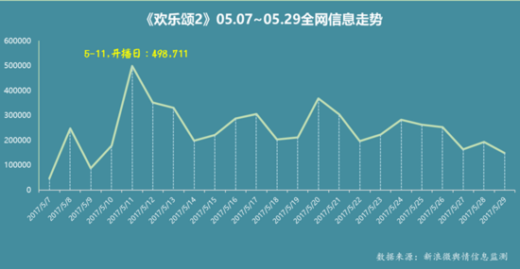

从前面的信息来源分布可以得知，该剧绝大部分的声量都来源于微博，尤其是新浪微博。为此，笔者单独调出5-11的微博信息趋势数据。

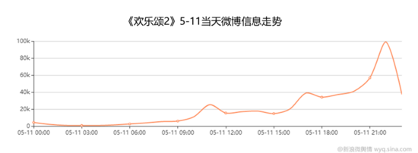

从上图可以看到，新浪微博上关于该剧的信息量大体上是呈现上升趋势的。在当日的23时左右达到高峰，而且这种增长趋势很有节奏感—从工作时间段9:00开始，声量随时间的推移不断上涨。

为了进一步发现其中的传播规律，笔者利用新浪微舆情的“信息监测”模块对其中有影响力的微博进行了进一步的搜寻和排查，也就是发现其中转发次数较多的微博，以及顺藤摸瓜，发现传播源头。

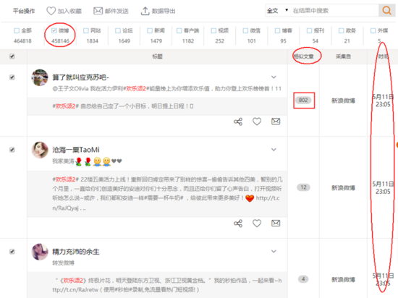

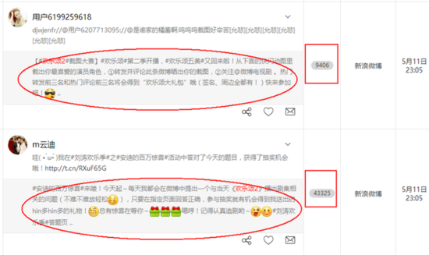

经过逐步地抽丝剥茧，笔者发现了其中转发量较多的几条微博，也就是传播源头，主要是《欢乐颂2》的几位主演的微博账号和一些跟该剧有关的微博话题。从实际效果来看，《欢乐颂2》的几位主演——刘涛、王凯、杨紫等人在新浪微博上的影响力较高，粉丝数量庞大，主动转发积极，使得对剧集宣传的效果也相对较好。







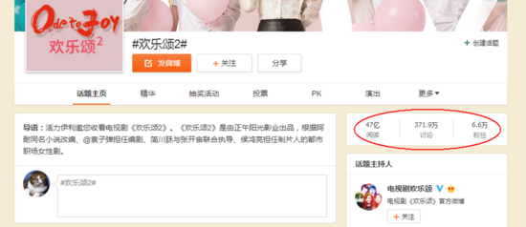

除了主创人员的主动推广外，《欢乐颂2》的推广营销方式也是丰富多样。在微博推广上，《欢乐颂2》的宣传物料准备充足，预告片、小花絮、主题曲MV等一应俱全；宣传矩阵搭建完整，不仅注意与微博官方账号“新浪娱乐”、“新浪电视”、“东方卫视番茄台”和”@微博电视剧“等）、广告品牌等多方联动，而且KOL舆论引导投入巨大，还邀请其他明星助力宣传（如范冰冰）。

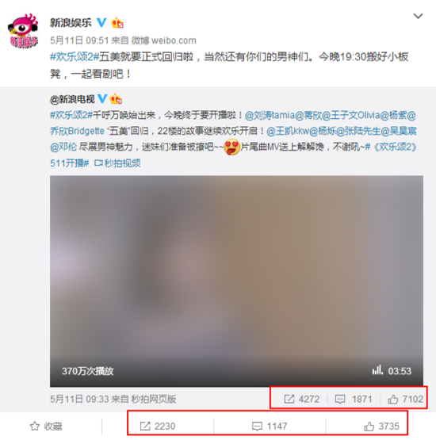





然而，从上面的传播效果来看，媒体大号的传播效果没有明星个人的微博账号传播效力大，那么，其中的原因又是什么呢？我们接着往下看。

1.4 微博传播效果分析

为了深入了解媒体大号和明星个人微博传播特点和规律，笔者特地找了5-11当天粉丝互动量较大的2条微博—分别为@微博电视剧和刘涛的个人微博账号@刘涛tamia，它们的转发评论几近一致，方便在同等条件下发现其中的传播规律。





将这两条微博的转发传播关系数据导出，制成能够清晰反映传播路径的可视化“力导向传播图“：

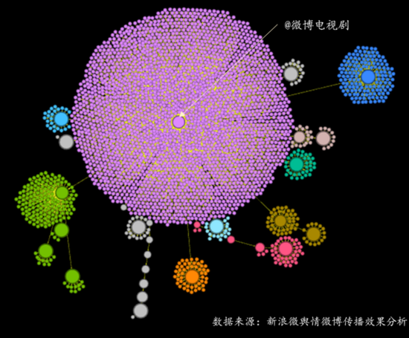

上图是@微博电视剧关于《欢乐颂2》的营销微博的传播路径图，其中紫色“簇群“的中心就是账号@微博电视剧，除了它自己带来的转发传播（也就是紫色簇群区域内的小圆点）之外，周围还有一些次级传播中心，比如“十三點半的kings”、“影视大米FAN”、“吴侃侃kkw”这样营销性质很强的自媒体账号进行协助宣传，显然这是宣传方砸钱买的流量，不是自带的。

而下面刘涛的该条微博就呈现出明显的“ **中心化** ”特点，也就是除了刘涛个人微博账号以外，就没有特别明显的次级传播中心，绝大部分的传播都来自于刘涛的账号粉丝。

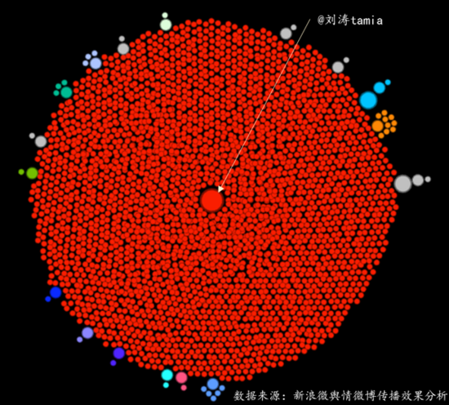

由此，结论不言自明：

明星个人微博的传播较媒体大号而言更有效力，因为明星因其个人魅力，吸聚的粉丝多，发的微博贴近生活，跟粉丝之间有较强的互动关系，而且他们的粉丝团体也会不遗余力的去散播此类消息，所以传播效力更强一些。相比之下，微博大号因为自身的营销属性，除非有利益驱动，粉丝才会主动参与互动，一般而言不会太强，更有甚者，会发动水军进行操作，通过不正当的手段以谋取利益。

好了，上面是关于《欢乐颂2》的大数据舆情传播分析，下面会进入到另一个板块——对该剧的口碑（主要是豆瓣影评）和小说文本进行文本挖掘，期待发现一些更有趣的内容。

2 《欢乐颂2》的豆瓣口碑分析和小说文本分析

一般来说，对于文本的深入挖掘往往能实现“知其然并知其所以然”的效力，因为文本不像数字那般空洞和抽象，内容往往能直接揭示出原因。

这部分的数据主要有：

* 《欢乐颂》第一季和第二季的豆瓣影评
* 《欢乐颂》第一季和第二季对应的原著小说，《欢乐颂2》的剧集将把后两季的小说内容进行打包拍摄，所以第二、第三季的小说内容都会出现在《欢乐颂2》的剧情里

豆瓣电影是中国最大与最权威的电影分享与评论社区，收录了百万条影片和影人的资料，有2500多家电影院加盟，更汇聚了数千万热爱电影的人，因而这里关于影视剧的评论具有一定的代表性和公信力，可以在很大程度上反映一部影视剧作品的口碑状况。所以，笔者抓取豆瓣上《欢乐颂》一二季的影评作为口碑分析的依据。

2.1《欢乐颂》一、二季的总体口碑对比分析

（1）评价星级

从总评分来看，《欢乐颂》第二季要明显逊色于第一季，前者拿到了7.3的高分，而后者仅获得了5.2的评分。



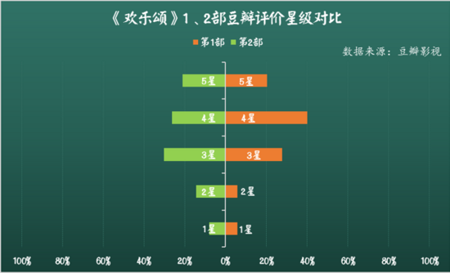

从第一季和第二季的评价星级占比可以看出，出现第二季总评分低于第一季的原因在于：第二季在中高分区间“4星”和“3星”中的占比要小于第一季，而在低分区间“2星”和“1星”中的比重要高于第一季。

（2）《欢乐颂2》的豆瓣影评情感倾向分析

由于第一季的口碑要好于第二季，所以笔者接下来着重分析一下第二季的豆瓣影评的“情感倾向”。

这里的“情感倾向”是以一个介于0~1之间的“情感极性值”来表征—如果某条评论的情感极性值越接近于0，说明它的负面情感倾向越明显，越接近于1，说明它的正面情感倾向越明显，而取值在0.5左右徘徊，这说明这种情感倾向不明显，是为“中性”。笔者将情感倾向值的取值区间0~1细分为3个子区间，分别对应不同的情感倾向：

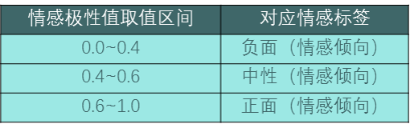

豆瓣影评具有独特的语言风格—反讽，贬义褒用，不像商品评论那般直白外露，它的语义往往含蓄且幽默。所以在分析之前，笔者找到大量有标注的豆瓣影评语料，利用 **机器学习** 进行情感语义模型训练，以期达到良好的情感正负面判断效果。初步结果如下：

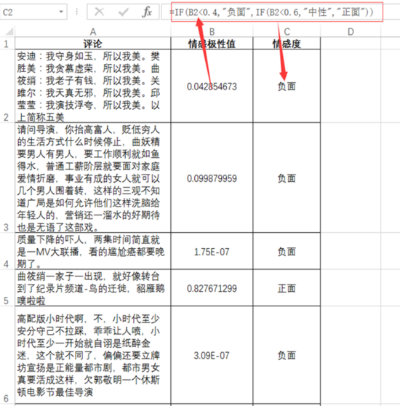

经情感倾向标签映射处理，得到如下结果：

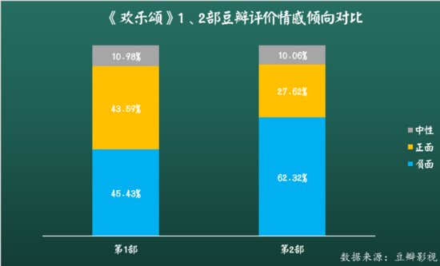

从上图可以看到，第一季和第二季的情感倾向的最大差异在于正负面情感的比重不同：第一季的评论正负面情感占比旗鼓相当，而第二季的负面情感明显占据主导地位，正面占比大幅压缩，这也是本剧豆瓣评分不高的原因之一。

再看一下情感倾向随时间发展的走势情况，笔者选取的分析时间段是3.31~5.22，也就是该剧播出前一个多月和播出后一段时间的情感倾向走势。这里采用的是情感倾向值累加的数值，越高说明口碑评价越好，这也兼顾了评论数量上的增减情况（豆油愿意参与评分，哪怕是负面评分，也说明对本剧有一定的关注度）。由此得到下图：

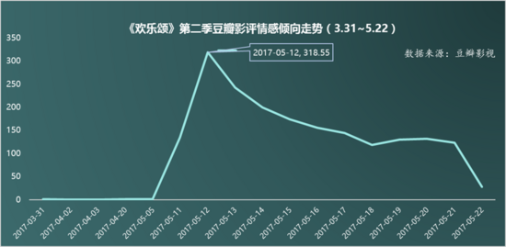

可以看出，在本剧播出次日，情感倾向值达到高峰，随后一路下降，结合这段时间内的总体情感倾向占比可知，豆油们对于该剧播出后的剧集的关注度和口碑评价都呈现出下降的趋势。

那么，究竟是什么原因让广大豆油们对该剧如此嫌弃呢？请接着往下看。

（3）《欢乐颂》一、二季豆瓣评论内容的关键词对比分析

以下是关于《欢乐颂》一、二季豆瓣评论文本的关键词对比分析，可以在这张直观的可视化效果图上看到“豆油”们对《欢乐颂》一二季方方面面的评价。

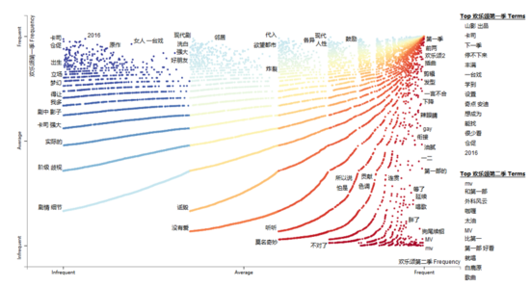

上图中，对于一二季的评论文本分别按照“高提及率(Frequent)”和“低提及率(Infrequent)”进行了划分。上图以横纵轴的“Average”进行切分，则可以分为4个象限，右上角的为2类文本提及率皆高的词汇，左下角为二者提及率皆低的词汇。左上和右下仅是二者之一高提及率的词汇。

另外，蓝色点阵代表的词汇属于对《欢乐颂》第一季的评价，黄色点阵所代表的的词汇属于对《欢乐颂》第二季的评价，右上角的象限二者的评语趋于重合。

在右边的TOP Terms（重点关键词汇）一栏中可以看到，对于第一季的评论，豆油们主要提到了该剧的cast/卡司（ 演员阵容强大）、山影（山东影视制作有限公司，该剧的出品方）、（看该剧）停不下来、（人物形象）丰满，以及关于安迪和奇点（魏渭）的情感主线的探讨，但没有出现明显的负面评价，甚至以褒赞为主。

而第二季里，很多豆油拿第一季和第二季进行对比，认为本剧和第一季没得比，还有就是本剧里的插曲太多，好似一个MV大集合（“MV”、“mv”、“歌曲”、“就唱”），正如某位豆油的评论所说“一开始就狂配bgm,而且感觉和剧情并不搭嘎，什么咖喱歌一股乡村风”。。。值得玩味的是，也有都有拿本剧和同一时间段的《白鹿原》做对比，两部剧均包含对时代环境和个体发展的探讨，但在格局、视野以及最终呈现方式上都有较大不同。

点击其中的关键词，看到关于这些关键词的评论详情（语句经过分词和去停用词）。

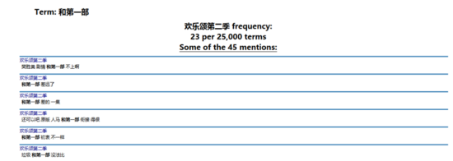

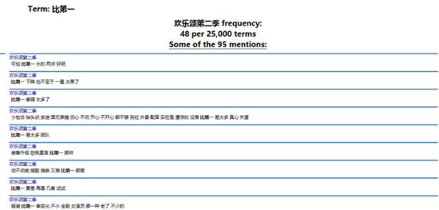

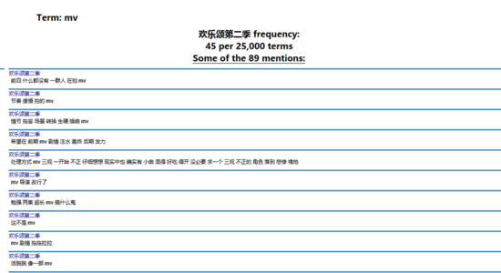

总之，豆油们关于第二季的吐槽很多。

由此，笔者想进一步看看豆油们到底还有哪些关于该剧的槽点。

（4）第二季的典型意见挖掘对比分析

将经预处理得到的5000条典型评论进行文本聚类，每一个文本聚类“簇群”都会有一个中心语句，也就是该“簇群”的典型意见，所以这种文本处理也叫做“典型意见挖掘”，用来从海量的文本里发掘主要的观点或意见。

经笔者处理，5000条评论被划分为300多个成分占比不一的“话题簇群”，笔者仅选取其中占比TOP10的典型意见进行展示。

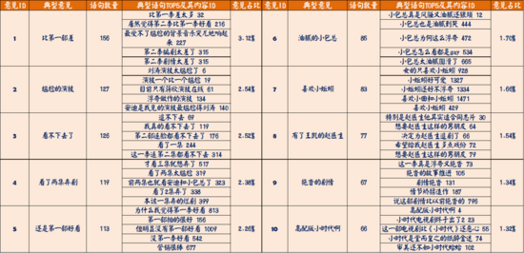

从上表可以看出，豆油们关于本剧的典型意见多为负面，集中在以下几个方面：

* 比第一部差，主要诟病的地方在于本剧的剧情、编剧和演员演技，以及硬生生的人物专属插曲/配乐乱入
* 三观不正，被吐槽为“高配版小时代”，倡导“纸醉金迷”的富人价值观
* 对本剧中的个别角色及其主演的喜好，如邱莹莹和赵启平及其扮演者

除此之外，本剧广告植入太多也是很多豆油吐槽的地方，本剧为了配合植入广告，角色人物的吃穿用度多处设定明显违和，甚至有豆油表示“《欢乐颂1》是在剧情里插播恰到好处的广告，而《欢乐颂2》是在硬生生的广告里插播剧情……”

（5）“五美”人物点评词云

综合豆油们关于《欢乐颂》第一季和第二季关于剧中“五美”的评论，笔者制作出安迪、曲筱绡、樊胜美、关雎尔和邱莹莹的个性化评论关键词词云。

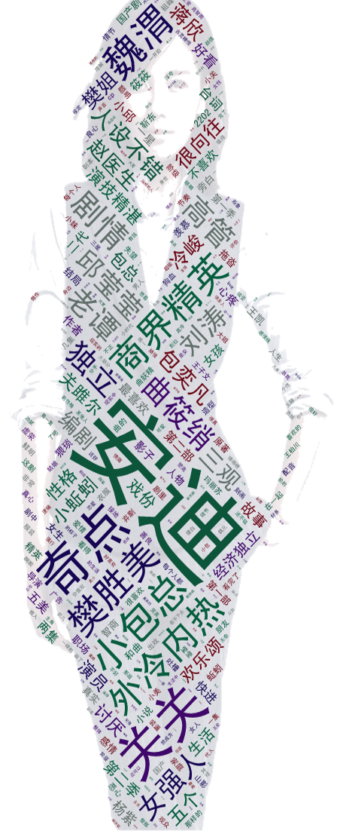

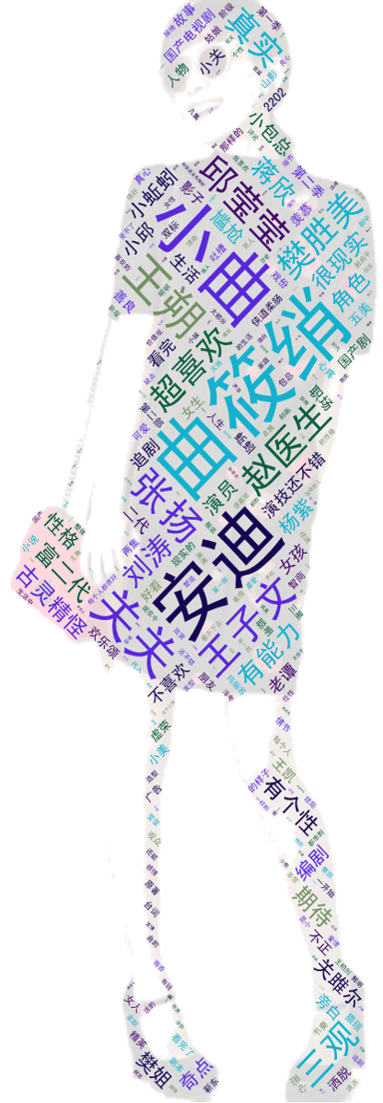

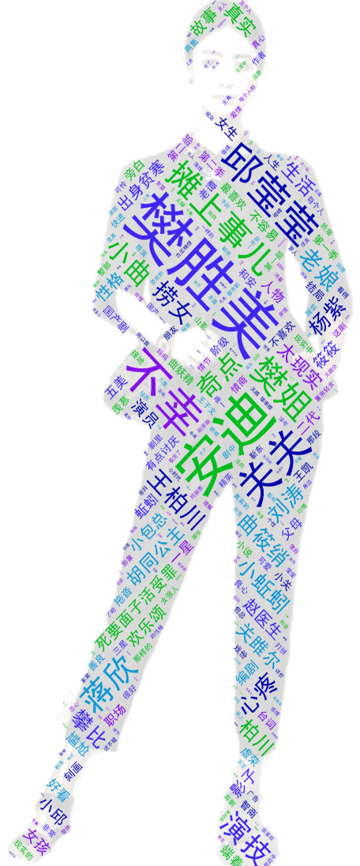

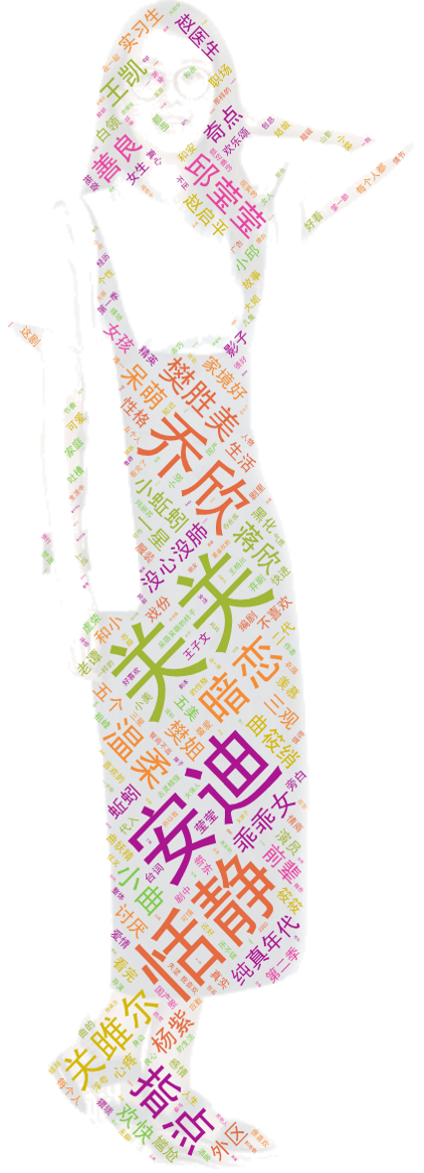



不消笔者多说，小伙伴们就能看出这些人物关键词词云，主要反映了豆油们对于“五美”的人物印象及其主要的关联人物。对于这五个人的性格特征，由上述关键词词云可以总结为：

* 外冷内热、气场强大的冰山御姐——安迪
* 古灵精怪、魅力超群的小妖精——曲筱绡
* 虚荣拜金、独立自强的骄傲女王——樊胜美
* 文静内敛、一团和气的优质女孩——关雎尔
* 单纯可爱、精力充沛的元气少女——邱莹莹

2.2 《欢乐颂》一、二季的小说文本分析

（1）一、二季的小说文本关键词对比

此处，对于小说文本的关键词提取，笔者没采取一般文本分析时所采用的词频统计，而采用的是TF-IDF（term frequency–inverse document frequency）关键词统计方法，从而更有效的提取文本中的关键信息。详情可以参阅《 [***以<大秦帝国之崛起>为例，来谈大数据舆情分析和文本挖掘***](http://www.woshipm.com/data-analysis/627688.html) 》的第三部分。

以下是《欢乐颂》一二季原著小说的关键词TOP20。

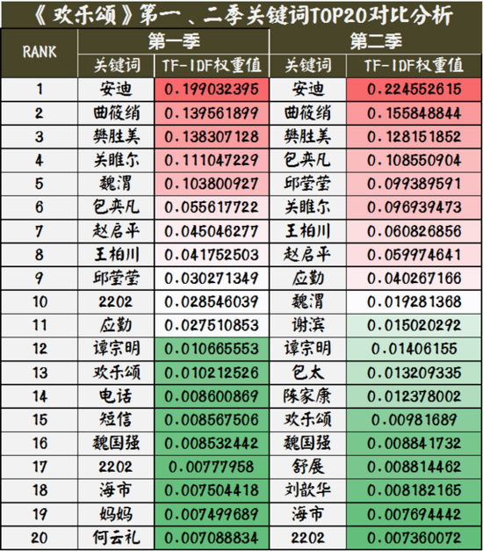

可以看出，一二季小说文本的关键词绝大部分是其中的主要人物，而主要人物的总体顺序（对于小说而言是人物的重要性）变动不大，个别人物出现重要性的“位移”：

* 安迪、曲筱绡和樊胜美是一二季中妥妥的一号、二号和三号女主人公；
* 包奕凡在第二季的重要性有所提升，而魏渭的重要性则呈现下降的趋势；
* 电视剧第二季中出现的谢滨（也就是电视剧中的音乐达人谢童）、舒展和陈家康也出现在小说二三季的关键词TOP20中，不过排名较为靠后。

这也说明，小说和剧本在人设上保持有连贯性，没有明显大的变动。

（2）一、二季剧中人物社交网络分析

通过设置人物词典，笔者从中提取出《欢乐颂》一二季对应小说文本的人物社交关系图谱，用来发现2部电视剧中人物关系的特征。

在人物社交网络中，每个节点代表一个人物，线条代表人物之间的关系，线条颜色的人物节点代表他们之间有着较为频繁的交往（或友或敌）。节点及其代表人物字体的大小表征的是“Betweenness Centrality （中介性核心性）”，该词学术的说法是“两个非邻接的成员间的相互作用依赖于网络中的其他成员，特别是位于两成员之间路径上的那些成员，他们对这两个非邻接成员的相互作用具有某种控制和制约作用“，说人话就是—字体大的人物具有更大的人际关系影响，能接触和影响的人物较多，而在小说中出现次数多的未必就是这类人物，这里的存在感需要以人脉和影响作为基石。详情可参看《 [***以<大秦帝国之崛起>为例，来谈大数据舆情分析和文本挖掘***](http://www.woshipm.com/data-analysis/627688.html) 》的第三部分。

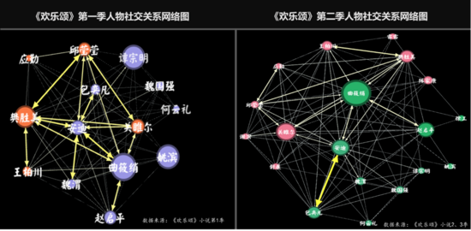

从上图可以看出，第一季中的安迪和几个主要人物都有很强的人际联系，他们之间的连线较粗，而谭宗明、曲筱绡、樊胜美等人的人脉资源丰富，或者是他们人际交往/应酬较多。

在第二季的人物社交网络中，则呈现出“去中心化”的趋势，除了成为爱人的包奕凡外，第一主角安迪与其他人的交往没之前那么密切了。按照剧情发展，他们之间迎来了情感的新可能，却也面临来自身世及包家内部带来的新困扰，加之后妈魏太太的不断责难，这样也不久难理解安迪和其他人的交往较第一季要少了，自身麻烦不断，所以无暇顾及。



当然，第二季的人物情感脉络也很清晰了，即使有搅局者的出现（魏渭、舒展、陈家康等），固定的CP组合也没有出现变化，如安迪-包奕凡、邱莹莹-应勤，曲筱绡-赵启平，樊胜美-王柏川，以及关雎尔-谢滨（谢童）。

（3）小说文本的人物关联词分析

在最后，笔者把《欢乐颂》小说1、2、3季合并，经过文本预处理后，再进行小说文本的词向量训练，将这些词汇映射到向量空间，变成一个个词向量（Word Vector），以使这些词汇在便于被计算机识别和分析的同时，还具有语义上的相关性，而不仅仅是基于词汇之间的共现关系。

由于篇幅原因，笔者仅涉及跟“五美”相关的关联词分析，各呈现TOP10的关联词，由此发现跟主设人物相关的词汇，发掘人物深层次的特点。

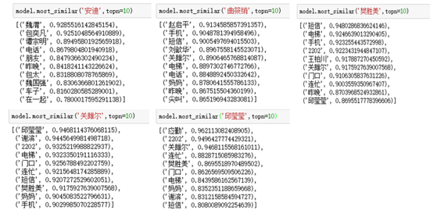

从上面“五美”的TOP10关联词可以得到两类关联词：

第一类词是 **跟主设关系密切的人物** ，如魏渭、包奕凡之于安迪，赵启平、刘歆华之于曲筱绡等，这些都符合大家对于电视剧的认知。

另一类是 **反映人物行为的词汇** 。如安迪和曲筱绡，二人常用的通信工具都有电话，其他三人只用手机进行通讯。而电话一般指固定电话，设在办公室，较为正式，领导或是管理层用的比较多；而手机具有便携性，无论室内和外出都用的多。

安迪、曲筱绡和樊胜美的关联词里有涉及“昨晚”，再对照小说原本，三人都有很多晚上交际应酬的场景。

此外，在樊胜美、关雎尔和邱莹莹的关联词里，都出现了“连忙”一词，有“立即”、“马上”的意思，也就是经常会出现仓促、手忙脚乱的情形。

字字珠玑间，折射出“五美”所处的社会阶层和自身心态。

结语

虽然分析下来，《欢乐颂2》在剧情和各种细节上多有瑕疵，加之违和感很强的硬广植入，所以它的口碑远不及第一季。然而，《欢乐颂2》还是较好的继承了第一季典型的人物设定，很多观众能够通过“五美”看到自己或者身边人的影子，虽是小说，但也紧密观照当下现实，拥有一种天然的熟悉感和代入感，更能引发剧集和观众之间的情感共鸣，甚至还被许多都市白领奉为生存指南和恋爱择偶教科书。

或许，像很多毁誉参半的影视剧那样，关于它们的评判本来就是模棱两可的，不能立即盖棺定论：

誉满天下，未必不为烂片；谤满天下，未必不为佳剧~

那么，看完本文或本剧的小伙伴，你觉得呢？

ps：笔者写完这篇文章的时候，第二季还一集没看哦，有对剧情误读的地方还请资深剧迷见谅哦，哈哈哈。

参考资料及工具：

1. 新浪微舆情：“全网事件分析”、“信息监测”及“微博传播效果分析”模块（数据采集、数据分析和数据可视化呈现）
2. 微指数（人物画像）
3. 《欢乐颂》1、2、3季的小说原著（文本数据）
4. 《欢乐颂1》和《欢乐颂2》的豆瓣影评（评分数据和文本数据）
5. Python，jieba分词、snownlp、gensim、tagul（文本分词、情感分析、词向量和词云制作）

#专栏作家#

作者：苏格兰折耳喵（微信公众号：运营喵是怎样炼成的），人人都是产品经理专栏作家。数据分析爱好者，擅长数据分析和可视化表达，喜欢研究各种跟数据相关的东东。

本文原创发布于人人都是产品经理。未经许可，禁止转载。

# 以《大秦帝国之崛起》为例，来谈大数据舆情分析和文本挖掘

| 人人都是产品经理

http://www.woshipm.com/data-analysis/627688.html

# 2@Bounded Force Layout - bl.ocks.org

https://bl.ocks.org/mbostock/1129492

Bounded Force Layout

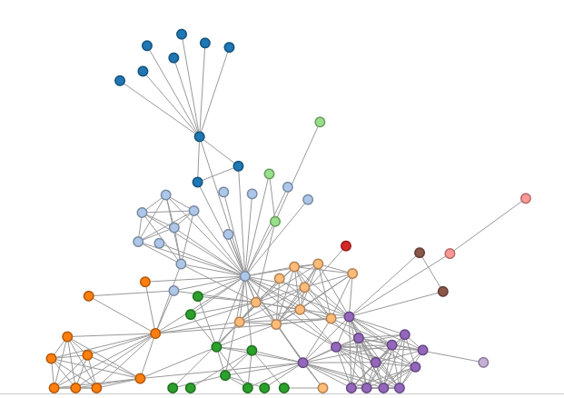

[Open](https://bl.ocks.org/mbostock/raw/1129492)

This [D3](http://d3js.org/) example shows how to constrain the position of nodes within the rectangular bounds of the containing SVG element. As a side-effect of updating the node's cx and cy attributes, we update the node positions to be within the range [radius, width - radius] for x, [radius, height - radius] for y. If you prefer, you could use the each operator to do this as a separate step, rather than as a side-effect of setting attributes.

index.html**[#](https://bl.ocks.org/mbostock/1129492" \l "index.html)**

<!DOCTYPE html>

<meta charset="utf-8">

<style>

circle {

stroke-width: 1.5px;

}

line {

stroke: #999;

}

</style>

<body>

<script src="//d3js.org/d3.v3.min.js"></script>

<script>

var width = 960,

height = 500,

radius = 6;

var fill = d3.scale.category20();

var force = d3.layout.force()

.gravity(.05)

.charge(-240)

.linkDistance(50)

.size([width, height]);

var svg = d3.select("body").append("svg")

.attr("width", width)

.attr("height", height);

d3.json("graph.json", function(error, graph) {

if (error) throw error;

var link = svg.selectAll("line")

.data(graph.links)

.enter().append("line");

var node = svg.selectAll("circle")

.data(graph.nodes)

.enter().append("circle")

.attr("r", radius - .75)

.style("fill", function(d) { return fill(d.group); })

.style("stroke", function(d) { return d3.rgb(fill(d.group)).darker(); })

.call(force.drag);

force

.nodes(graph.nodes)

.links(graph.links)

.on("tick", tick)

.start();

function tick() {

node.attr("cx", function(d) { return d.x = Math.max(radius, Math.min(width - radius, d.x)); })

.attr("cy", function(d) { return d.y = Math.max(radius, Math.min(height - radius, d.y)); });

link.attr("x1", function(d) { return d.source.x; })

.attr("y1", function(d) { return d.source.y; })

.attr("x2", function(d) { return d.target.x; })

.attr("y2", function(d) { return d.target.y; });

}

});

</script>

graph.json**[#](https://bl.ocks.org/mbostock/1129492" \l "graph.json)**

{

"nodes": [

{"name": "Myriel", "group": 1},

{"name": "Napoleon", "group": 1},

{"name": "Mlle.Baptistine", "group": 1},

{"name": "Mme.Magloire", "group": 1},

{"name": "CountessdeLo", "group": 1},

{"name": "Geborand", "group": 1},

{"name": "Champtercier", "group": 1},

{"name": "Cravatte", "group": 1},

{"name": "Count", "group": 1},

{"name": "OldMan", "group": 1},

{"name": "Labarre", "group": 2},

{"name": "Valjean", "group": 2},

{"name": "Marguerite", "group": 3},

{"name": "Mme.deR", "group": 2},

{"name": "Isabeau", "group": 2},

{"name": "Gervais", "group": 2},

{"name": "Tholomyes", "group": 3},

{"name": "Listolier", "group": 3},

{"name": "Fameuil", "group": 3},

{"name": "Blacheville", "group": 3},

{"name": "Favourite", "group": 3},

{"name": "Dahlia", "group": 3},

{"name": "Zephine", "group": 3},

{"name": "Fantine", "group": 3},

{"name": "Mme.Thenardier", "group": 4},

{"name": "Thenardier", "group": 4},

{"name": "Cosette", "group": 5},

{"name": "Javert", "group": 4},

{"name": "Fauchelevent", "group": 0},

{"name": "Bamatabois", "group": 2},

{"name": "Perpetue", "group": 3},

{"name": "Simplice", "group": 2},

{"name": "Scaufflaire", "group": 2},

{"name": "Woman1", "group": 2},

{"name": "Judge", "group": 2},

{"name": "Champmathieu", "group": 2},

{"name": "Brevet", "group": 2},

{"name": "Chenildieu", "group": 2},

{"name": "Cochepaille", "group": 2},

{"name": "Pontmercy", "group": 4},

{"name": "Boulatruelle", "group": 6},

{"name": "Eponine", "group": 4},

{"name": "Anzelma", "group": 4},

{"name": "Woman2", "group": 5},

{"name": "MotherInnocent", "group": 0},

{"name": "Gribier", "group": 0},

{"name": "Jondrette", "group": 7},

{"name": "Mme.Burgon", "group": 7},

{"name": "Gavroche", "group": 8},

{"name": "Gillenormand", "group": 5},

{"name": "Magnon", "group": 5},

{"name": "Mlle.Gillenormand", "group": 5},

{"name": "Mme.Pontmercy", "group": 5},

{"name": "Mlle.Vaubois", "group": 5},

{"name": "Lt.Gillenormand", "group": 5},

{"name": "Marius", "group": 8},

{"name": "BaronessT", "group": 5},

{"name": "Mabeuf", "group": 8},

{"name": "Enjolras", "group": 8},

{"name": "Combeferre", "group": 8},

{"name": "Prouvaire", "group": 8},

{"name": "Feuilly", "group": 8},

{"name": "Courfeyrac", "group": 8},

{"name": "Bahorel", "group": 8},

{"name": "Bossuet", "group": 8},

{"name": "Joly", "group": 8},

{"name": "Grantaire", "group": 8},

{"name": "MotherPlutarch", "group": 9},

{"name": "Gueulemer", "group": 4},

{"name": "Babet", "group": 4},

{"name": "Claquesous", "group": 4},

{"name": "Montparnasse", "group": 4},

{"name": "Toussaint", "group": 5},

{"name": "Child1", "group": 10},

{"name": "Child2", "group": 10},

{"name": "Brujon", "group": 4},

{"name": "Mme.Hucheloup", "group": 8}

],

"links": [

{"source": 1, "target": 0, "value": 1},

{"source": 2, "target": 0, "value": 8},

{"source": 3, "target": 0, "value": 10},

{"source": 3, "target": 2, "value": 6},

{"source": 4, "target": 0, "value": 1},

{"source": 5, "target": 0, "value": 1},

{"source": 6, "target": 0, "value": 1},

{"source": 7, "target": 0, "value": 1},

{"source": 8, "target": 0, "value": 2},

{"source": 9, "target": 0, "value": 1},

{"source": 11, "target": 10, "value": 1},

{"source": 11, "target": 3, "value": 3},

{"source": 11, "target": 2, "value": 3},

{"source": 11, "target": 0, "value": 5},

{"source": 12, "target": 11, "value": 1},

{"source": 13, "target": 11, "value": 1},

{"source": 14, "target": 11, "value": 1},

{"source": 15, "target": 11, "value": 1},

{"source": 17, "target": 16, "value": 4},

{"source": 18, "target": 16, "value": 4},

{"source": 18, "target": 17, "value": 4},

{"source": 19, "target": 16, "value": 4},

{"source": 19, "target": 17, "value": 4},

{"source": 19, "target": 18, "value": 4},

{"source": 20, "target": 16, "value": 3},

{"source": 20, "target": 17, "value": 3},

{"source": 20, "target": 18, "value": 3},

{"source": 20, "target": 19, "value": 4},

{"source": 21, "target": 16, "value": 3},

{"source": 21, "target": 17, "value": 3},

{"source": 21, "target": 18, "value": 3},

{"source": 21, "target": 19, "value": 3},

{"source": 21, "target": 20, "value": 5},

{"source": 22, "target": 16, "value": 3},

{"source": 22, "target": 17, "value": 3},

{"source": 22, "target": 18, "value": 3},

{"source": 22, "target": 19, "value": 3},

{"source": 22, "target": 20, "value": 4},

{"source": 22, "target": 21, "value": 4},

{"source": 23, "target": 16, "value": 3},

{"source": 23, "target": 17, "value": 3},

{"source": 23, "target": 18, "value": 3},

{"source": 23, "target": 19, "value": 3},

{"source": 23, "target": 20, "value": 4},

{"source": 23, "target": 21, "value": 4},

{"source": 23, "target": 22, "value": 4},

{"source": 23, "target": 12, "value": 2},

{"source": 23, "target": 11, "value": 9},

{"source": 24, "target": 23, "value": 2},

{"source": 24, "target": 11, "value": 7},

{"source": 25, "target": 24, "value": 13},

{"source": 25, "target": 23, "value": 1},

{"source": 25, "target": 11, "value": 12},

{"source": 26, "target": 24, "value": 4},

{"source": 26, "target": 11, "value": 31},

{"source": 26, "target": 16, "value": 1},

{"source": 26, "target": 25, "value": 1},

{"source": 27, "target": 11, "value": 17},

{"source": 27, "target": 23, "value": 5},

{"source": 27, "target": 25, "value": 5},

{"source": 27, "target": 24, "value": 1},

{"source": 27, "target": 26, "value": 1},

{"source": 28, "target": 11, "value": 8},

{"source": 28, "target": 27, "value": 1},

{"source": 29, "target": 23, "value": 1},

{"source": 29, "target": 27, "value": 1},

{"source": 29, "target": 11, "value": 2},

{"source": 30, "target": 23, "value": 1},

{"source": 31, "target": 30, "value": 2},

{"source": 31, "target": 11, "value": 3},

{"source": 31, "target": 23, "value": 2},

{"source": 31, "target": 27, "value": 1},

{"source": 32, "target": 11, "value": 1},

{"source": 33, "target": 11, "value": 2},

{"source": 33, "target": 27, "value": 1},

{"source": 34, "target": 11, "value": 3},

{"source": 34, "target": 29, "value": 2},

{"source": 35, "target": 11, "value": 3},

{"source": 35, "target": 34, "value": 3},

{"source": 35, "target": 29, "value": 2},

{"source": 36, "target": 34, "value": 2},

{"source": 36, "target": 35, "value": 2},

{"source": 36, "target": 11, "value": 2},

{"source": 36, "target": 29, "value": 1},

{"source": 37, "target": 34, "value": 2},

{"source": 37, "target": 35, "value": 2},

{"source": 37, "target": 36, "value": 2},

{"source": 37, "target": 11, "value": 2},

{"source": 37, "target": 29, "value": 1},

{"source": 38, "target": 34, "value": 2},

{"source": 38, "target": 35, "value": 2},

{"source": 38, "target": 36, "value": 2},

{"source": 38, "target": 37, "value": 2},

{"source": 38, "target": 11, "value": 2},

{"source": 38, "target": 29, "value": 1},

{"source": 39, "target": 25, "value": 1},

{"source": 40, "target": 25, "value": 1},

{"source": 41, "target": 24, "value": 2},

{"source": 41, "target": 25, "value": 3},

{"source": 42, "target": 41, "value": 2},

{"source": 42, "target": 25, "value": 2},

{"source": 42, "target": 24, "value": 1},

{"source": 43, "target": 11, "value": 3},

{"source": 43, "target": 26, "value": 1},

{"source": 43, "target": 27, "value": 1},

{"source": 44, "target": 28, "value": 3},

{"source": 44, "target": 11, "value": 1},

{"source": 45, "target": 28, "value": 2},

{"source": 47, "target": 46, "value": 1},

{"source": 48, "target": 47, "value": 2},

{"source": 48, "target": 25, "value": 1},

{"source": 48, "target": 27, "value": 1},

{"source": 48, "target": 11, "value": 1},

{"source": 49, "target": 26, "value": 3},

{"source": 49, "target": 11, "value": 2},

{"source": 50, "target": 49, "value": 1},

{"source": 50, "target": 24, "value": 1},

{"source": 51, "target": 49, "value": 9},

{"source": 51, "target": 26, "value": 2},

{"source": 51, "target": 11, "value": 2},

{"source": 52, "target": 51, "value": 1},

{"source": 52, "target": 39, "value": 1},

{"source": 53, "target": 51, "value": 1},

{"source": 54, "target": 51, "value": 2},

{"source": 54, "target": 49, "value": 1},

{"source": 54, "target": 26, "value": 1},

{"source": 55, "target": 51, "value": 6},

{"source": 55, "target": 49, "value": 12},

{"source": 55, "target": 39, "value": 1},

{"source": 55, "target": 54, "value": 1},

{"source": 55, "target": 26, "value": 21},

{"source": 55, "target": 11, "value": 19},

{"source": 55, "target": 16, "value": 1},

{"source": 55, "target": 25, "value": 2},

{"source": 55, "target": 41, "value": 5},

{"source": 55, "target": 48, "value": 4},

{"source": 56, "target": 49, "value": 1},

{"source": 56, "target": 55, "value": 1},

{"source": 57, "target": 55, "value": 1},

{"source": 57, "target": 41, "value": 1},

{"source": 57, "target": 48, "value": 1},

{"source": 58, "target": 55, "value": 7},

{"source": 58, "target": 48, "value": 7},

{"source": 58, "target": 27, "value": 6},

{"source": 58, "target": 57, "value": 1},

{"source": 58, "target": 11, "value": 4},

{"source": 59, "target": 58, "value": 15},

{"source": 59, "target": 55, "value": 5},

{"source": 59, "target": 48, "value": 6},

{"source": 59, "target": 57, "value": 2},

{"source": 60, "target": 48, "value": 1},

{"source": 60, "target": 58, "value": 4},

{"source": 60, "target": 59, "value": 2},

{"source": 61, "target": 48, "value": 2},

{"source": 61, "target": 58, "value": 6},

{"source": 61, "target": 60, "value": 2},

{"source": 61, "target": 59, "value": 5},

{"source": 61, "target": 57, "value": 1},

{"source": 61, "target": 55, "value": 1},

{"source": 62, "target": 55, "value": 9},

{"source": 62, "target": 58, "value": 17},

{"source": 62, "target": 59, "value": 13},

{"source": 62, "target": 48, "value": 7},

{"source": 62, "target": 57, "value": 2},

{"source": 62, "target": 41, "value": 1},

{"source": 62, "target": 61, "value": 6},

{"source": 62, "target": 60, "value": 3},

{"source": 63, "target": 59, "value": 5},

{"source": 63, "target": 48, "value": 5},

{"source": 63, "target": 62, "value": 6},

{"source": 63, "target": 57, "value": 2},

{"source": 63, "target": 58, "value": 4},

{"source": 63, "target": 61, "value": 3},

{"source": 63, "target": 60, "value": 2},

{"source": 63, "target": 55, "value": 1},

{"source": 64, "target": 55, "value": 5},

{"source": 64, "target": 62, "value": 12},

{"source": 64, "target": 48, "value": 5},

{"source": 64, "target": 63, "value": 4},

{"source": 64, "target": 58, "value": 10},

{"source": 64, "target": 61, "value": 6},

{"source": 64, "target": 60, "value": 2},

{"source": 64, "target": 59, "value": 9},

{"source": 64, "target": 57, "value": 1},

{"source": 64, "target": 11, "value": 1},

{"source": 65, "target": 63, "value": 5},

{"source": 65, "target": 64, "value": 7},

{"source": 65, "target": 48, "value": 3},

{"source": 65, "target": 62, "value": 5},

{"source": 65, "target": 58, "value": 5},

{"source": 65, "target": 61, "value": 5},

{"source": 65, "target": 60, "value": 2},

{"source": 65, "target": 59, "value": 5},

{"source": 65, "target": 57, "value": 1},

{"source": 65, "target": 55, "value": 2},

{"source": 66, "target": 64, "value": 3},

{"source": 66, "target": 58, "value": 3},

{"source": 66, "target": 59, "value": 1},

{"source": 66, "target": 62, "value": 2},

{"source": 66, "target": 65, "value": 2},

{"source": 66, "target": 48, "value": 1},

{"source": 66, "target": 63, "value": 1},

{"source": 66, "target": 61, "value": 1},

{"source": 66, "target": 60, "value": 1},

{"source": 67, "target": 57, "value": 3},

{"source": 68, "target": 25, "value": 5},

{"source": 68, "target": 11, "value": 1},

{"source": 68, "target": 24, "value": 1},

{"source": 68, "target": 27, "value": 1},

{"source": 68, "target": 48, "value": 1},

{"source": 68, "target": 41, "value": 1},

{"source": 69, "target": 25, "value": 6},

{"source": 69, "target": 68, "value": 6},

{"source": 69, "target": 11, "value": 1},

{"source": 69, "target": 24, "value": 1},

{"source": 69, "target": 27, "value": 2},

{"source": 69, "target": 48, "value": 1},

{"source": 69, "target": 41, "value": 1},

{"source": 70, "target": 25, "value": 4},

{"source": 70, "target": 69, "value": 4},

{"source": 70, "target": 68, "value": 4},

{"source": 70, "target": 11, "value": 1},

{"source": 70, "target": 24, "value": 1},

{"source": 70, "target": 27, "value": 1},

{"source": 70, "target": 41, "value": 1},

{"source": 70, "target": 58, "value": 1},

{"source": 71, "target": 27, "value": 1},

{"source": 71, "target": 69, "value": 2},

{"source": 71, "target": 68, "value": 2},

{"source": 71, "target": 70, "value": 2},

{"source": 71, "target": 11, "value": 1},

{"source": 71, "target": 48, "value": 1},

{"source": 71, "target": 41, "value": 1},

{"source": 71, "target": 25, "value": 1},

{"source": 72, "target": 26, "value": 2},

{"source": 72, "target": 27, "value": 1},

{"source": 72, "target": 11, "value": 1},

{"source": 73, "target": 48, "value": 2},

{"source": 74, "target": 48, "value": 2},

{"source": 74, "target": 73, "value": 3},

{"source": 75, "target": 69, "value": 3},

{"source": 75, "target": 68, "value": 3},

{"source": 75, "target": 25, "value": 3},

{"source": 75, "target": 48, "value": 1},

{"source": 75, "target": 41, "value": 1},

{"source": 75, "target": 70, "value": 1},

{"source": 75, "target": 71, "value": 1},

{"source": 76, "target": 64, "value": 1},

{"source": 76, "target": 65, "value": 1},

{"source": 76, "target": 66, "value": 1},

{"source": 76, "target": 63, "value": 1},

{"source": 76, "target": 62, "value": 1},

{"source": 76, "target": 48, "value": 1},

{"source": 76, "target": 58, "value": 1}

]

}

LICENSE**[#](https://bl.ocks.org/mbostock/1129492" \l "license)**

Released under the [GNU General Public License, version 3](https://opensource.org/licenses/GPL-3.0).

# Force-Directed SVG Icons - bl.ocks.org

http://bl.ocks.org/syntagmatic/4963194

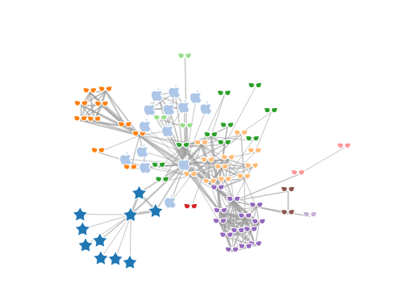

Replaces the circles in the force-directed graph with some [SVG icons](http://raphaeljs.com/icons/#glasses).

index.html[**#**](http://bl.ocks.org/syntagmatic/4963194#index.html)

<!DOCTYPE html>

<meta charset="utf-8">

<style>

.node {

stroke: #fff;

stroke-width: 1.5px;

}

.link {

stroke: #999;

stroke-opacity: .6;

}

</style>

<body>

<script src="http://d3js.org/d3.v3.min.js"></script>

<script>

var logos = {

star: "M14.615,4.928c0.487-0.986,1.284-0.986,1.771,0l2.249,4.554c0.486,0.986,1.775,1.923,2.864,2.081l5.024,0.73c1.089,0.158,1.335,0.916,0.547,1.684l-3.636,3.544c-0.788,0.769-1.28,2.283-1.095,3.368l0.859,5.004c0.186,1.085-0.459,1.553-1.433,1.041l-4.495-2.363c-0.974-0.512-2.567-0.512-3.541,0l-4.495,2.363c-0.974,0.512-1.618,0.044-1.432-1.041l0.858-5.004c0.186-1.085-0.307-2.6-1.094-3.368L3.93,13.977c-0.788-0.768-0.542-1.525,0.547-1.684l5.026-0.73c1.088-0.158,2.377-1.095,2.864-2.081L14.615,4.928z",

apple: "M24.32,10.85c-1.743,1.233-2.615,2.719-2.615,4.455c0,2.079,1.078,3.673,3.232,4.786c-0.578,1.677-1.416,3.134-2.514,4.375c-1.097,1.241-2.098,1.862-3.004,1.862c-0.427,0-1.009-0.143-1.748-0.423l-0.354-0.138c-0.725-0.281-1.363-0.423-1.92-0.423c-0.525,0-1.1,0.11-1.725,0.331l-0.445,0.16l-0.56,0.229c-0.441,0.176-0.888,0.264-1.337,0.264c-1.059,0-2.228-0.872-3.507-2.616c-1.843-2.498-2.764-5.221-2.764-8.167c0-2.095,0.574-3.781,1.725-5.061c1.149-1.279,2.673-1.92,4.568-1.92c0.709,0,1.371,0.13,1.988,0.389l0.423,0.172l0.445,0.183c0.396,0.167,0.716,0.251,0.959,0.251c0.312,0,0.659-0.072,1.04-0.217l0.582-0.229l0.435-0.16c0.693-0.251,1.459-0.377,2.297-0.377C21.512,8.576,23.109,9.334,24.32,10.85zM19.615,3.287c0.021,0.267,0.033,0.473,0.033,0.617c0,1.317-0.479,2.473-1.438,3.467s-2.075,1.49-3.347,1.49c-0.038-0.297-0.058-0.51-0.058-0.639c0-1.12,0.445-2.171,1.337-3.153c0.891-0.982,1.922-1.558,3.096-1.725C19.32,3.329,19.447,3.311,19.615,3.287z",

glasses: "M14.075,9.531c0,0-2.705-1.438-5.158-1.438c-2.453,0-4.862,0.593-4.862,0.593L3.971,9.869c0,0,0.19,0.19,0.528,0.53c0.338,0.336,0.486,3.741,1.838,5.094c1.353,1.354,4.82,1.396,5.963,0.676c1.14-0.718,2.241-3.466,2.241-4.693c0-0.38,0-0.676,0-0.676c0.274-0.275,1.615-0.303,1.917,0c0,0,0,0.296,0,0.676c0,1.227,1.101,3.975,2.241,4.693c1.144,0.72,4.611,0.678,5.963-0.676c1.355-1.353,1.501-4.757,1.839-5.094c0.338-0.34,0.528-0.53,0.528-0.53l-0.084-1.183c0,0-2.408-0.593-4.862-0.593c-2.453,0-5.158,1.438-5.158,1.438C16.319,9.292,14.737,9.32,14.075,9.531z"

};

var groupLogo = {

1: logos.star,

2: logos.apple

}

var width = 960,

height = 500;

var color = d3.scale.category20();

var force = d3.layout.force()

.charge(-120)

.linkDistance(30)

.size([width, height]);

var svg = d3.select("body").append("svg")

.attr("width", width)

.attr("height", height);

d3.json("miserables.json", function(error, graph) {

force

.nodes(graph.nodes)

.links(graph.links)

.start();

var link = svg.selectAll(".link")

.data(graph.links)

.enter().append("line")

.attr("class", "link")

.style("stroke-width", function(d) { return Math.sqrt(d.value); });

var node = svg.selectAll(".node")

.data(graph.nodes)

.enter().append("g")

.attr("class", "node")

.call(force.drag);

node.append("path")

.attr("d", function(d) {

if (d.group in groupLogo) return groupLogo[d.group];

return logos.glasses;

})

.attr("transform", "scale(0.75)")

.style("fill", function(d) { return color(d.group); });

node.append("title")

.text(function(d) { return d.name; });

force.on("tick", function() {

link.attr("x1", function(d) { return d.source.x; })

.attr("y1", function(d) { return d.source.y; })

.attr("x2", function(d) { return d.target.x; })

.attr("y2", function(d) { return d.target.y; });

node.attr("transform", function(d) { return "translate(" + (d.x-12) + "," + (d.y-12) + ")"; });

});

});

</script>

miserables.json**[#](http://bl.ocks.org/syntagmatic/4963194" \l "miserables.json)**

{

"nodes":[

{"name":"Myriel","group":1},

{"name":"Napoleon","group":1},

{"name":"Mlle.Baptistine","group":1},

{"name":"Mme.Magloire","group":1},

{"name":"CountessdeLo","group":1},

{"name":"Geborand","group":1},

{"name":"Champtercier","group":1},

{"name":"Cravatte","group":1},

{"name":"Count","group":1},

{"name":"OldMan","group":1},

{"name":"Labarre","group":2},

{"name":"Valjean","group":2},

{"name":"Marguerite","group":3},

{"name":"Mme.deR","group":2},

{"name":"Isabeau","group":2},

{"name":"Gervais","group":2},

{"name":"Tholomyes","group":3},

{"name":"Listolier","group":3},

{"name":"Fameuil","group":3},

{"name":"Blacheville","group":3},

{"name":"Favourite","group":3},

{"name":"Dahlia","group":3},

{"name":"Zephine","group":3},

{"name":"Fantine","group":3},

{"name":"Mme.Thenardier","group":4},

{"name":"Thenardier","group":4},

{"name":"Cosette","group":5},

{"name":"Javert","group":4},

{"name":"Fauchelevent","group":0},

{"name":"Bamatabois","group":2},

{"name":"Perpetue","group":3},

{"name":"Simplice","group":2},

{"name":"Scaufflaire","group":2},

{"name":"Woman1","group":2},

{"name":"Judge","group":2},

{"name":"Champmathieu","group":2},

{"name":"Brevet","group":2},

{"name":"Chenildieu","group":2},

{"name":"Cochepaille","group":2},

{"name":"Pontmercy","group":4},

{"name":"Boulatruelle","group":6},

{"name":"Eponine","group":4},

{"name":"Anzelma","group":4},

{"name":"Woman2","group":5},

{"name":"MotherInnocent","group":0},

{"name":"Gribier","group":0},

{"name":"Jondrette","group":7},

{"name":"Mme.Burgon","group":7},

{"name":"Gavroche","group":8},

{"name":"Gillenormand","group":5},

{"name":"Magnon","group":5},

{"name":"Mlle.Gillenormand","group":5},

{"name":"Mme.Pontmercy","group":5},

{"name":"Mlle.Vaubois","group":5},

{"name":"Lt.Gillenormand","group":5},

{"name":"Marius","group":8},

{"name":"BaronessT","group":5},

{"name":"Mabeuf","group":8},

{"name":"Enjolras","group":8},

{"name":"Combeferre","group":8},

{"name":"Prouvaire","group":8},

{"name":"Feuilly","group":8},

{"name":"Courfeyrac","group":8},

{"name":"Bahorel","group":8},

{"name":"Bossuet","group":8},

{"name":"Joly","group":8},

{"name":"Grantaire","group":8},

{"name":"MotherPlutarch","group":9},

{"name":"Gueulemer","group":4},

{"name":"Babet","group":4},

{"name":"Claquesous","group":4},

{"name":"Montparnasse","group":4},

{"name":"Toussaint","group":5},

{"name":"Child1","group":10},

{"name":"Child2","group":10},

{"name":"Brujon","group":4},

{"name":"Mme.Hucheloup","group":8}

],

"links":[

{"source":1,"target":0,"value":1},

{"source":2,"target":0,"value":8},

{"source":3,"target":0,"value":10},

{"source":3,"target":2,"value":6},

{"source":4,"target":0,"value":1},

{"source":5,"target":0,"value":1},

{"source":6,"target":0,"value":1},

{"source":7,"target":0,"value":1},

{"source":8,"target":0,"value":2},

{"source":9,"target":0,"value":1},

{"source":11,"target":10,"value":1},

{"source":11,"target":3,"value":3},

{"source":11,"target":2,"value":3},

{"source":11,"target":0,"value":5},

{"source":12,"target":11,"value":1},

{"source":13,"target":11,"value":1},

{"source":14,"target":11,"value":1},

{"source":15,"target":11,"value":1},

{"source":17,"target":16,"value":4},

{"source":18,"target":16,"value":4},

{"source":18,"target":17,"value":4},

{"source":19,"target":16,"value":4},

{"source":19,"target":17,"value":4},

{"source":19,"target":18,"value":4},

{"source":20,"target":16,"value":3},

{"source":20,"target":17,"value":3},

{"source":20,"target":18,"value":3},

{"source":20,"target":19,"value":4},

{"source":21,"target":16,"value":3},

{"source":21,"target":17,"value":3},

{"source":21,"target":18,"value":3},

{"source":21,"target":19,"value":3},

{"source":21,"target":20,"value":5},

{"source":22,"target":16,"value":3},

{"source":22,"target":17,"value":3},

{"source":22,"target":18,"value":3},

{"source":22,"target":19,"value":3},

{"source":22,"target":20,"value":4},

{"source":22,"target":21,"value":4},

{"source":23,"target":16,"value":3},

{"source":23,"target":17,"value":3},

{"source":23,"target":18,"value":3},

{"source":23,"target":19,"value":3},

{"source":23,"target":20,"value":4},

{"source":23,"target":21,"value":4},

{"source":23,"target":22,"value":4},

{"source":23,"target":12,"value":2},

{"source":23,"target":11,"value":9},

{"source":24,"target":23,"value":2},

{"source":24,"target":11,"value":7},

{"source":25,"target":24,"value":13},

{"source":25,"target":23,"value":1},

{"source":25,"target":11,"value":12},

{"source":26,"target":24,"value":4},

{"source":26,"target":11,"value":31},

{"source":26,"target":16,"value":1},

{"source":26,"target":25,"value":1},

{"source":27,"target":11,"value":17},

{"source":27,"target":23,"value":5},

{"source":27,"target":25,"value":5},

{"source":27,"target":24,"value":1},

{"source":27,"target":26,"value":1},

{"source":28,"target":11,"value":8},

{"source":28,"target":27,"value":1},

{"source":29,"target":23,"value":1},

{"source":29,"target":27,"value":1},

{"source":29,"target":11,"value":2},

{"source":30,"target":23,"value":1},

{"source":31,"target":30,"value":2},

{"source":31,"target":11,"value":3},

{"source":31,"target":23,"value":2},

{"source":31,"target":27,"value":1},

{"source":32,"target":11,"value":1},

{"source":33,"target":11,"value":2},

{"source":33,"target":27,"value":1},

{"source":34,"target":11,"value":3},

{"source":34,"target":29,"value":2},

{"source":35,"target":11,"value":3},

{"source":35,"target":34,"value":3},

{"source":35,"target":29,"value":2},

{"source":36,"target":34,"value":2},

{"source":36,"target":35,"value":2},

{"source":36,"target":11,"value":2},

{"source":36,"target":29,"value":1},

{"source":37,"target":34,"value":2},

{"source":37,"target":35,"value":2},

{"source":37,"target":36,"value":2},

{"source":37,"target":11,"value":2},

{"source":37,"target":29,"value":1},

{"source":38,"target":34,"value":2},

{"source":38,"target":35,"value":2},

{"source":38,"target":36,"value":2},

{"source":38,"target":37,"value":2},

{"source":38,"target":11,"value":2},

{"source":38,"target":29,"value":1},

{"source":39,"target":25,"value":1},

{"source":40,"target":25,"value":1},

{"source":41,"target":24,"value":2},

{"source":41,"target":25,"value":3},

{"source":42,"target":41,"value":2},

{"source":42,"target":25,"value":2},

{"source":42,"target":24,"value":1},

{"source":43,"target":11,"value":3},

{"source":43,"target":26,"value":1},

{"source":43,"target":27,"value":1},

{"source":44,"target":28,"value":3},

{"source":44,"target":11,"value":1},

{"source":45,"target":28,"value":2},

{"source":47,"target":46,"value":1},

{"source":48,"target":47,"value":2},

{"source":48,"target":25,"value":1},

{"source":48,"target":27,"value":1},

{"source":48,"target":11,"value":1},

{"source":49,"target":26,"value":3},

{"source":49,"target":11,"value":2},

{"source":50,"target":49,"value":1},

{"source":50,"target":24,"value":1},

{"source":51,"target":49,"value":9},

{"source":51,"target":26,"value":2},

{"source":51,"target":11,"value":2},

{"source":52,"target":51,"value":1},

{"source":52,"target":39,"value":1},

{"source":53,"target":51,"value":1},

{"source":54,"target":51,"value":2},

{"source":54,"target":49,"value":1},

{"source":54,"target":26,"value":1},

{"source":55,"target":51,"value":6},

{"source":55,"target":49,"value":12},

{"source":55,"target":39,"value":1},

{"source":55,"target":54,"value":1},

{"source":55,"target":26,"value":21},

{"source":55,"target":11,"value":19},

{"source":55,"target":16,"value":1},

{"source":55,"target":25,"value":2},

{"source":55,"target":41,"value":5},

{"source":55,"target":48,"value":4},

{"source":56,"target":49,"value":1},

{"source":56,"target":55,"value":1},

{"source":57,"target":55,"value":1},

{"source":57,"target":41,"value":1},

{"source":57,"target":48,"value":1},

{"source":58,"target":55,"value":7},

{"source":58,"target":48,"value":7},

{"source":58,"target":27,"value":6},

{"source":58,"target":57,"value":1},

{"source":58,"target":11,"value":4},

{"source":59,"target":58,"value":15},

{"source":59,"target":55,"value":5},

{"source":59,"target":48,"value":6},

{"source":59,"target":57,"value":2},

{"source":60,"target":48,"value":1},

{"source":60,"target":58,"value":4},

{"source":60,"target":59,"value":2},

{"source":61,"target":48,"value":2},

{"source":61,"target":58,"value":6},

{"source":61,"target":60,"value":2},

{"source":61,"target":59,"value":5},

{"source":61,"target":57,"value":1},

{"source":61,"target":55,"value":1},

{"source":62,"target":55,"value":9},

{"source":62,"target":58,"value":17},

{"source":62,"target":59,"value":13},

{"source":62,"target":48,"value":7},

{"source":62,"target":57,"value":2},

{"source":62,"target":41,"value":1},

{"source":62,"target":61,"value":6},

{"source":62,"target":60,"value":3},

{"source":63,"target":59,"value":5},

{"source":63,"target":48,"value":5},

{"source":63,"target":62,"value":6},

{"source":63,"target":57,"value":2},

{"source":63,"target":58,"value":4},

{"source":63,"target":61,"value":3},

{"source":63,"target":60,"value":2},

{"source":63,"target":55,"value":1},

{"source":64,"target":55,"value":5},

{"source":64,"target":62,"value":12},

{"source":64,"target":48,"value":5},

{"source":64,"target":63,"value":4},

{"source":64,"target":58,"value":10},

{"source":64,"target":61,"value":6},

{"source":64,"target":60,"value":2},

{"source":64,"target":59,"value":9},

{"source":64,"target":57,"value":1},

{"source":64,"target":11,"value":1},

{"source":65,"target":63,"value":5},

{"source":65,"target":64,"value":7},

{"source":65,"target":48,"value":3},

{"source":65,"target":62,"value":5},

{"source":65,"target":58,"value":5},

{"source":65,"target":61,"value":5},

{"source":65,"target":60,"value":2},

{"source":65,"target":59,"value":5},

{"source":65,"target":57,"value":1},

{"source":65,"target":55,"value":2},

{"source":66,"target":64,"value":3},

{"source":66,"target":58,"value":3},

{"source":66,"target":59,"value":1},

{"source":66,"target":62,"value":2},

{"source":66,"target":65,"value":2},

{"source":66,"target":48,"value":1},

{"source":66,"target":63,"value":1},

{"source":66,"target":61,"value":1},

{"source":66,"target":60,"value":1},

{"source":67,"target":57,"value":3},

{"source":68,"target":25,"value":5},

{"source":68,"target":11,"value":1},

{"source":68,"target":24,"value":1},

{"source":68,"target":27,"value":1},

{"source":68,"target":48,"value":1},

{"source":68,"target":41,"value":1},

{"source":69,"target":25,"value":6},

{"source":69,"target":68,"value":6},

{"source":69,"target":11,"value":1},

{"source":69,"target":24,"value":1},

{"source":69,"target":27,"value":2},

{"source":69,"target":48,"value":1},

{"source":69,"target":41,"value":1},

{"source":70,"target":25,"value":4},

{"source":70,"target":69,"value":4},

{"source":70,"target":68,"value":4},

{"source":70,"target":11,"value":1},

{"source":70,"target":24,"value":1},

{"source":70,"target":27,"value":1},

{"source":70,"target":41,"value":1},

{"source":70,"target":58,"value":1},

{"source":71,"target":27,"value":1},

{"source":71,"target":69,"value":2},

{"source":71,"target":68,"value":2},

{"source":71,"target":70,"value":2},

{"source":71,"target":11,"value":1},

{"source":71,"target":48,"value":1},

{"source":71,"target":41,"value":1},

{"source":71,"target":25,"value":1},

{"source":72,"target":26,"value":2},

{"source":72,"target":27,"value":1},

{"source":72,"target":11,"value":1},

{"source":73,"target":48,"value":2},

{"source":74,"target":48,"value":2},

{"source":74,"target":73,"value":3},

{"source":75,"target":69,"value":3},

{"source":75,"target":68,"value":3},

{"source":75,"target":25,"value":3},

{"source":75,"target":48,"value":1},

{"source":75,"target":41,"value":1},

{"source":75,"target":70,"value":1},

{"source":75,"target":71,"value":1},

{"source":76,"target":64,"value":1},

{"source":76,"target":65,"value":1},

{"source":76,"target":66,"value":1},

{"source":76,"target":63,"value":1},

{"source":76,"target":62,"value":1},

{"source":76,"target":48,"value":1},

{"source":76,"target":58,"value":1}

]

}

LICENSE[**#**](http://bl.ocks.org/syntagmatic/4963194#license)

This block appears to have [no license](http://choosealicense.com/no-license/). Please contact [the author](https://github.com/syntagmatic) to request a license.

# 2@Force-Directed Graph - bl.ocks.org

https://bl.ocks.org/mbostock/4062045

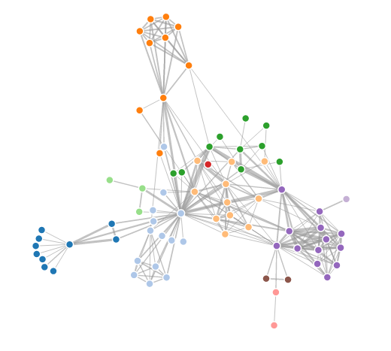

This simple force-directed graph shows character co-occurence in Les Misérables. A physical simulation of charged particles and springs places related characters in closer proximity, while unrelated characters are farther apart. Layout algorithm inspired by [Tim Dwyer](http://www.csse.monash.edu.au/~tdwyer/) and [Thomas Jakobsen](http://web.archive.org/web/20080410171619/http:/www.teknikus.dk/tj/gdc2001.htm). Data based on character coappearence in Victor Hugo's Les Misérables, compiled by [Donald Knuth](http://www-cs-faculty.stanford.edu/~uno/sgb.html).

Compare this display to a force layout with [curved links](https://bl.ocks.org/mbostock/4600693), a force layout with [fisheye distortion](http://bost.ocks.org/mike/fisheye/) and a [matrix diagram](http://bost.ocks.org/mike/miserables/).

index.html[**#**](https://bl.ocks.org/mbostock/4062045#index.html)

<!DOCTYPE html>

<meta charset="utf-8">

<style>

.links line {

stroke: #999;

stroke-opacity: 0.6;

}

.nodes circle {

stroke: #fff;

stroke-width: 1.5px;

}

</style>

<svg width="960" height="600"></svg>

<script src="https://d3js.org/d3.v4.min.js"></script>

<script>

var svg = d3.select("svg"),

width = +svg.attr("width"),

height = +svg.attr("height");

var color = d3.scaleOrdinal(d3.schemeCategory20);

var simulation = d3.forceSimulation()

.force("link", d3.forceLink().id(function(d) { return d.id; }))

.force("charge", d3.forceManyBody())

.force("center", d3.forceCenter(width / 2, height / 2));

d3.json("miserables.json", function(error, graph) {

if (error) throw error;

var link = svg.append("g")

.attr("class", "links")

.selectAll("line")

.data(graph.links)

.enter().append("line")

.attr("stroke-width", function(d) { return Math.sqrt(d.value); });

var node = svg.append("g")

.attr("class", "nodes")

.selectAll("circle")

.data(graph.nodes)

.enter().append("circle")

.attr("r", 5)

.attr("fill", function(d) { return color(d.group); })

.call(d3.drag()

.on("start", dragstarted)

.on("drag", dragged)

.on("end", dragended));

node.append("title")

.text(function(d) { return d.id; });

simulation

.nodes(graph.nodes)

.on("tick", ticked);

simulation.force("link")

.links(graph.links);

function ticked() {

link

.attr("x1", function(d) { return d.source.x; })

.attr("y1", function(d) { return d.source.y; })

.attr("x2", function(d) { return d.target.x; })

.attr("y2", function(d) { return d.target.y; });

node

.attr("cx", function(d) { return d.x; })

.attr("cy", function(d) { return d.y; });

}

});

function dragstarted(d) {

if (!d3.event.active) simulation.alphaTarget(0.3).restart();

d.fx = d.x;

d.fy = d.y;

}

function dragged(d) {

d.fx = d3.event.x;

d.fy = d3.event.y;

}

function dragended(d) {

if (!d3.event.active) simulation.alphaTarget(0);

d.fx = null;

d.fy = null;

}

</script>

miserables.json[**#**](https://bl.ocks.org/mbostock/4062045#miserables.json)

{

"nodes": [

{"id": "Myriel", "group": 1},

{"id": "Napoleon", "group": 1},

{"id": "Mlle.Baptistine", "group": 1},

{"id": "Mme.Magloire", "group": 1},

{"id": "CountessdeLo", "group": 1},

{"id": "Geborand", "group": 1},

{"id": "Champtercier", "group": 1},

{"id": "Cravatte", "group": 1},

{"id": "Count", "group": 1},

{"id": "OldMan", "group": 1},

{"id": "Labarre", "group": 2},

{"id": "Valjean", "group": 2},

{"id": "Marguerite", "group": 3},

{"id": "Mme.deR", "group": 2},

{"id": "Isabeau", "group": 2},

{"id": "Gervais", "group": 2},

{"id": "Tholomyes", "group": 3},

{"id": "Listolier", "group": 3},

{"id": "Fameuil", "group": 3},

{"id": "Blacheville", "group": 3},

{"id": "Favourite", "group": 3},

{"id": "Dahlia", "group": 3},

{"id": "Zephine", "group": 3},

{"id": "Fantine", "group": 3},

{"id": "Mme.Thenardier", "group": 4},

{"id": "Thenardier", "group": 4},

{"id": "Cosette", "group": 5},

{"id": "Javert", "group": 4},

{"id": "Fauchelevent", "group": 0},

{"id": "Bamatabois", "group": 2},

{"id": "Perpetue", "group": 3},

{"id": "Simplice", "group": 2},

{"id": "Scaufflaire", "group": 2},

{"id": "Woman1", "group": 2},

{"id": "Judge", "group": 2},

{"id": "Champmathieu", "group": 2},

{"id": "Brevet", "group": 2},

{"id": "Chenildieu", "group": 2},

{"id": "Cochepaille", "group": 2},

{"id": "Pontmercy", "group": 4},

{"id": "Boulatruelle", "group": 6},

{"id": "Eponine", "group": 4},

{"id": "Anzelma", "group": 4},

{"id": "Woman2", "group": 5},

{"id": "MotherInnocent", "group": 0},

{"id": "Gribier", "group": 0},

{"id": "Jondrette", "group": 7},

{"id": "Mme.Burgon", "group": 7},

{"id": "Gavroche", "group": 8},

{"id": "Gillenormand", "group": 5},

{"id": "Magnon", "group": 5},

{"id": "Mlle.Gillenormand", "group": 5},

{"id": "Mme.Pontmercy", "group": 5},

{"id": "Mlle.Vaubois", "group": 5},

{"id": "Lt.Gillenormand", "group": 5},

{"id": "Marius", "group": 8},

{"id": "BaronessT", "group": 5},

{"id": "Mabeuf", "group": 8},

{"id": "Enjolras", "group": 8},

{"id": "Combeferre", "group": 8},

{"id": "Prouvaire", "group": 8},

{"id": "Feuilly", "group": 8},

{"id": "Courfeyrac", "group": 8},

{"id": "Bahorel", "group": 8},

{"id": "Bossuet", "group": 8},

{"id": "Joly", "group": 8},

{"id": "Grantaire", "group": 8},

{"id": "MotherPlutarch", "group": 9},

{"id": "Gueulemer", "group": 4},

{"id": "Babet", "group": 4},

{"id": "Claquesous", "group": 4},

{"id": "Montparnasse", "group": 4},

{"id": "Toussaint", "group": 5},

{"id": "Child1", "group": 10},

{"id": "Child2", "group": 10},

{"id": "Brujon", "group": 4},

{"id": "Mme.Hucheloup", "group": 8}

],

"links": [

{"source": "Napoleon", "target": "Myriel", "value": 1},

{"source": "Mlle.Baptistine", "target": "Myriel", "value": 8},

{"source": "Mme.Magloire", "target": "Myriel", "value": 10},

{"source": "Mme.Magloire", "target": "Mlle.Baptistine", "value": 6},

{"source": "CountessdeLo", "target": "Myriel", "value": 1},

{"source": "Geborand", "target": "Myriel", "value": 1},

{"source": "Champtercier", "target": "Myriel", "value": 1},

{"source": "Cravatte", "target": "Myriel", "value": 1},

{"source": "Count", "target": "Myriel", "value": 2},

{"source": "OldMan", "target": "Myriel", "value": 1},

{"source": "Valjean", "target": "Labarre", "value": 1},

{"source": "Valjean", "target": "Mme.Magloire", "value": 3},

{"source": "Valjean", "target": "Mlle.Baptistine", "value": 3},

{"source": "Valjean", "target": "Myriel", "value": 5},

{"source": "Marguerite", "target": "Valjean", "value": 1},

{"source": "Mme.deR", "target": "Valjean", "value": 1},

{"source": "Isabeau", "target": "Valjean", "value": 1},

{"source": "Gervais", "target": "Valjean", "value": 1},

{"source": "Listolier", "target": "Tholomyes", "value": 4},

{"source": "Fameuil", "target": "Tholomyes", "value": 4},

{"source": "Fameuil", "target": "Listolier", "value": 4},

{"source": "Blacheville", "target": "Tholomyes", "value": 4},

{"source": "Blacheville", "target": "Listolier", "value": 4},

{"source": "Blacheville", "target": "Fameuil", "value": 4},

{"source": "Favourite", "target": "Tholomyes", "value": 3},

{"source": "Favourite", "target": "Listolier", "value": 3},

{"source": "Favourite", "target": "Fameuil", "value": 3},

{"source": "Favourite", "target": "Blacheville", "value": 4},

{"source": "Dahlia", "target": "Tholomyes", "value": 3},

{"source": "Dahlia", "target": "Listolier", "value": 3},

{"source": "Dahlia", "target": "Fameuil", "value": 3},

{"source": "Dahlia", "target": "Blacheville", "value": 3},

{"source": "Dahlia", "target": "Favourite", "value": 5},

{"source": "Zephine", "target": "Tholomyes", "value": 3},

{"source": "Zephine", "target": "Listolier", "value": 3},

{"source": "Zephine", "target": "Fameuil", "value": 3},

{"source": "Zephine", "target": "Blacheville", "value": 3},

{"source": "Zephine", "target": "Favourite", "value": 4},

{"source": "Zephine", "target": "Dahlia", "value": 4},

{"source": "Fantine", "target": "Tholomyes", "value": 3},

{"source": "Fantine", "target": "Listolier", "value": 3},

{"source": "Fantine", "target": "Fameuil", "value": 3},

{"source": "Fantine", "target": "Blacheville", "value": 3},

{"source": "Fantine", "target": "Favourite", "value": 4},

{"source": "Fantine", "target": "Dahlia", "value": 4},

{"source": "Fantine", "target": "Zephine", "value": 4},

{"source": "Fantine", "target": "Marguerite", "value": 2},

{"source": "Fantine", "target": "Valjean", "value": 9},

{"source": "Mme.Thenardier", "target": "Fantine", "value": 2},

{"source": "Mme.Thenardier", "target": "Valjean", "value": 7},

{"source": "Thenardier", "target": "Mme.Thenardier", "value": 13},

{"source": "Thenardier", "target": "Fantine", "value": 1},

{"source": "Thenardier", "target": "Valjean", "value": 12},

{"source": "Cosette", "target": "Mme.Thenardier", "value": 4},

{"source": "Cosette", "target": "Valjean", "value": 31},

{"source": "Cosette", "target": "Tholomyes", "value": 1},

{"source": "Cosette", "target": "Thenardier", "value": 1},

{"source": "Javert", "target": "Valjean", "value": 17},

{"source": "Javert", "target": "Fantine", "value": 5},

{"source": "Javert", "target": "Thenardier", "value": 5},

{"source": "Javert", "target": "Mme.Thenardier", "value": 1},

{"source": "Javert", "target": "Cosette", "value": 1},

{"source": "Fauchelevent", "target": "Valjean", "value": 8},

{"source": "Fauchelevent", "target": "Javert", "value": 1},

{"source": "Bamatabois", "target": "Fantine", "value": 1},

{"source": "Bamatabois", "target": "Javert", "value": 1},

{"source": "Bamatabois", "target": "Valjean", "value": 2},

{"source": "Perpetue", "target": "Fantine", "value": 1},

{"source": "Simplice", "target": "Perpetue", "value": 2},

{"source": "Simplice", "target": "Valjean", "value": 3},

{"source": "Simplice", "target": "Fantine", "value": 2},

{"source": "Simplice", "target": "Javert", "value": 1},

{"source": "Scaufflaire", "target": "Valjean", "value": 1},

{"source": "Woman1", "target": "Valjean", "value": 2},

{"source": "Woman1", "target": "Javert", "value": 1},

{"source": "Judge", "target": "Valjean", "value": 3},

{"source": "Judge", "target": "Bamatabois", "value": 2},

{"source": "Champmathieu", "target": "Valjean", "value": 3},

{"source": "Champmathieu", "target": "Judge", "value": 3},

{"source": "Champmathieu", "target": "Bamatabois", "value": 2},

{"source": "Brevet", "target": "Judge", "value": 2},

{"source": "Brevet", "target": "Champmathieu", "value": 2},

{"source": "Brevet", "target": "Valjean", "value": 2},

{"source": "Brevet", "target": "Bamatabois", "value": 1},

{"source": "Chenildieu", "target": "Judge", "value": 2},

{"source": "Chenildieu", "target": "Champmathieu", "value": 2},

{"source": "Chenildieu", "target": "Brevet", "value": 2},

{"source": "Chenildieu", "target": "Valjean", "value": 2},

{"source": "Chenildieu", "target": "Bamatabois", "value": 1},

{"source": "Cochepaille", "target": "Judge", "value": 2},

{"source": "Cochepaille", "target": "Champmathieu", "value": 2},

{"source": "Cochepaille", "target": "Brevet", "value": 2},

{"source": "Cochepaille", "target": "Chenildieu", "value": 2},

{"source": "Cochepaille", "target": "Valjean", "value": 2},

{"source": "Cochepaille", "target": "Bamatabois", "value": 1},

{"source": "Pontmercy", "target": "Thenardier", "value": 1},

{"source": "Boulatruelle", "target": "Thenardier", "value": 1},

{"source": "Eponine", "target": "Mme.Thenardier", "value": 2},

{"source": "Eponine", "target": "Thenardier", "value": 3},

{"source": "Anzelma", "target": "Eponine", "value": 2},

{"source": "Anzelma", "target": "Thenardier", "value": 2},

{"source": "Anzelma", "target": "Mme.Thenardier", "value": 1},

{"source": "Woman2", "target": "Valjean", "value": 3},

{"source": "Woman2", "target": "Cosette", "value": 1},

{"source": "Woman2", "target": "Javert", "value": 1},

{"source": "MotherInnocent", "target": "Fauchelevent", "value": 3},

{"source": "MotherInnocent", "target": "Valjean", "value": 1},

{"source": "Gribier", "target": "Fauchelevent", "value": 2},

{"source": "Mme.Burgon", "target": "Jondrette", "value": 1},

{"source": "Gavroche", "target": "Mme.Burgon", "value": 2},

{"source": "Gavroche", "target": "Thenardier", "value": 1},

{"source": "Gavroche", "target": "Javert", "value": 1},

{"source": "Gavroche", "target": "Valjean", "value": 1},

{"source": "Gillenormand", "target": "Cosette", "value": 3},

{"source": "Gillenormand", "target": "Valjean", "value": 2},

{"source": "Magnon", "target": "Gillenormand", "value": 1},

{"source": "Magnon", "target": "Mme.Thenardier", "value": 1},

{"source": "Mlle.Gillenormand", "target": "Gillenormand", "value": 9},

{"source": "Mlle.Gillenormand", "target": "Cosette", "value": 2},

{"source": "Mlle.Gillenormand", "target": "Valjean", "value": 2},

{"source": "Mme.Pontmercy", "target": "Mlle.Gillenormand", "value": 1},

{"source": "Mme.Pontmercy", "target": "Pontmercy", "value": 1},

{"source": "Mlle.Vaubois", "target": "Mlle.Gillenormand", "value": 1},

{"source": "Lt.Gillenormand", "target": "Mlle.Gillenormand", "value": 2},

{"source": "Lt.Gillenormand", "target": "Gillenormand", "value": 1},

{"source": "Lt.Gillenormand", "target": "Cosette", "value": 1},

{"source": "Marius", "target": "Mlle.Gillenormand", "value": 6},

{"source": "Marius", "target": "Gillenormand", "value": 12},

{"source": "Marius", "target": "Pontmercy", "value": 1},

{"source": "Marius", "target": "Lt.Gillenormand", "value": 1},

{"source": "Marius", "target": "Cosette", "value": 21},

{"source": "Marius", "target": "Valjean", "value": 19},

{"source": "Marius", "target": "Tholomyes", "value": 1},

{"source": "Marius", "target": "Thenardier", "value": 2},

{"source": "Marius", "target": "Eponine", "value": 5},

{"source": "Marius", "target": "Gavroche", "value": 4},

{"source": "BaronessT", "target": "Gillenormand", "value": 1},

{"source": "BaronessT", "target": "Marius", "value": 1},

{"source": "Mabeuf", "target": "Marius", "value": 1},

{"source": "Mabeuf", "target": "Eponine", "value": 1},

{"source": "Mabeuf", "target": "Gavroche", "value": 1},

{"source": "Enjolras", "target": "Marius", "value": 7},

{"source": "Enjolras", "target": "Gavroche", "value": 7},

{"source": "Enjolras", "target": "Javert", "value": 6},

{"source": "Enjolras", "target": "Mabeuf", "value": 1},

{"source": "Enjolras", "target": "Valjean", "value": 4},

{"source": "Combeferre", "target": "Enjolras", "value": 15},

{"source": "Combeferre", "target": "Marius", "value": 5},

{"source": "Combeferre", "target": "Gavroche", "value": 6},

{"source": "Combeferre", "target": "Mabeuf", "value": 2},

{"source": "Prouvaire", "target": "Gavroche", "value": 1},

{"source": "Prouvaire", "target": "Enjolras", "value": 4},

{"source": "Prouvaire", "target": "Combeferre", "value": 2},

{"source": "Feuilly", "target": "Gavroche", "value": 2},

{"source": "Feuilly", "target": "Enjolras", "value": 6},

{"source": "Feuilly", "target": "Prouvaire", "value": 2},

{"source": "Feuilly", "target": "Combeferre", "value": 5},

{"source": "Feuilly", "target": "Mabeuf", "value": 1},

{"source": "Feuilly", "target": "Marius", "value": 1},

{"source": "Courfeyrac", "target": "Marius", "value": 9},

{"source": "Courfeyrac", "target": "Enjolras", "value": 17},

{"source": "Courfeyrac", "target": "Combeferre", "value": 13},

{"source": "Courfeyrac", "target": "Gavroche", "value": 7},

{"source": "Courfeyrac", "target": "Mabeuf", "value": 2},

{"source": "Courfeyrac", "target": "Eponine", "value": 1},

{"source": "Courfeyrac", "target": "Feuilly", "value": 6},

{"source": "Courfeyrac", "target": "Prouvaire", "value": 3},

{"source": "Bahorel", "target": "Combeferre", "value": 5},

{"source": "Bahorel", "target": "Gavroche", "value": 5},

{"source": "Bahorel", "target": "Courfeyrac", "value": 6},

{"source": "Bahorel", "target": "Mabeuf", "value": 2},

{"source": "Bahorel", "target": "Enjolras", "value": 4},

{"source": "Bahorel", "target": "Feuilly", "value": 3},

{"source": "Bahorel", "target": "Prouvaire", "value": 2},

{"source": "Bahorel", "target": "Marius", "value": 1},

{"source": "Bossuet", "target": "Marius", "value": 5},

{"source": "Bossuet", "target": "Courfeyrac", "value": 12},

{"source": "Bossuet", "target": "Gavroche", "value": 5},

{"source": "Bossuet", "target": "Bahorel", "value": 4},

{"source": "Bossuet", "target": "Enjolras", "value": 10},

{"source": "Bossuet", "target": "Feuilly", "value": 6},

{"source": "Bossuet", "target": "Prouvaire", "value": 2},

{"source": "Bossuet", "target": "Combeferre", "value": 9},

{"source": "Bossuet", "target": "Mabeuf", "value": 1},

{"source": "Bossuet", "target": "Valjean", "value": 1},

{"source": "Joly", "target": "Bahorel", "value": 5},

{"source": "Joly", "target": "Bossuet", "value": 7},

{"source": "Joly", "target": "Gavroche", "value": 3},

{"source": "Joly", "target": "Courfeyrac", "value": 5},

{"source": "Joly", "target": "Enjolras", "value": 5},

{"source": "Joly", "target": "Feuilly", "value": 5},

{"source": "Joly", "target": "Prouvaire", "value": 2},

{"source": "Joly", "target": "Combeferre", "value": 5},

{"source": "Joly", "target": "Mabeuf", "value": 1},

{"source": "Joly", "target": "Marius", "value": 2},

{"source": "Grantaire", "target": "Bossuet", "value": 3},

{"source": "Grantaire", "target": "Enjolras", "value": 3},

{"source": "Grantaire", "target": "Combeferre", "value": 1},

{"source": "Grantaire", "target": "Courfeyrac", "value": 2},

{"source": "Grantaire", "target": "Joly", "value": 2},

{"source": "Grantaire", "target": "Gavroche", "value": 1},

{"source": "Grantaire", "target": "Bahorel", "value": 1},

{"source": "Grantaire", "target": "Feuilly", "value": 1},

{"source": "Grantaire", "target": "Prouvaire", "value": 1},

{"source": "MotherPlutarch", "target": "Mabeuf", "value": 3},

{"source": "Gueulemer", "target": "Thenardier", "value": 5},

{"source": "Gueulemer", "target": "Valjean", "value": 1},

{"source": "Gueulemer", "target": "Mme.Thenardier", "value": 1},

{"source": "Gueulemer", "target": "Javert", "value": 1},

{"source": "Gueulemer", "target": "Gavroche", "value": 1},

{"source": "Gueulemer", "target": "Eponine", "value": 1},

{"source": "Babet", "target": "Thenardier", "value": 6},

{"source": "Babet", "target": "Gueulemer", "value": 6},

{"source": "Babet", "target": "Valjean", "value": 1},

{"source": "Babet", "target": "Mme.Thenardier", "value": 1},

{"source": "Babet", "target": "Javert", "value": 2},

{"source": "Babet", "target": "Gavroche", "value": 1},

{"source": "Babet", "target": "Eponine", "value": 1},

{"source": "Claquesous", "target": "Thenardier", "value": 4},

{"source": "Claquesous", "target": "Babet", "value": 4},

{"source": "Claquesous", "target": "Gueulemer", "value": 4},

{"source": "Claquesous", "target": "Valjean", "value": 1},

{"source": "Claquesous", "target": "Mme.Thenardier", "value": 1},

{"source": "Claquesous", "target": "Javert", "value": 1},

{"source": "Claquesous", "target": "Eponine", "value": 1},

{"source": "Claquesous", "target": "Enjolras", "value": 1},

{"source": "Montparnasse", "target": "Javert", "value": 1},

{"source": "Montparnasse", "target": "Babet", "value": 2},

{"source": "Montparnasse", "target": "Gueulemer", "value": 2},

{"source": "Montparnasse", "target": "Claquesous", "value": 2},

{"source": "Montparnasse", "target": "Valjean", "value": 1},

{"source": "Montparnasse", "target": "Gavroche", "value": 1},

{"source": "Montparnasse", "target": "Eponine", "value": 1},

{"source": "Montparnasse", "target": "Thenardier", "value": 1},

{"source": "Toussaint", "target": "Cosette", "value": 2},

{"source": "Toussaint", "target": "Javert", "value": 1},

{"source": "Toussaint", "target": "Valjean", "value": 1},

{"source": "Child1", "target": "Gavroche", "value": 2},

{"source": "Child2", "target": "Gavroche", "value": 2},

{"source": "Child2", "target": "Child1", "value": 3},

{"source": "Brujon", "target": "Babet", "value": 3},

{"source": "Brujon", "target": "Gueulemer", "value": 3},

{"source": "Brujon", "target": "Thenardier", "value": 3},

{"source": "Brujon", "target": "Gavroche", "value": 1},

{"source": "Brujon", "target": "Eponine", "value": 1},

{"source": "Brujon", "target": "Claquesous", "value": 1},

{"source": "Brujon", "target": "Montparnasse", "value": 1},

{"source": "Mme.Hucheloup", "target": "Bossuet", "value": 1},

{"source": "Mme.Hucheloup", "target": "Joly", "value": 1},

{"source": "Mme.Hucheloup", "target": "Grantaire", "value": 1},

{"source": "Mme.Hucheloup", "target": "Bahorel", "value": 1},

{"source": "Mme.Hucheloup", "target": "Courfeyrac", "value": 1},

{"source": "Mme.Hucheloup", "target": "Gavroche", "value": 1},

{"source": "Mme.Hucheloup", "target": "Enjolras", "value": 1}

]

}

LICENSE[**#**](https://bl.ocks.org/mbostock/4062045#license)

Released under the [GNU General Public License, version 3](https://opensource.org/licenses/GPL-3.0).

## 代码

F:\book\研究生\答辩\深大\Clustering\WebContent\4062045\4062045.html

//设置颜色比例尺，使用非定量值（如类名）作为输出的序数比例尺，非常适合比较苹果和桔子，比如0对应蓝色

var color = d3.scaleOrdinal(d3.schemeCategory20);

.nodes circle {

stroke: #fff;

stroke-width: 1.5px;

}

var node = svg.append("g")

.attr("class", "nodes")//选择nodes

.selectAll("circle")//选择circle

.data(graph.nodes)

.enter().append("circle")

.attr("r", 5) //使用圆形追加填充到svg中，半径为r

.attr("fill", function(d) { return color(d.group); })

.call(d3.drag()

.on("start", dragstarted)

.on("drag", dragged)

.on("end", dragended));

# 2@使用d3.js实现力矩散点图+图例

- 弹指天下 - 博客频道 - CSDN.NET

http://blog.csdn.net/w1014074794/article/details/54018647

首先导入相关js依赖，

**[javascript]** [view plain](http://blog.csdn.net/w1014074794/article/details/54018647) [copy](http://blog.csdn.net/w1014074794/article/details/54018647)

1. <script type="text/javascript" src="${pageContext.request.contextPath }/static/scripts/d3.v4.min.js"></script>

然后具体实现：

**[javascript]** [view plain](http://blog.csdn.net/w1014074794/article/details/54018647) [copy](http://blog.csdn.net/w1014074794/article/details/54018647)

1. <!DOCTYPE html>
2. <meta charset="utf-8">
3. <style>
5. .links line {
6. stroke: #999;
7. stroke-opacity: 0.6;
8. }
10. .nodes circle {
11. stroke: #fff;
12. stroke-width: 1.5px;
13. }
15. .linetext {
16. font-size: 18px ;
17. font-family: SimSun;
18. fill:#0000FF;
19. /* fill-opacity:0.0; */
20. }
21. .nodetext {
22. font-size: 12px ;
23. font-family: SimSun;
24. fill:#000000;
25. }
26. </style>
27. <input id="imageViewUrl" type="hidden" value="${pageContext.request.contextPath}/creditloan/creditlaonInfo/imagView">
28. <svg width="1340" height="700">
30. </svg>
31. <svg1 width="300" height="200">
33. </svg1>
35. <script type="text/javascript" src="${pageContext.request.contextPath }/static/scripts/easyui/jquery.min.js"></script>
36. <script type="text/javascript" src="${pageContext.request.contextPath }/static/scripts/d3.v4.min.js"></script>
37. <script>
39. **var** graph={
40. "nodes": [{
41. "orderno": "LP13839785634",
42. "id": "479980",
43. "group": "3",
44. "mobile": "13819785614"
45. },{
46. "id": "479964",
47. "group": "1",
48. "mobile": "13819785614"
49. },{
50. "id": "479963",
51. "group": "1",
52. "mobile": "13819785613"
53. },{
54. "orderno": "LP13839785633",
55. "id": "479979",
56. "group": "3",
57. "mobile": "13819785613"
58. },{
59. "orderno": "LP13839785637",
60. "id": "479983",
61. "group": "3",
62. "mobile": "13829785627"
63. },{
64. "id": "479972",
65. "group": "2",
66. "mobile": "13829785624"
67. },{
68. "id": "479971",
69. "group": "2",
70. "mobile": "13829785623"
71. }],
72. "links": [{
73. "relationType": "loanapply",
74. "source": "479980",
75. "target": "479964"
76. },
77. {
78. "relationType": "contact",
79. "source": "479963",
80. "target": "479964"
81. },
82. {
83. "relationType": "loanapply",
84. "source": "479979",
85. "target": "479963"
86. },
87. {
88. "relationType": "loanapply",
89. "source": "479983",
90. "target": "479963"
91. },
92. {
93. "relationType": "loanapply",
94. "source": "479980",
95. "target": "479972"
96. },
97. {
98. "relationType": "contact",
99. "source": "479971",
100. "target": "479972"
101. },
102. {
103. "relationType": "loanapply",
104. "source": "479979",
105. "target": "479971"
106. },
107. {
108. "relationType": "loanapply",
109. "source": "479983",
110. "target": "479971"
111. }]
112. };
114. **var** orderNo = "${orderNo}";
115. //orderNo = 'TNA20161212141255338039';
116. graph = ${jsonData};

119. //选择svg，选择svg声明一个画布
120. **var** svg = d3.select("svg"),
121. width = +svg.attr("width"),
122. height = +svg.attr("height");

125. //设置颜色比例尺，使用非定量值（如类名）作为输出的序数比例尺，非常适合比较苹果和桔子，比如0对应蓝色
126. **var** color = d3.scaleOrdinal(d3.schemeCategory20);
127. //var color = d3.scaleOrdinal(d3.scale.category10());
129. **var** simulation = d3.forceSimulation() //力学模仿图
130. .force("link", d3.forceLink().id(**function**(d) { **return** d.id; }).distance(**function**(d) { **return** 160; })) //link.id指的是link与node关联的关键字，这里是通过node中的id属性关联，force.links - 取得或者设置节点间的链接数组 ，force('link', d3.forceLink(dataset.links))
131. .force("charge", d3.forceManyBody()) //force.charge - 取得或者设置电荷强度。
132. .force("collision", d3.forceCollide(-20)) //控制相邻2点的排斥力度
133. .force("center", d3.forceCenter(width / 2, height / 2));//设置力的中心 force('center', d3.forceCenter(width / 2, height / 2));

136. //link 中source是原始点node，target连接属性的node ,link的一共有三个属性source，target，index
137. **var** link = svg.append("g")
138. .attr("class", "links")
139. .selectAll("line")
140. .data(graph.links)
141. .enter().append("line") //追加线条
142. .attr("stroke-width", //stroke-width: 1.5px，线条的粗细 Math.sqrt(d.value)
143. **function**(d) { **return** 1.5; }
144. ).attr("stroke",**function**(d){// 设置线的颜色
145. **return** d.relationtype==0?'black': color(d.relationtype);
146. });

149. **var** edges_text = svg.append("g")
150. .attr("class", "linetext")
151. .selectAll(".linetext")
152. .data(graph.links)
153. .enter()
154. .append("text") //追加的是文本
155. .text(**function**(d){
156. **return** d.relationType;
157. });


161. **var** node = svg.append("g")
162. .attr("class", "nodes")
163. .selectAll("circle")
164. .data(graph.nodes)
165. .enter().append("circle")//使用圆形追加填充到svg中，半径为r
166. .attr("r", **function**(d){ **if**(d.orderno == orderNo){**return** 38;} **return** 28;})
167. .attr("fill", **function**(d) { **return** d.group==0?'black': color(d.group);})
168. .call(d3.drag()
169. .on("start", dragstarted)
170. .on("drag", dragged)
171. .on("end", dragended))
172. .on("click",**function**(d,i){
173. **if**(d.group == 3){//跳转标志不为空，才可以跳转
174. OpenFrame(d.orderno);
175. }
176. })
177. /* .on("mouseover",function(d,i){
178. //显示连接线上的文字
179. edges_text.style("fill-opacity",function(edge){
180. if( edge.source === d || edge.target === d ){
181. return 1.0;
182. }
183. });
184. })
185. .on("mouseout",function(d,i){
186. //隐去连接线上的文字
187. edges_text.style("fill-opacity",function(edge){
188. if( edge.source === d || edge.target === d ){
189. return 0.0;
190. }
191. });
192. }) */;
194. **var** text_dx = -35;
195. **var** text_dy = 40;
196. **var** nodes_text = svg.append("g")
197. .attr("class","nodetext")
198. .selectAll(".nodetext")
199. .data(graph.nodes)
200. .enter()
201. .append("text")
202. .attr("dx",text_dx)
203. .attr("dy",text_dy)
204. .text(**function**(d){
205. //根据groupid来判断显示什么属性
206. **if**(d.group == 1 || d.group == 2){
207. **return** d.mobile;
208. }**else** **if**(d.group == 0){
209. **if**(d.mobile){
210. **return** d.mobile;
211. }
212. **if**(d.deviceid){
213. **return** d.deviceid;
214. }
215. }**else** **if**(d.group == 4){
216. **return** d.deviceid;
217. }**else** **if**(d.group == 3){
218. **return** d.orderno;
219. }
220. **return** d.orderno;
221. });

224. node.append("title")//添加展示的title属性，鼠标停留展现
225. .text(**function**(d) {
226. **if**(d.group == 3){
227. **var** title = "订单号:"+d.orderno;
228. **if**(d.mobile){
229. title += "\n手机号:" + d.mobile;
230. }
231. **if**(d.deviceid){
232. title +="\n设备号:" + d.deviceid;
233. }
234. **if**(d.debitcart){
235. title +="\n借记卡:" + d.deviceid;
236. }
237. **if**(d.creditcard){
238. title +="\n信用卡:" + d.deviceid;
239. }
240. **if**(d.certno){
241. title +="\n身份证号:" + d.deviceid;
242. }
243. //debitcart借记卡，creditcard信用卡，certno身份证号码
244. **return** title;
245. }
246. });
248. simulation
249. .nodes(graph.nodes)
250. .on("tick", ticked);
252. simulation.force("link")
253. .links(graph.links);
255. **function** ticked() {
256. link
257. .attr("x1", **function**(d) { **return** d.source.x; })
258. .attr("y1", **function**(d) { **return** d.source.y; })
259. .attr("x2", **function**(d) { **return** d.target.x; })
260. .attr("y2", **function**(d) { **return** d.target.y; });
262. node
263. .attr("cx", **function**(d) { **return** d.x; })
264. .attr("cy", **function**(d) { **return** d.y; });
266. //更新连接线上文字的位置
267. edges_text.attr("x",**function**(d){ **return** (d.source.x + d.target.x) / 2 ; });
268. edges_text.attr("y",**function**(d){ **return** (d.source.y + d.target.y) / 2 ; });
270. nodes_text.attr("x",**function**(d){ **return** d.x});
271. nodes_text.attr("y",**function**(d){ **return** d.y; });
272. }

275. **function** dragstarted(d) {
276. **if** (!d3.event.active) simulation.alphaTarget(0.3).restart();
277. d.fx = d.x;
278. d.fy = d.y;
279. }
281. **function** dragged(d) {
282. d.fx = d3.event.x;
283. d.fy = d3.event.y;
284. }
286. **function** dragended(d) {
287. **if** (!d3.event.active) simulation.alphaTarget(0);
288. d.fx = **null**;
289. d.fy = **null**;
290. }
292. **function** OpenFrame(val) {
293. **var** url = $('#imageViewUrl').val()+"?orderNo="+val;
294. window.open(url);
295. }

298. //添加图例，说明每个点的意义
299. **var** seriesData = {series:[
300. {
301. "seriesName": "黑名单",
302. "group": "0"},
303. {
304. "seriesName": "通话记录",
305. "group": "1"},
306. {
307. "seriesName": "通讯录",
308. "group": "2"},
309. {
310. "seriesName": "进件",
311. "group": "3"},
312. {
313. "seriesName": "设备id",
314. "group": "4"}
315. ]
316. };
317. addLegend();
319. **function** addLegend() {
320. **var** seriesNames=getSeriesName(seriesData);
322. **var** legend = svg.selectAll(".legend")
323. .data(seriesNames)//seriesNames.slice().reverse()
324. .enter().append("g")
325. .attr("class", "legend")
326. .attr("transform", **function** (d, i) { **return** "translate(0," + i * 20 + ")"; });
328. legend.append("circle")
329. .attr("cx", **function** (d,i) {
330. **return** width - 80;
331. })
332. .attr("cy", **function** (d,i) {
333. **return** i>0?50+25*i:50;
334. })
335. .attr("r", **function**(d){**return** 16;})
336. .data(seriesData.series)
337. .style("fill", **function**(d) {
338. /* if(d.group==2){
339. alert(color(d.group));
340. }else if(d.group==4){
341. alert(color(d.group));
342. } */
343. **return** d.group==0?'black': color(d.group);
344. });


348. legend.append("text")
349. .attr("x", width - 100)
350. .attr("y", **function** (d,i) {
351. **return** i>0?50+25*i:50;
352. })
353. .data(seriesData.series)
354. .attr("dy", ".35em")
355. .style("text-anchor", "end")
356. .text(**function** (d) { **return** d.seriesName; });
357. };
358. /**返回系列名
359. * @参数 data 柱图数据
360. */
361. **function** getSeriesName(data)
362. {
363. **var** len=data.series.length;
364. **var** seriesName = [];
365. **for**(**var** i=0;i<len;i++)
366. {
367. seriesName.push(data.series[i].seriesName);
368. }
369. **return** seriesName;
370. }

373. </script>

# Curved Links - bl.ocks.org

https://bl.ocks.org/mbostock/4600693

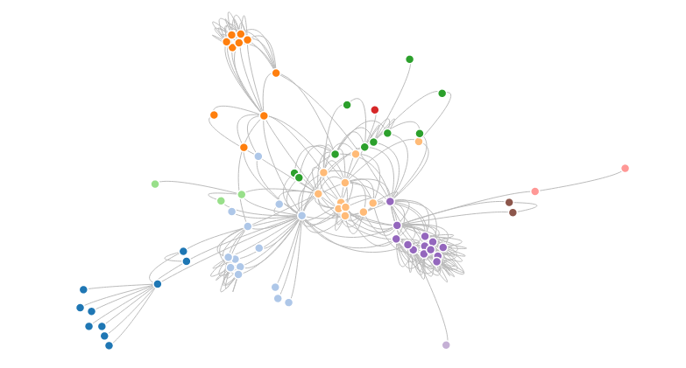

This variation of a [force-directed graph](https://bl.ocks.org/4062045) uses intermediate nodes in links to create aesthetically-pleasing Bézier curves.

index.html[**#**](https://bl.ocks.org/mbostock/4600693#index.html)

<!DOCTYPE html>

<meta charset="utf-8">

<style>

.node {

stroke: #fff;

stroke-width: 1.5px;

}

.link {

fill: none;

stroke: #bbb;

}

</style>

<svg width="960" height="600"></svg>

<script src="https://d3js.org/d3.v4.min.js"></script>

<script>

var svg = d3.select("svg"),

width = +svg.attr("width"),

height = +svg.attr("height");

var color = d3.scaleOrdinal(d3.schemeCategory20);

var simulation = d3.forceSimulation()

.force("link", d3.forceLink().distance(10).strength(0.5))

.force("charge", d3.forceManyBody())

.force("center", d3.forceCenter(width / 2, height / 2));

d3.json("miserables.json", function(error, graph) {

if (error) throw error;

var nodes = graph.nodes,

nodeById = d3.map(nodes, function(d) { return d.id; }),

links = graph.links,

bilinks = [];

links.forEach(function(link) {

var s = link.source = nodeById.get(link.source),

t = link.target = nodeById.get(link.target),

i = {}; // intermediate node

nodes.push(i);

links.push({source: s, target: i}, {source: i, target: t});

bilinks.push([s, i, t]);

});

var link = svg.selectAll(".link")

.data(bilinks)

.enter().append("path")

.attr("class", "link");

var node = svg.selectAll(".node")

.data(nodes.filter(function(d) { return d.id; }))

.enter().append("circle")

.attr("class", "node")

.attr("r", 5)

.attr("fill", function(d) { return color(d.group); })

.call(d3.drag()

.on("start", dragstarted)

.on("drag", dragged)

.on("end", dragended));

node.append("title")

.text(function(d) { return d.id; });

simulation

.nodes(nodes)

.on("tick", ticked);

simulation.force("link")

.links(links);

function ticked() {

link.attr("d", positionLink);

node.attr("transform", positionNode);

}

});

function positionLink(d) {

return "M" + d[0].x + "," + d[0].y

+ "S" + d[1].x + "," + d[1].y

+ " " + d[2].x + "," + d[2].y;

}

function positionNode(d) {

return "translate(" + d.x + "," + d.y + ")";

}

function dragstarted(d) {

if (!d3.event.active) simulation.alphaTarget(0.3).restart();

d.fx = d.x, d.fy = d.y;

}

function dragged(d) {

d.fx = d3.event.x, d.fy = d3.event.y;

}

function dragended(d) {

if (!d3.event.active) simulation.alphaTarget(0);

d.fx = null, d.fy = null;

}

</script>

miserables.json[**#**](https://bl.ocks.org/mbostock/4600693#miserables.json)

{

"nodes": [

{"id": "Myriel", "group": 1},

{"id": "Napoleon", "group": 1},

{"id": "Mlle.Baptistine", "group": 1},

{"id": "Mme.Magloire", "group": 1},

{"id": "CountessdeLo", "group": 1},

{"id": "Geborand", "group": 1},

{"id": "Champtercier", "group": 1},

{"id": "Cravatte", "group": 1},

{"id": "Count", "group": 1},

{"id": "OldMan", "group": 1},

{"id": "Labarre", "group": 2},

{"id": "Valjean", "group": 2},

{"id": "Marguerite", "group": 3},

{"id": "Mme.deR", "group": 2},

{"id": "Isabeau", "group": 2},

{"id": "Gervais", "group": 2},

{"id": "Tholomyes", "group": 3},

{"id": "Listolier", "group": 3},

{"id": "Fameuil", "group": 3},

{"id": "Blacheville", "group": 3},

{"id": "Favourite", "group": 3},

{"id": "Dahlia", "group": 3},

{"id": "Zephine", "group": 3},

{"id": "Fantine", "group": 3},

{"id": "Mme.Thenardier", "group": 4},

{"id": "Thenardier", "group": 4},

{"id": "Cosette", "group": 5},

{"id": "Javert", "group": 4},

{"id": "Fauchelevent", "group": 0},

{"id": "Bamatabois", "group": 2},

{"id": "Perpetue", "group": 3},

{"id": "Simplice", "group": 2},

{"id": "Scaufflaire", "group": 2},

{"id": "Woman1", "group": 2},

{"id": "Judge", "group": 2},

{"id": "Champmathieu", "group": 2},

{"id": "Brevet", "group": 2},

{"id": "Chenildieu", "group": 2},

{"id": "Cochepaille", "group": 2},

{"id": "Pontmercy", "group": 4},

{"id": "Boulatruelle", "group": 6},

{"id": "Eponine", "group": 4},

{"id": "Anzelma", "group": 4},

{"id": "Woman2", "group": 5},

{"id": "MotherInnocent", "group": 0},

{"id": "Gribier", "group": 0},

{"id": "Jondrette", "group": 7},

{"id": "Mme.Burgon", "group": 7},

{"id": "Gavroche", "group": 8},

{"id": "Gillenormand", "group": 5},

{"id": "Magnon", "group": 5},

{"id": "Mlle.Gillenormand", "group": 5},

{"id": "Mme.Pontmercy", "group": 5},

{"id": "Mlle.Vaubois", "group": 5},

{"id": "Lt.Gillenormand", "group": 5},

{"id": "Marius", "group": 8},

{"id": "BaronessT", "group": 5},

{"id": "Mabeuf", "group": 8},

{"id": "Enjolras", "group": 8},

{"id": "Combeferre", "group": 8},

{"id": "Prouvaire", "group": 8},

{"id": "Feuilly", "group": 8},

{"id": "Courfeyrac", "group": 8},

{"id": "Bahorel", "group": 8},

{"id": "Bossuet", "group": 8},

{"id": "Joly", "group": 8},

{"id": "Grantaire", "group": 8},

{"id": "MotherPlutarch", "group": 9},

{"id": "Gueulemer", "group": 4},

{"id": "Babet", "group": 4},

{"id": "Claquesous", "group": 4},

{"id": "Montparnasse", "group": 4},

{"id": "Toussaint", "group": 5},

{"id": "Child1", "group": 10},

{"id": "Child2", "group": 10},

{"id": "Brujon", "group": 4},

{"id": "Mme.Hucheloup", "group": 8}

],

"links": [

{"source": "Napoleon", "target": "Myriel", "value": 1},

{"source": "Mlle.Baptistine", "target": "Myriel", "value": 8},

{"source": "Mme.Magloire", "target": "Myriel", "value": 10},

{"source": "Mme.Magloire", "target": "Mlle.Baptistine", "value": 6},

{"source": "CountessdeLo", "target": "Myriel", "value": 1},

{"source": "Geborand", "target": "Myriel", "value": 1},

{"source": "Champtercier", "target": "Myriel", "value": 1},

{"source": "Cravatte", "target": "Myriel", "value": 1},

{"source": "Count", "target": "Myriel", "value": 2},

{"source": "OldMan", "target": "Myriel", "value": 1},

{"source": "Valjean", "target": "Labarre", "value": 1},

{"source": "Valjean", "target": "Mme.Magloire", "value": 3},

{"source": "Valjean", "target": "Mlle.Baptistine", "value": 3},

{"source": "Valjean", "target": "Myriel", "value": 5},

{"source": "Marguerite", "target": "Valjean", "value": 1},

{"source": "Mme.deR", "target": "Valjean", "value": 1},

{"source": "Isabeau", "target": "Valjean", "value": 1},

{"source": "Gervais", "target": "Valjean", "value": 1},

{"source": "Listolier", "target": "Tholomyes", "value": 4},

{"source": "Fameuil", "target": "Tholomyes", "value": 4},

{"source": "Fameuil", "target": "Listolier", "value": 4},

{"source": "Blacheville", "target": "Tholomyes", "value": 4},

{"source": "Blacheville", "target": "Listolier", "value": 4},

{"source": "Blacheville", "target": "Fameuil", "value": 4},

{"source": "Favourite", "target": "Tholomyes", "value": 3},

{"source": "Favourite", "target": "Listolier", "value": 3},

{"source": "Favourite", "target": "Fameuil", "value": 3},

{"source": "Favourite", "target": "Blacheville", "value": 4},

{"source": "Dahlia", "target": "Tholomyes", "value": 3},

{"source": "Dahlia", "target": "Listolier", "value": 3},

{"source": "Dahlia", "target": "Fameuil", "value": 3},

{"source": "Dahlia", "target": "Blacheville", "value": 3},

{"source": "Dahlia", "target": "Favourite", "value": 5},

{"source": "Zephine", "target": "Tholomyes", "value": 3},

{"source": "Zephine", "target": "Listolier", "value": 3},

{"source": "Zephine", "target": "Fameuil", "value": 3},

{"source": "Zephine", "target": "Blacheville", "value": 3},

{"source": "Zephine", "target": "Favourite", "value": 4},

{"source": "Zephine", "target": "Dahlia", "value": 4},

{"source": "Fantine", "target": "Tholomyes", "value": 3},

{"source": "Fantine", "target": "Listolier", "value": 3},

{"source": "Fantine", "target": "Fameuil", "value": 3},

{"source": "Fantine", "target": "Blacheville", "value": 3},

{"source": "Fantine", "target": "Favourite", "value": 4},

{"source": "Fantine", "target": "Dahlia", "value": 4},

{"source": "Fantine", "target": "Zephine", "value": 4},

{"source": "Fantine", "target": "Marguerite", "value": 2},

{"source": "Fantine", "target": "Valjean", "value": 9},

{"source": "Mme.Thenardier", "target": "Fantine", "value": 2},

{"source": "Mme.Thenardier", "target": "Valjean", "value": 7},

{"source": "Thenardier", "target": "Mme.Thenardier", "value": 13},

{"source": "Thenardier", "target": "Fantine", "value": 1},

{"source": "Thenardier", "target": "Valjean", "value": 12},

{"source": "Cosette", "target": "Mme.Thenardier", "value": 4},

{"source": "Cosette", "target": "Valjean", "value": 31},

{"source": "Cosette", "target": "Tholomyes", "value": 1},

{"source": "Cosette", "target": "Thenardier", "value": 1},

{"source": "Javert", "target": "Valjean", "value": 17},

{"source": "Javert", "target": "Fantine", "value": 5},

{"source": "Javert", "target": "Thenardier", "value": 5},

{"source": "Javert", "target": "Mme.Thenardier", "value": 1},

{"source": "Javert", "target": "Cosette", "value": 1},

{"source": "Fauchelevent", "target": "Valjean", "value": 8},

{"source": "Fauchelevent", "target": "Javert", "value": 1},

{"source": "Bamatabois", "target": "Fantine", "value": 1},

{"source": "Bamatabois", "target": "Javert", "value": 1},

{"source": "Bamatabois", "target": "Valjean", "value": 2},

{"source": "Perpetue", "target": "Fantine", "value": 1},

{"source": "Simplice", "target": "Perpetue", "value": 2},

{"source": "Simplice", "target": "Valjean", "value": 3},

{"source": "Simplice", "target": "Fantine", "value": 2},

{"source": "Simplice", "target": "Javert", "value": 1},

{"source": "Scaufflaire", "target": "Valjean", "value": 1},

{"source": "Woman1", "target": "Valjean", "value": 2},

{"source": "Woman1", "target": "Javert", "value": 1},

{"source": "Judge", "target": "Valjean", "value": 3},

{"source": "Judge", "target": "Bamatabois", "value": 2},

{"source": "Champmathieu", "target": "Valjean", "value": 3},

{"source": "Champmathieu", "target": "Judge", "value": 3},

{"source": "Champmathieu", "target": "Bamatabois", "value": 2},

{"source": "Brevet", "target": "Judge", "value": 2},

{"source": "Brevet", "target": "Champmathieu", "value": 2},

{"source": "Brevet", "target": "Valjean", "value": 2},

{"source": "Brevet", "target": "Bamatabois", "value": 1},

{"source": "Chenildieu", "target": "Judge", "value": 2},

{"source": "Chenildieu", "target": "Champmathieu", "value": 2},

{"source": "Chenildieu", "target": "Brevet", "value": 2},

{"source": "Chenildieu", "target": "Valjean", "value": 2},

{"source": "Chenildieu", "target": "Bamatabois", "value": 1},

{"source": "Cochepaille", "target": "Judge", "value": 2},

{"source": "Cochepaille", "target": "Champmathieu", "value": 2},

{"source": "Cochepaille", "target": "Brevet", "value": 2},

{"source": "Cochepaille", "target": "Chenildieu", "value": 2},

{"source": "Cochepaille", "target": "Valjean", "value": 2},

{"source": "Cochepaille", "target": "Bamatabois", "value": 1},

{"source": "Pontmercy", "target": "Thenardier", "value": 1},

{"source": "Boulatruelle", "target": "Thenardier", "value": 1},

{"source": "Eponine", "target": "Mme.Thenardier", "value": 2},

{"source": "Eponine", "target": "Thenardier", "value": 3},

{"source": "Anzelma", "target": "Eponine", "value": 2},

{"source": "Anzelma", "target": "Thenardier", "value": 2},

{"source": "Anzelma", "target": "Mme.Thenardier", "value": 1},

{"source": "Woman2", "target": "Valjean", "value": 3},

{"source": "Woman2", "target": "Cosette", "value": 1},

{"source": "Woman2", "target": "Javert", "value": 1},

{"source": "MotherInnocent", "target": "Fauchelevent", "value": 3},

{"source": "MotherInnocent", "target": "Valjean", "value": 1},

{"source": "Gribier", "target": "Fauchelevent", "value": 2},

{"source": "Mme.Burgon", "target": "Jondrette", "value": 1},

{"source": "Gavroche", "target": "Mme.Burgon", "value": 2},

{"source": "Gavroche", "target": "Thenardier", "value": 1},

{"source": "Gavroche", "target": "Javert", "value": 1},

{"source": "Gavroche", "target": "Valjean", "value": 1},

{"source": "Gillenormand", "target": "Cosette", "value": 3},

{"source": "Gillenormand", "target": "Valjean", "value": 2},

{"source": "Magnon", "target": "Gillenormand", "value": 1},

{"source": "Magnon", "target": "Mme.Thenardier", "value": 1},

{"source": "Mlle.Gillenormand", "target": "Gillenormand", "value": 9},

{"source": "Mlle.Gillenormand", "target": "Cosette", "value": 2},

{"source": "Mlle.Gillenormand", "target": "Valjean", "value": 2},

{"source": "Mme.Pontmercy", "target": "Mlle.Gillenormand", "value": 1},

{"source": "Mme.Pontmercy", "target": "Pontmercy", "value": 1},

{"source": "Mlle.Vaubois", "target": "Mlle.Gillenormand", "value": 1},

{"source": "Lt.Gillenormand", "target": "Mlle.Gillenormand", "value": 2},

{"source": "Lt.Gillenormand", "target": "Gillenormand", "value": 1},

{"source": "Lt.Gillenormand", "target": "Cosette", "value": 1},

{"source": "Marius", "target": "Mlle.Gillenormand", "value": 6},

{"source": "Marius", "target": "Gillenormand", "value": 12},

{"source": "Marius", "target": "Pontmercy", "value": 1},

{"source": "Marius", "target": "Lt.Gillenormand", "value": 1},

{"source": "Marius", "target": "Cosette", "value": 21},

{"source": "Marius", "target": "Valjean", "value": 19},

{"source": "Marius", "target": "Tholomyes", "value": 1},

{"source": "Marius", "target": "Thenardier", "value": 2},

{"source": "Marius", "target": "Eponine", "value": 5},

{"source": "Marius", "target": "Gavroche", "value": 4},

{"source": "BaronessT", "target": "Gillenormand", "value": 1},

{"source": "BaronessT", "target": "Marius", "value": 1},

{"source": "Mabeuf", "target": "Marius", "value": 1},

{"source": "Mabeuf", "target": "Eponine", "value": 1},

{"source": "Mabeuf", "target": "Gavroche", "value": 1},

{"source": "Enjolras", "target": "Marius", "value": 7},

{"source": "Enjolras", "target": "Gavroche", "value": 7},

{"source": "Enjolras", "target": "Javert", "value": 6},

{"source": "Enjolras", "target": "Mabeuf", "value": 1},

{"source": "Enjolras", "target": "Valjean", "value": 4},

{"source": "Combeferre", "target": "Enjolras", "value": 15},

{"source": "Combeferre", "target": "Marius", "value": 5},

{"source": "Combeferre", "target": "Gavroche", "value": 6},

{"source": "Combeferre", "target": "Mabeuf", "value": 2},

{"source": "Prouvaire", "target": "Gavroche", "value": 1},

{"source": "Prouvaire", "target": "Enjolras", "value": 4},

{"source": "Prouvaire", "target": "Combeferre", "value": 2},

{"source": "Feuilly", "target": "Gavroche", "value": 2},

{"source": "Feuilly", "target": "Enjolras", "value": 6},

{"source": "Feuilly", "target": "Prouvaire", "value": 2},

{"source": "Feuilly", "target": "Combeferre", "value": 5},

{"source": "Feuilly", "target": "Mabeuf", "value": 1},

{"source": "Feuilly", "target": "Marius", "value": 1},

{"source": "Courfeyrac", "target": "Marius", "value": 9},

{"source": "Courfeyrac", "target": "Enjolras", "value": 17},

{"source": "Courfeyrac", "target": "Combeferre", "value": 13},

{"source": "Courfeyrac", "target": "Gavroche", "value": 7},

{"source": "Courfeyrac", "target": "Mabeuf", "value": 2},

{"source": "Courfeyrac", "target": "Eponine", "value": 1},

{"source": "Courfeyrac", "target": "Feuilly", "value": 6},

{"source": "Courfeyrac", "target": "Prouvaire", "value": 3},

{"source": "Bahorel", "target": "Combeferre", "value": 5},

{"source": "Bahorel", "target": "Gavroche", "value": 5},

{"source": "Bahorel", "target": "Courfeyrac", "value": 6},

{"source": "Bahorel", "target": "Mabeuf", "value": 2},

{"source": "Bahorel", "target": "Enjolras", "value": 4},

{"source": "Bahorel", "target": "Feuilly", "value": 3},

{"source": "Bahorel", "target": "Prouvaire", "value": 2},

{"source": "Bahorel", "target": "Marius", "value": 1},

{"source": "Bossuet", "target": "Marius", "value": 5},

{"source": "Bossuet", "target": "Courfeyrac", "value": 12},

{"source": "Bossuet", "target": "Gavroche", "value": 5},

{"source": "Bossuet", "target": "Bahorel", "value": 4},

{"source": "Bossuet", "target": "Enjolras", "value": 10},

{"source": "Bossuet", "target": "Feuilly", "value": 6},

{"source": "Bossuet", "target": "Prouvaire", "value": 2},

{"source": "Bossuet", "target": "Combeferre", "value": 9},

{"source": "Bossuet", "target": "Mabeuf", "value": 1},

{"source": "Bossuet", "target": "Valjean", "value": 1},

{"source": "Joly", "target": "Bahorel", "value": 5},

{"source": "Joly", "target": "Bossuet", "value": 7},

{"source": "Joly", "target": "Gavroche", "value": 3},

{"source": "Joly", "target": "Courfeyrac", "value": 5},

{"source": "Joly", "target": "Enjolras", "value": 5},

{"source": "Joly", "target": "Feuilly", "value": 5},

{"source": "Joly", "target": "Prouvaire", "value": 2},

{"source": "Joly", "target": "Combeferre", "value": 5},

{"source": "Joly", "target": "Mabeuf", "value": 1},

{"source": "Joly", "target": "Marius", "value": 2},

{"source": "Grantaire", "target": "Bossuet", "value": 3},

{"source": "Grantaire", "target": "Enjolras", "value": 3},

{"source": "Grantaire", "target": "Combeferre", "value": 1},

{"source": "Grantaire", "target": "Courfeyrac", "value": 2},

{"source": "Grantaire", "target": "Joly", "value": 2},

{"source": "Grantaire", "target": "Gavroche", "value": 1},

{"source": "Grantaire", "target": "Bahorel", "value": 1},

{"source": "Grantaire", "target": "Feuilly", "value": 1},

{"source": "Grantaire", "target": "Prouvaire", "value": 1},

{"source": "MotherPlutarch", "target": "Mabeuf", "value": 3},

{"source": "Gueulemer", "target": "Thenardier", "value": 5},

{"source": "Gueulemer", "target": "Valjean", "value": 1},

{"source": "Gueulemer", "target": "Mme.Thenardier", "value": 1},

{"source": "Gueulemer", "target": "Javert", "value": 1},

{"source": "Gueulemer", "target": "Gavroche", "value": 1},

{"source": "Gueulemer", "target": "Eponine", "value": 1},

{"source": "Babet", "target": "Thenardier", "value": 6},

{"source": "Babet", "target": "Gueulemer", "value": 6},

{"source": "Babet", "target": "Valjean", "value": 1},

{"source": "Babet", "target": "Mme.Thenardier", "value": 1},

{"source": "Babet", "target": "Javert", "value": 2},

{"source": "Babet", "target": "Gavroche", "value": 1},

{"source": "Babet", "target": "Eponine", "value": 1},

{"source": "Claquesous", "target": "Thenardier", "value": 4},

{"source": "Claquesous", "target": "Babet", "value": 4},

{"source": "Claquesous", "target": "Gueulemer", "value": 4},

{"source": "Claquesous", "target": "Valjean", "value": 1},

{"source": "Claquesous", "target": "Mme.Thenardier", "value": 1},

{"source": "Claquesous", "target": "Javert", "value": 1},

{"source": "Claquesous", "target": "Eponine", "value": 1},

{"source": "Claquesous", "target": "Enjolras", "value": 1},

{"source": "Montparnasse", "target": "Javert", "value": 1},

{"source": "Montparnasse", "target": "Babet", "value": 2},

{"source": "Montparnasse", "target": "Gueulemer", "value": 2},

{"source": "Montparnasse", "target": "Claquesous", "value": 2},

{"source": "Montparnasse", "target": "Valjean", "value": 1},

{"source": "Montparnasse", "target": "Gavroche", "value": 1},

{"source": "Montparnasse", "target": "Eponine", "value": 1},

{"source": "Montparnasse", "target": "Thenardier", "value": 1},

{"source": "Toussaint", "target": "Cosette", "value": 2},

{"source": "Toussaint", "target": "Javert", "value": 1},

{"source": "Toussaint", "target": "Valjean", "value": 1},

{"source": "Child1", "target": "Gavroche", "value": 2},

{"source": "Child2", "target": "Gavroche", "value": 2},

{"source": "Child2", "target": "Child1", "value": 3},

{"source": "Brujon", "target": "Babet", "value": 3},

{"source": "Brujon", "target": "Gueulemer", "value": 3},

{"source": "Brujon", "target": "Thenardier", "value": 3},

{"source": "Brujon", "target": "Gavroche", "value": 1},

{"source": "Brujon", "target": "Eponine", "value": 1},

{"source": "Brujon", "target": "Claquesous", "value": 1},

{"source": "Brujon", "target": "Montparnasse", "value": 1},

{"source": "Mme.Hucheloup", "target": "Bossuet", "value": 1},

{"source": "Mme.Hucheloup", "target": "Joly", "value": 1},

{"source": "Mme.Hucheloup", "target": "Grantaire", "value": 1},

{"source": "Mme.Hucheloup", "target": "Bahorel", "value": 1},

{"source": "Mme.Hucheloup", "target": "Courfeyrac", "value": 1},

{"source": "Mme.Hucheloup", "target": "Gavroche", "value": 1},

{"source": "Mme.Hucheloup", "target": "Enjolras", "value": 1}

]

}

LICENSE[**#**](https://bl.ocks.org/mbostock/4600693#license)

Released under the [GNU General Public License, version 3](https://opensource.org/licenses/GPL-3.0).

# Tim Dwyer's Homepage

http://marvl.infotech.monash.edu/~dwyer/

My research concerns many different aspects of Information Visualisation and Visual Analytics. In other words, I am interested in visual interfaces for the exploration and communication of data. An area of key interest for me is network visualization, which I believe has a critical role to play in helping people to understand complex, interlinked data. Network visualisation is already widely used in disciplines like software engineering, biology and social network analysis; however, I believe it can play a greater role in many other areas of our lives if we can present complex information to people in an understandable and engaging way.

Much of my work has focused on the problem of finding high-quality layout for network diagrams. To create such diagrams automatically, we must compute positions for nodes and paths for links that are both readable and aesthetically pleasing. This computation is a significant optimisation challenge that tests the limits of current technologies. I am also interested in the development of novel representations of data and all aspects of interaction design for data exploration.

Another aspect of my research is the exploration of how we can effectively use emerging display technologies—such as large interactive surfaces and augmented and virtual reality—to help people perform data analysis. We call this research initiative*Immersive Analytics*.

Bio:

I received my PhD on ["Two and a Half Dimensional Visualisation of Relational Networks"](http://marvl.infotech.monash.edu/~dwyer/papers/thesis_20050609.pdf) from the University of Sydney in 2005. I was a post-doctoral Research Fellow at Monash University from 2005 to 2008, then a Visiting Researcher at Microsoft Research, USA in 2008-2009. From 2009 to 2012 I worked as a Senior Software Development Engineer with the Visual Studio product group at Microsoft, USA. A highlight of this period was shipping the [Code Map](https://msdn.microsoft.com/en-us/library/jj739835.aspx) software dependency visualisation tool with Visual Studio 2012. In late 2012 I returned to Monash University as a Larkins Fellow where I now co-direct the [Immersive Analytics Initiative](http://infotech.monash.edu/research/about/initiatives/immersive-analytics/) and am a founding member of the [Monash Adaptive Visualisation Lab](http://marvl.infotech.monash.edu/).

Recent Research Gallery:

[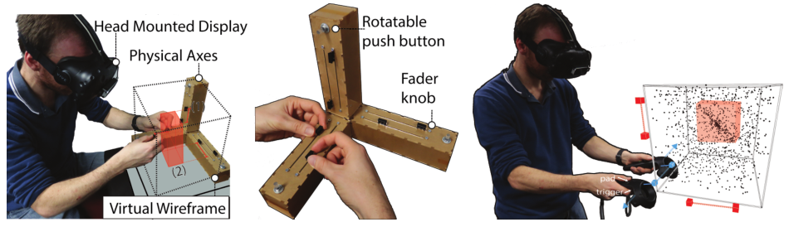](http://marvl.infotech.monash.edu/~dwyer/papers/spatiocoordinated.pdf)

*A Design Space for Spatio-Data Coordination: Tangible Interaction Devices for Immersive Information Visualisation*   
Maxime Cordeil, Benjamin Bach, Yongchao Li, Elliott Wilson, Tim Dwyer   
PacificVis 2017 Notes, To Appear 2017.   
[pre-print](http://marvl.infotech.monash.edu/~dwyer/papers/spatiocoordinated.pdf).

[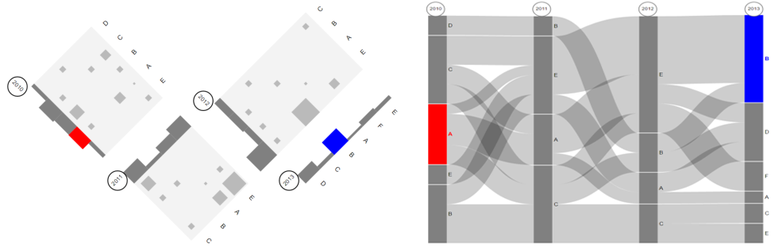](http://marvl.infotech.monash.edu/~dwyer/papers/proceedings_complementaryviews.pdf)

*Evaluating Perceptually Complementary Views for Network Exploration Tasks*   
Chunlei Chang, Benjamin Bach, Tim Dwyer, Kim Marriott   
Proceedings of ACM CHI, To Appear 2017.   
[pre-print](http://marvl.infotech.monash.edu/~dwyer/papers/proceedings_complementaryviews.pdf).

[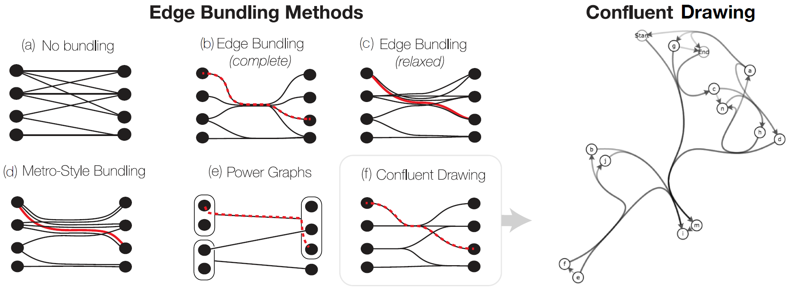](http://marvl.infotech.monash.edu/~dwyer/papers/confluentbundling.pdf)

*Towards Unambiguous Edge Bundling: Investigating Confluent Drawings for Network Visualization*   
Benjamin Bach, Nathalie Henry Riche, Christophe Hurter, Kim Marriott, Tim Dwyer   
IEEE TVCG, To Appear 2016.   
[pre-print](http://marvl.infotech.monash.edu/~dwyer/papers/confluentbundling.pdf) [demos](http://www.aviz.fr/~bbach/confluentgraphs/).

[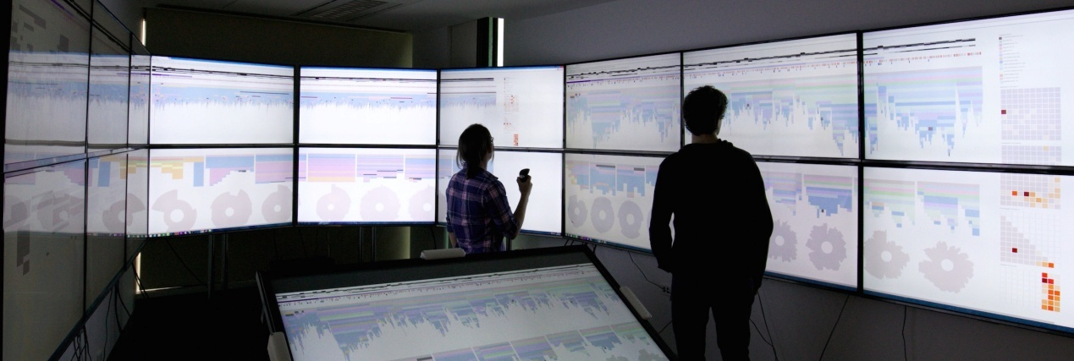](http://marvl.infotech.monash.edu/~dwyer/papers/cpprofiling.pdf)

*What do Constraint Programming Users Want to See? Exploring the role of Visualisation in Profiling of Models and Search*   
Sarah Goodwin, Christopher Mears, Tim Dwyer, Maria Garcia de la Banda, Guido Tack and Mark Wallace  
IEEE TVCG, To Appear 2016.   
[pre-print](http://marvl.infotech.monash.edu/~dwyer/papers/cpprofiling.pdf) [video](https://vimeo.com/186209274).

[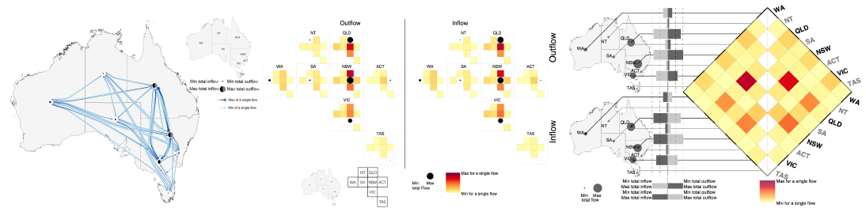](http://marvl.infotech.monash.edu/~dwyer/papers/maptrix.pdf)

*Many-to-Many Geographically-Embedded Flow Visualisation: An Evaluation*   
Yalong Yang, Tim Dwyer, Sarah Goodwin and Kim Marriott   
IEEE TVCG, To Appear 2016.**Infovis 2016 Honorable Mention Award**   
[pre-print](http://marvl.infotech.monash.edu/~dwyer/papers/maptrix.pdf) [video](http://vis.yalongyang.com/videos/maptrix-interaction-video.mp4).

[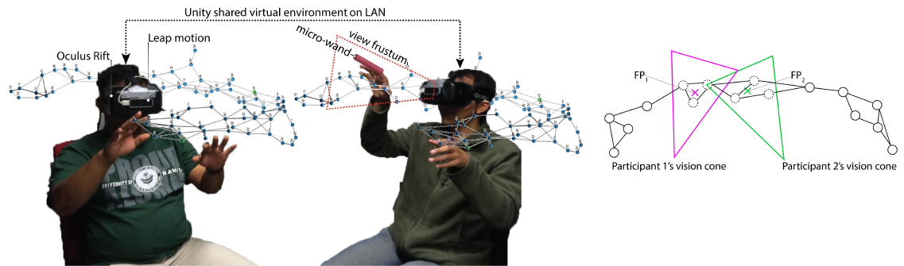](http://marvl.infotech.monash.edu/~dwyer/papers/Cave_vs_HMD2016.pdf)

*Immersive Collaborative Analysis of Network Connectivity: CAVE-style or Head-Mounted Display?*   
Maxime Cordeil, Tim Dwyer, Karsten Klein, Bireswar Laha, Kim Marriott, Bruce H. Thomas   
IEEE TVCG, To Appear 2016.   
[pre-print](http://marvl.infotech.monash.edu/~dwyer/papers/Cave_vs_HMD2016.pdf).

[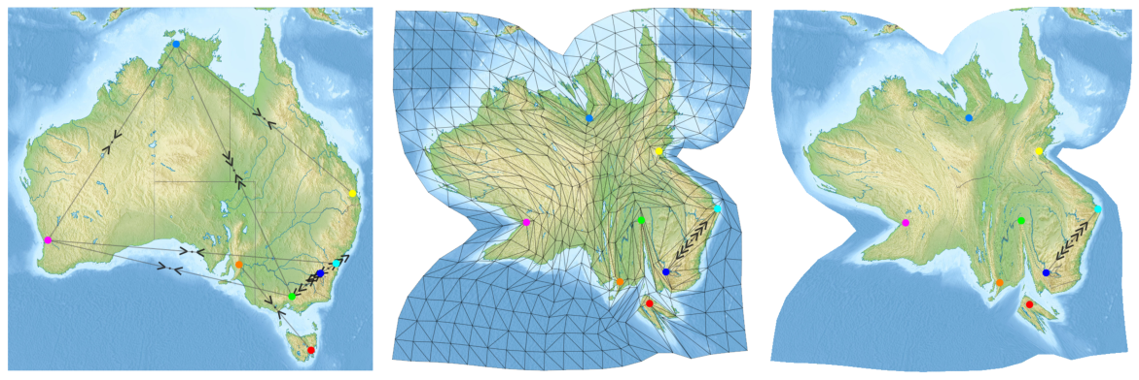](https://youtu.be/w8WfmUfkvBQ)

*Visual Encoding of Dissimilarity Data via Topology-Preserving Map Deformation*   
Collaboration with TU Eindhoven, City University London and MSR.   
IEEE TVCG, To Appear 2015. [pre-print](http://marvl.infotech.monash.edu/~dwyer/papers/mapdissimilarity.pdf).

[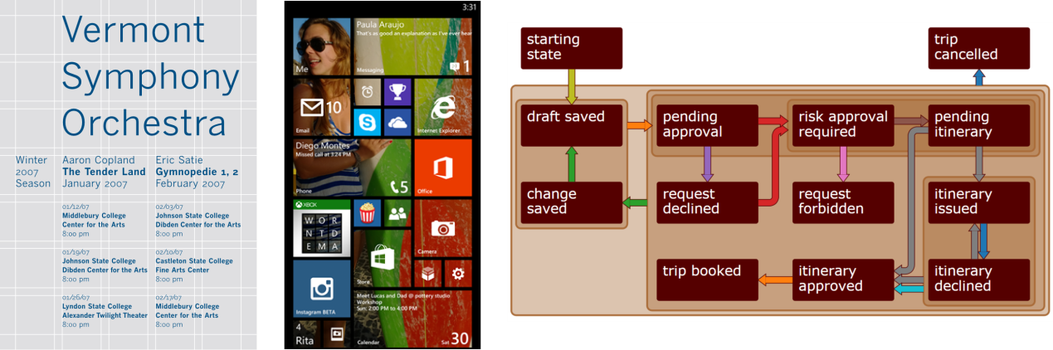](http://youtu.be/xwKj27dVR4o)

*High-Quality Ultra-Compact Grid Layout of Grouped Networks*   
Vahan Yoghourdjian, Tim Dwyer, Graeme Gange, Steve Kieffer, Karsten Klein, and Kim Marriott.   
Presented at Infovis 2015. [pre-print](http://marvl.infotech.monash.edu/~dwyer/papers/gridlayout2015.pdf).

[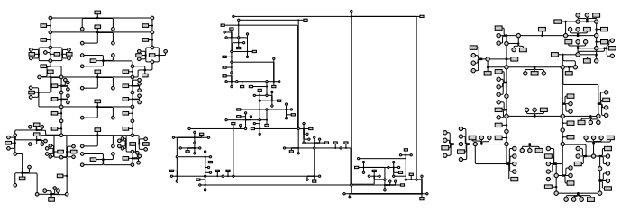](http://youtu.be/-qr9XXckIJE)

*HOLA: Human-like Orthogonal Network Layout*   
Steve Kieffer, Tim Dwyer, Kim Marriott and Michael Wybrow.   
**Infovis 2015 Best Paper Award** [pre-print](http://marvl.infotech.monash.edu/~dwyer/papers/hola2015.pdf).

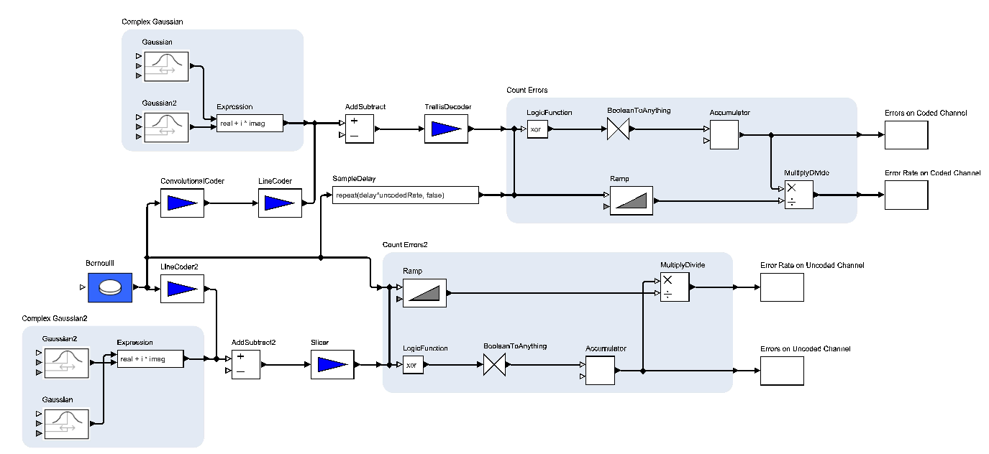

*Stress-Minimizing Orthogonal Layout of Data Flow Diagrams with Ports*   
U Rüegg, S Kieffer, T Dwyer, K Marriott, M Wybrow   
Proc. of Graph Drawing 2014, 319-330 [pdf](http://arxiv.org/pdf/1408.4626.pdf)

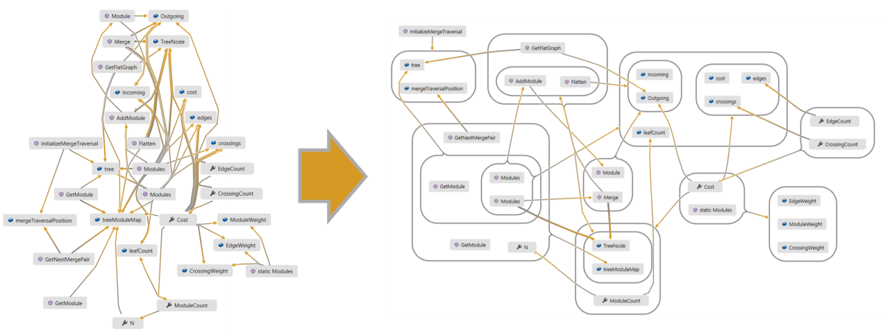

*Improved Optimal and Approximate Power Graph Compression for Clearer Visualisation of Dense Graphs*   
T Dwyer, C Mears, K Morgan, T Niven, K Marriott, M Wallace Pacific Visualization Symposium (PacificVis), 2014 IEEE, 105-112 [pdf](http://arxiv.org/pdf/1311.6996v1.pdf)

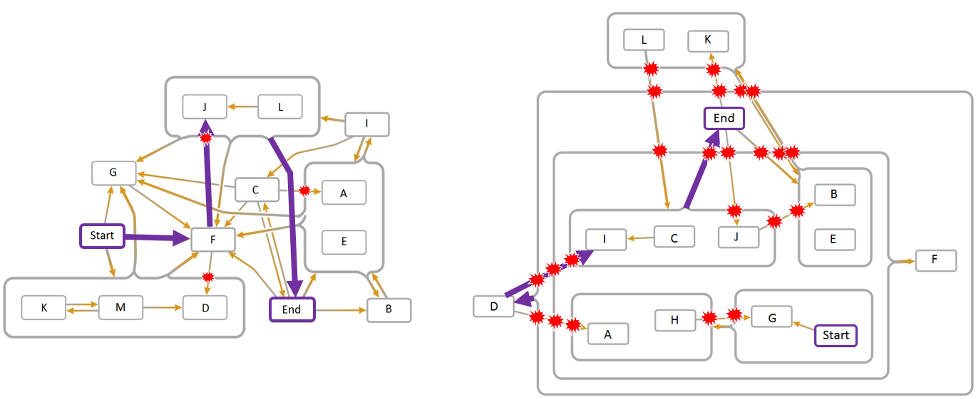

*Edge compression techniques for visualization of dense directed graphs*   
T Dwyer, NH Riche, K Marriott, C Mears   
Presented at InfoVis 2013   
Visualization and Computer Graphics, IEEE Transactions on 19 (12), 2596-2605 [pdf](http://research.microsoft.com/en-us/um/people/nath/docs/edgecompression_infovis2013.pdf)



Tim Dwyer

Associate Professor   
Faculty of Information Technology   
Monash University   
Melbourne, Australia

[Full Publications](https://scholar.google.com.au/citations?user=cOEUhBAAAAAJ&hl=en)

[YouTube channel](https://www.youtube.com/channel/UChOvGVKO1SY42Aw08LEIf3g)

[Resume](https://onedrive.live.com/redir?resid=C392F435292681D6!33650&authkey=!AAWVfPDU7tCp440&ithint=file%2cdocx)

Software

[WebCoLa](http://marvl.infotech.monash.edu/webcola) - a javascript library for constraint-based network layout.

[adaptagrams](http://www.adaptagrams.org/) - a C++ library of tools for adaptive diagrams.

[Code Map](https://msdn.microsoft.com/en-us/library/jj739835.aspx) - interactive software dependency exploration in Visual Studio

PhD Students

[Steve Kieffer](http://skieffer.info/)  
[Yalong Yang](http://profile.yalongyang.com/)  
[Vahan Yoghourdjian](http://vahany.com/)  
[Chunlei Chang](http://changchunlei.com/)  
[Domenico Mazza](https://do.meni.co/)  
[Jie Liu](http://marvl.infotech.monash.edu/~dwyer/)

Teaching

[FIT2102 - Programming paradigms](https://www.monash.edu.au/pubs/2016handbooks/units/FIT2102.html)   
[FIT3020 - Information Visualisation](https://www.monash.edu.au/pubs/2016handbooks/units/FIT3020.html)   
[FIT2079 - Data Visualisation](https://www.monash.edu.au/pubs/2016handbooks/units/FIT2079.html)   
[FIT2071 - Foundations of C++](https://www.monash.edu.au/pubs/2016handbooks/units/FIT2071.html)

Contact

*email:* tim.dwyer@monash.edu

*office location:*   
Building H, room 6.36   
900 Dandenong Rd   
Caulfield East

*postal address:*   
PO Box 197   
Caulfield East   
VIC 3145

# Knuth: The Stanford GraphBase

http://www-cs-faculty.stanford.edu/~uno/sgb.html

|  |
| --- |
| The Stanford GraphBase: A Platform for Combinatorial Computing |

by Donald E. Knuth (New York: ACM Press, 1994), viii+576pp.  
Co-published by Addison-Wesley Publishing Company.  
ISBN 0-201-54275-7 (original hardcover edition)  
ISBN 0-321-60632-9 (paperback edition, published 2009)

This award-winning book demonstrates the art of [literate programming](http://www-cs-faculty.stanford.edu/~uno/lp.html) with more than 30 examples. Each example is a programmatic essay: a short story that can be read and enjoyed by human beings as readily as it can be read and interpreted by machines. The programs contain state-of-the-art explanations of many important algorithms and data structures. They also define a workbench for combinatorial computing, and standard sets of data that can be used for benchmark tests of competing methods, as well as demonstration programs and games that make use of the data.

Hundreds of example programs that use The Stanford GraphBase will be distributed electronically as supplements to Volume 4 of [The Art of Computer Programming](http://www-cs-faculty.stanford.edu/~uno/taocp.html) when that volume is available, because Knuth will be using The Stanford GraphBase for many of the examples in that book.

Major topics include

* contributions to our understanding of significant algorithms and data structures
* standard tools for evaluating combinatorial algorithms
* a more readable, more practical style of programming
* challenges to readers who seek methods that are even better

Available from the publishers, [ACM Press](http://www.acm.org/pubs/pressbooks/homepage.html/) or [Addison-Wesley Publishing Company](http://www.informit.com/title/0321606329).

Public-domain sources for all programs and data of The Stanford GraphBase are freely available. They can be obtained, for example, by anonymous ftp from the [master sources](ftp://ftp.cs.stanford.edu/pub/sgb/sgb.tar.gz) on ftp.cs.stanford.edu in directory ~ftp/pub/sgb. The programs are highly portable and have been installed on a wide variety of computers and operating systems.

[Download sgb-words.txt, the 5757 five-letter words of English](http://www-cs-faculty.stanford.edu/~uno/sgb-words.txt)

[Download contiguous-usa.dat, adjacencies between the contiguous United States and DC](http://www-cs-faculty.stanford.edu/~uno/contiguous-usa.dat)

Sample graphs from TAOCP: [chvatal-12.gb](http://www-cs-faculty.stanford.edu/~uno/chvatal-12.gb) [contiguous-usa.gb](http://www-cs-faculty.stanford.edu/~uno/contiguous-usa.gb) [orient-express.gb](http://www-cs-faculty.stanford.edu/~uno/orient-express.gb)

Other example graphs: [knight3.gb](http://www-cs-faculty.stanford.edu/~uno/knight3.gb) (from the paper ``long and skinny knight's tours'') (and a [verbose text printout](http://www-cs-faculty.stanford.edu/~uno/knight3.txt))  
[somap3.gb>](http://www-cs-faculty.stanford.edu/~uno/somap3.gb) (the Somap of Berlekamp, Conway, and Guy, complete with all possible dotted edges) (and a [verbose text printout, with explanation](http://www-cs-faculty.stanford.edu/~uno/somap-list.txt))   
[somap2.gb>](http://www-cs-faculty.stanford.edu/~uno/somap2.gb) (the Somap with solid edges only)

This book was cited by the Association of American Publishers as the best new book in Computer Science, 1994.

There's a nice online writeup in the [Stony Brook Algorithm Repository](http://www.cs.sunysb.edu/~algorith/implement/graphbase/implement.shtml).



Challenge Problems

The book contains several yet-unsolved problems on which I'm hoping readers will make significant progress. One of the most fun problems is based on the 1990 football season: What is the biggest score Stanford can rack up over Harvard by a simple chain of results from that year? My best solution was 2279, but Buel Chandler has improved that to 2448 by applying genetic programming ideas to some of my algorithms. See [Chandler's cool page about genetic football](http://lobotomy.kicks-ass.org/bec/genetic/) for further information.

News flash, 25 November 2001: Mark Cooke has just reported the discovery of a sequence by which Stanford racks up 2473 points over Harvard, together with a matching upper bound (found in February 2002)! Also, Harvard over Stanford by 2358; Penn State over Columbia by 2542 (and that's the max over all pairs of teams). Details to follow...



IMPORTANT ANNOUNCEMENT

An embarrassing off-by-one error was corrected in the programs that create random graphs (*random_graph* and *random_bigraph*). When making this change, I decided it was better to conform to the documentation than to remain totally compatible with past history. The graph that now is called random_graph(n,m,x,l,o,f,t,a,b,s), and which properly deserves that name, is the same as the graph that used to be called random_graph(n,m,x,l,o,f,t,a,b+1,s)---unless a=b, in which case the old program was correct and no change was necessary.

Please upgrade to the new versions of the SGB source programs, if your copy is dated earlier than July 1999. (I also made minor corrections in May 2007---worth making, but not crucial. They did, however, affect lisa.dat and jean.dat in tiny ways.)

“Defects” in the data files

Since the data files were prepared by hand, they are subject to human error. They should therefore not be considered to be definite sources of facts, which are correctible like an article in the Wikipedia. They are intended simply as forever-frozen examples of typical data that is more or less accurate.

In particular, I recently learned that I forgot to include any connection between Fantine and her infant daughter Cosette, when I summarized the encounters between the characters of Les Misérables in the data file jean.dat. Fantine and Cosette appear together in chapter 1.4.1 (and then, of course -- alas -- they never see each other again). Upon rereading the chapter, I see that my file should have had "1.4.1:TM,AZ,EP;TM,FN;FN,CO;AZ,EP,CO;TH,TM,FN" in place of the line "1.4.1:TM,FN;TH,TM,FN". However, I shall never update the file jean.dat, because it is “correct by definition.”

Errata

A list of corrections to all changes made to the first printings of this book can be found [here](http://www-cs-faculty.stanford.edu/~uno/sgberr3.html).

Here is a list of all nits that have been picked so far since 2009. An asterisk (*) marks significant technical errors that are not merely typographical:

*page 136, line 11 (09 Aug 09)

change $\{0,1,2\}$ to $\{0,1,1\},\quad\{0,1,2\}

*page 136, line 13 (09 Aug 09)

change $\{1,1,1\}$ to $\{1,2,0\},\quad\{1,1,1\}

*page 136, line 18 (09 Aug 09)

change $\{0,2,2\}$ to $\{0,2,2\}$, $\{1,1,2\}$,

page 438, line 3 of section 23 (06 Aug 15)

change "rds," to "rds’,"

page 474, line 11 (09 Mar 11)

change "the vertex of" to "the key of"

I will gratefully deposit [0x$1.00](http://www-cs-faculty.stanford.edu/~uno/boss.html) ($2.56) to the account of the first person who finds and reports anything else that remains technically, historically, typographically, or politically incorrect. Please send suggested corrections to [sgb@cs.stanford.edu](mailto:sgb@cs.stanford.edu), or send snail mail to Prof. D. Knuth, Computer Science Department, Gates Building 4B, Stanford University, Stanford, CA 94305-9045 USA.

**PLEASE DO NOT SEND EMAIL TO SGB EXCEPT TO REPORT ERRORS!** And if you do report an error via email, please **do not include attachments** of any kind; your message should be readable on brand-X operating systems for all values of X.

[View this page in Romanian](http://www.azoft.com/people/seremina/edu/sgb-rom.html) (courtesy of Aleksandra Seremina)



[[](http://www-cs-faculty.stanford.edu/~uno/index.html)Don Knuth's home page](http://www-cs-faculty.stanford.edu/~uno/index.html)

[[](http://www-cs-faculty.stanford.edu/~uno/books.html)Don Knuth's other books](http://www-cs-faculty.stanford.edu/~uno/books.html)

# Home · d3/d3 Wiki

https://github.com/d3/d3/wiki

# d3-force/README.md

at master · d3/d3-force

https://github.com/d3/d3-force/blob/master/README.md#simulation_tick